

Click HERE to access a teacher training video

To order Reading with TLC as a curriculum choice, parents/LC can order through Enrichment:

- Log into your Enrichment account
- Hit create request
- Approved vendors
- Type in Reading with TLC- Click it
- Then click on Vendor tips

This will show the reading with TLC package $287.00

The package includes:

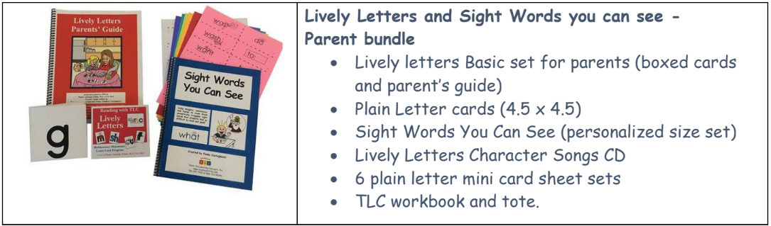

 Click the pictures to begin instruction

Sight Words Lesson One  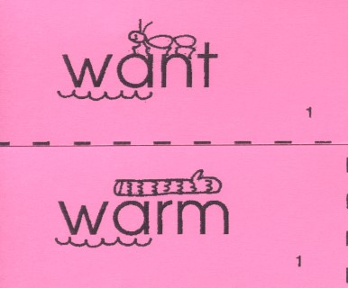 | I Can Statements:  I can read common high-frequency words. RF.K.3  I can tell about different sounds in a word. RF.1.2  I can read one-syllable words. RF.1.3  I can read two-syllable words. RF.1.3  I can read first grade words. RF.1.3  I can read second-grade words. RF.2.3  Resources:  Extended learning click here for your Sight word cards
Sight Words Lesson Two  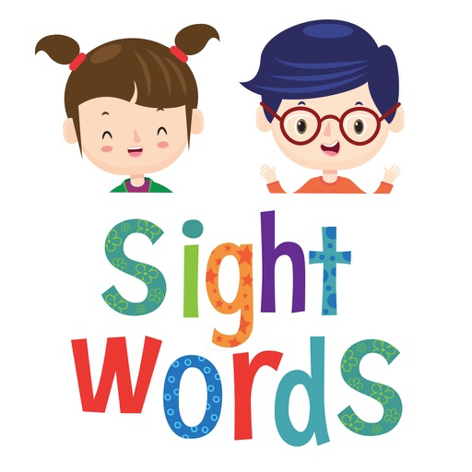 | I Can Statements:  I can read common high-frequency words. RF.K.3  I can tell about different sounds in a word. RF.1.2  I can read one-syllable words. RF.1.3  I can read two-syllable words. RF.1.3  I can read first grade words. RF.1.3  I can read second-grade words. RF.2.3  Resources:  Extended learning click here for your Sight word cards
Sight Words Lesson Three  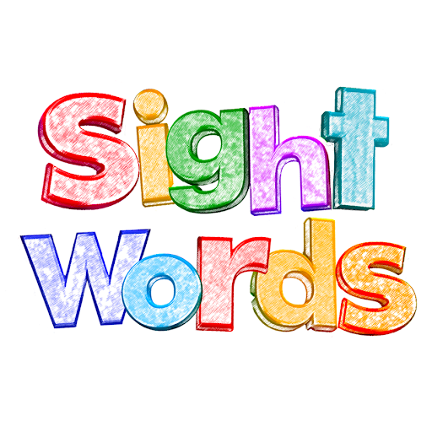 | I Can Statements:  I can read common high-frequency words. RF.K.3  I can tell about different sounds in a word. RF.1.2  I can read one-syllable words. RF.1.3  I can read two-syllable words. RF.1.3  I can read first grade words. RF.1.3  I can read second-grade words. RF.2.3  Resources:  Extended learning click here for your Sight word cards
Sight Words Lesson Four   | I Can Statements:  I can read common high-frequency words. RF.K.3  I can tell about different sounds in a word. RF.1.2  I can read one-syllable words. RF.1.3  I can read two-syllable words. RF.1.3  I can read first grade words. RF.1.3  I can read second-grade words. RF.2.3  Resources:  Extended learning click here for your for your Sight word cards
Sight Words Lesson Five  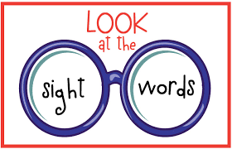 | I Can Statements:  I can read common high-frequency words. RF.K.3  I can tell about different sounds in a word. RF.1.2  I can read one-syllable words. RF.1.3  I can read two-syllable words. RF.1.3  I can read first grade words. RF.1.3  I can read second-grade words. RF.2.3  Resources:  King Ed Video  Extended learning click here for your for your Sight word cards
Sight Words Lesson Six  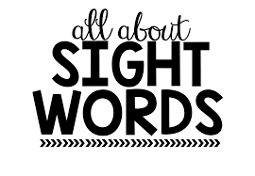 | I Can Statements:  I can read common high-frequency words. RF.K.3  I can tell about different sounds in a word. RF.1.2  I can read one-syllable words. RF.1.3  I can read two-syllable words. RF.1.3  I can read first grade words. RF.1.3  I can read second-grade words. RF.2.3  Resources:  King Ed Video  Extended learning click here for your for your Sight word cards
Sight Words Lesson Seven  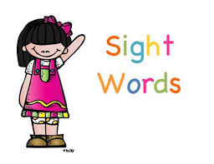 | I Can Statements:  I can read common high-frequency words. RF.K.3  I can tell about different sounds in a word. RF.1.2  I can read one-syllable words. RF.1.3  I can read two-syllable words. RF.1.3  I can read first grade words. RF.1.3  I can read second grade words. RF.2.3  Resources:  Extended learning click here for your for your Sight word cards
Sight Words Lesson Eight  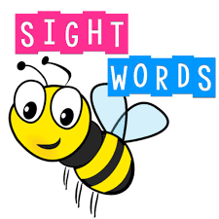 | I Can Statements:  I can read common high-frequency words. RF.K.3  I can tell about different sounds in a word. RF.1.2  I can read one-syllable words. RF.1.3  I can read two-syllable words. RF.1.3  I can read first grade words. RF.1.3  I can read second-grade words. RF.2.3  Resources:  Extended learning click here for your for your Sight word cards
Sight Words Lesson Nine  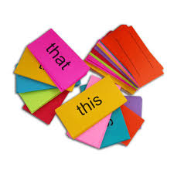 | I Can Statements:  I can read common high-frequency words. RF.K.3  I can tell about different sounds in a word. RF.1.2  I can read one-syllable words. RF.1.3  I can read two-syllable words. RF.1.3  I can read first grade words. RF.1.3  I can read second-grade words. RF.2.3  Resources:  Extended learning click here for your for your Sight word cards
Sight Words Lesson Ten | I Can Statements:  I can read common high-frequency words. RF.K.3  I can tell about different sounds in a word. RF.1.2  I can read one-syllable words. RF.1.3  I can read two-syllable words. RF.1.3  I can read first grade words. RF.1.3  I can read second-grade words. RF.2.3  Resources:  Extended learning click here for your for your Sight word cards
Sight Words Lesson Eleven  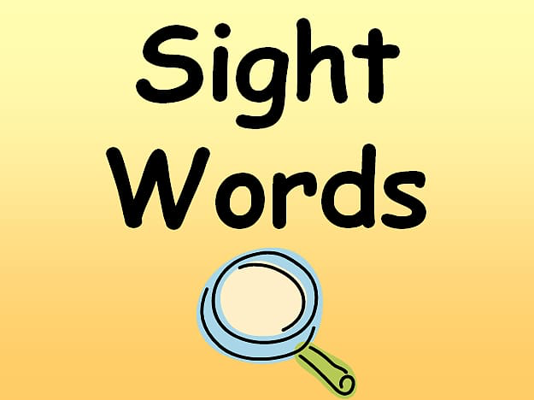 | I Can Statements:  I can read common high-frequency words. RF.K.3  I can tell about different sounds in a word. RF.1.2  I can read one-syllable words. RF.1.3  I can read two-syllable words. RF.1.3  I can read first grade words. RF.1.3  I can read second-grade words. RF.2.3  Resources:  Extended learning click here for your for your Sight word cards
Sight Words Lesson Twelve  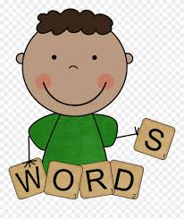 | I Can Statements:  I can read common high-frequency words. RF.K.3  I can tell about different sounds in a word. RF.1.2  I can read one-syllable words. RF.1.3  I can read two-syllable words. RF.1.3  I can read first grade words. RF.1.3  I can read second-grade words. RF.2.3  Resources:  Extended learning click here for your for your Sight word cards
Sight Words Lesson Thirteen  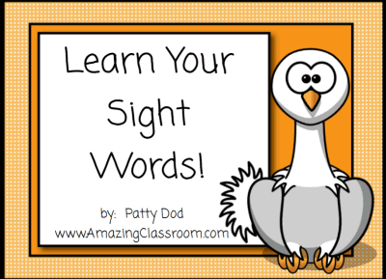 | I Can Statements:  I can read common high-frequency words. RF.K.3  I can tell about different sounds in a word. RF.1.2  I can read one-syllable words. RF.1.3  I can read two-syllable words. RF.1.3  I can read first grade words. RF.1.3  I can read second-grade words. RF.2.3  Resources:  Extended learning click here for your for your Sight word cards
Sight Words Lesson Fourteen  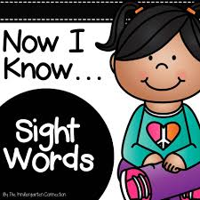 | I Can Statements:  I can read common high-frequency words. RF.K.3  I can tell about different sounds in a word. RF.1.2  I can read one-syllable words. RF.1.3  I can read two-syllable words. RF.1.3  I can read first grade words. RF.1.3  I can read second-grade words. RF.2.3  Resources:  Extended learning click here for your for your Sight word cards
Additional Resources | - How To Teach Reading

