

Click HERE to access a teacher training video

To order Reading with TLC as a curriculum choice,
parents/LC can order through Enrichment:
Log into your Enrichment account
Hit create request
Approved vendors
Type in Reading with TLC- Click it
then click on Vendor tips. This will show the reading with TLC package $287.00
The package includes:
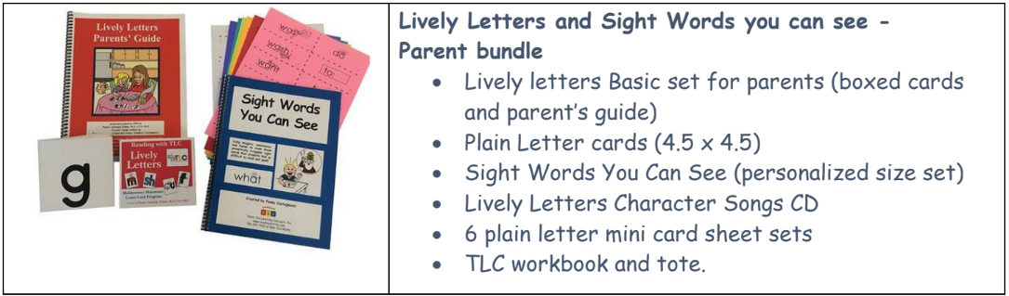

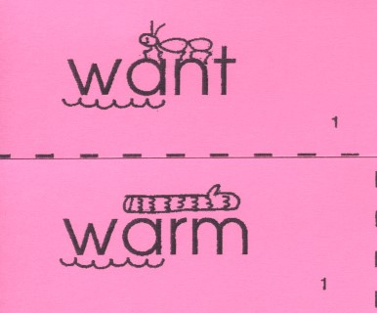 | Sight Words Lesson One  I Can Statements  I can read common high-frequency words. RF.K.3  I can tell about different sounds in a word. RF.1.2  I can read one-syllable words. RF.1.3  I can read two-syllable words. RF.1.3  I can read first grade words. RF.1.3  I can read second-grade words. RF.2.3  Resources  Extended learning click here for your Sight word cards
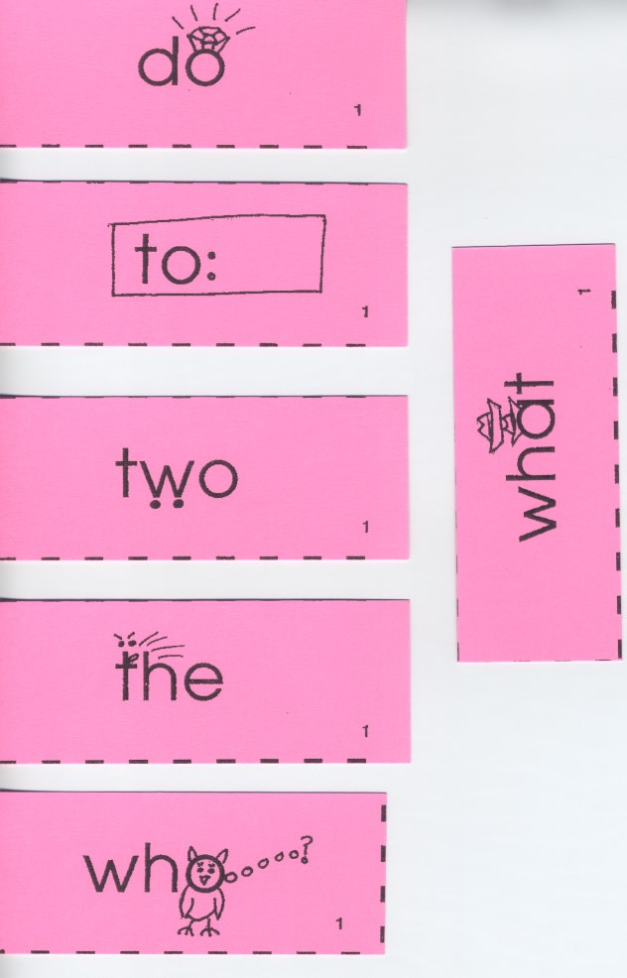 | Sight Words Lesson Two  I Can Statements  I can read common high-frequency words. RF.K.3  I can tell about different sounds in a word. RF.1.2  I can read one-syllable words. RF.1.3  I can read two-syllable words. RF.1.3  I can read first grade words. RF.1.3  I can read second-grade words. RF.2.3  Resources  Extended learning click here for your Sight word cards
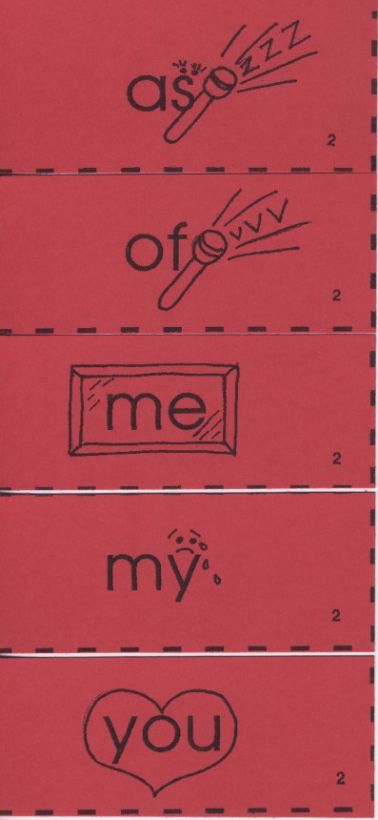 | Sight Words Lesson Three  I Can Statements  I can read common high-frequency words. RF.K.3  I can tell about different sounds in a word. RF.1.2  I can read one-syllable words. RF.1.3  I can read two-syllable words. RF.1.3  I can read first grade words. RF.1.3  I can read second-grade words. RF.2.3  Resources  Extended learning click here for your Sight word cards
 | Sight Words Lesson Four  I Can Statements  I can read common high-frequency words. RF.K.3  I can tell about different sounds in a word. RF.1.2  I can read one-syllable words. RF.1.3  I can read two-syllable words. RF.1.3  I can read first grade words. RF.1.3  I can read second-grade words. RF.2.3  Resources  Extended learning click here for your for your Sight word cards
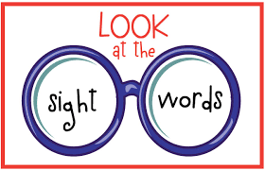 | Sight Words Lesson Five  I Can Statements  I can read common high-frequency words. RF.K.3  I can tell about different sounds in a word. RF.1.2  I can read one-syllable words. RF.1.3  I can read two-syllable words. RF.1.3  I can read first grade words. RF.1.3  I can read second-grade words. RF.2.3  Resources King Ed Video  Extended learning click here for your for your Sight word cards
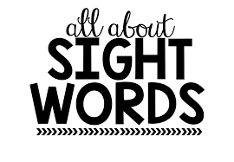 | Sight Words Lesson Six  I Can Statements  I can read common high-frequency words. RF.K.3  I can tell about different sounds in a word. RF.1.2  I can read one-syllable words. RF.1.3  I can read two-syllable words. RF.1.3  I can read first grade words. RF.1.3  I can read second-grade words. RF.2.3  Resources King Ed Video  Extended learning click here for your for your Sight word cards
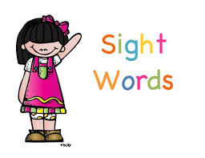 | Sight Words Lesson Seven  I Can Statements  I can read common high-frequency words. RF.K.3  I can tell about different sounds in a word. RF.1.2  I can read one-syllable words. RF.1.3  I can read two-syllable words. RF.1.3  I can read first grade words. RF.1.3  I can read second grade words. RF.2.3  Resources  Extended learning click here for your for your Sight word cards
 | Sight Words Lesson Eight  I Can Statements  I can read common high-frequency words. RF.K.3  I can tell about different sounds in a word. RF.1.2  I can read one-syllable words. RF.1.3  I can read two-syllable words. RF.1.3  I can read first grade words. RF.1.3  I can read second-grade words. RF.2.3  Resources  Extended learning click here for your for your Sight word cards
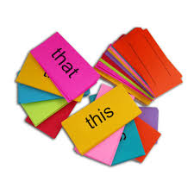 | Sight Words Lesson Nine  I Can Statements  I can read common high-frequency words. RF.K.3  I can tell about different sounds in a word. RF.1.2  I can read one-syllable words. RF.1.3  I can read two-syllable words. RF.1.3  I can read first grade words. RF.1.3  I can read second-grade words. RF.2.3  Resources  Extended learning click here for your for your Sight word cards
Sight Words Lesson Ten
I Can Statements

I can read common high-frequency words. RF.K.3
I can tell about different sounds in a word. RF.1.2
I can read one-syllable words. RF.1.3
I can read two-syllable words. RF.1.3
I can read first grade words. RF.1.3
I can read second-grade words. RF.2.3
Resources
Extended learning click here for your for your Sight word cards
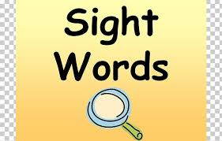 | Sight Words Lesson Eleven  I Can Statements  I can read common high-frequency words. RF.K.3  I can tell about different sounds in a word. RF.1.2  I can read one-syllable words. RF.1.3  I can read two-syllable words. RF.1.3  I can read first grade words. RF.1.3  I can read second-grade words. RF.2.3  Resources  Extended learning click here for your for your Sight word cards
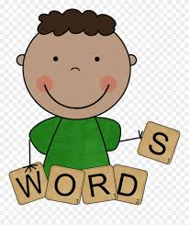 | Sight Words Lesson Twelve  I Can Statements  I can read common high-frequency words. RF.K.3  I can tell about different sounds in a word. RF.1.2  I can read one-syllable words. RF.1.3  I can read two-syllable words. RF.1.3  I can read first grade words. RF.1.3  I can read second-grade words. RF.2.3  Resources  Extended learning click here for your for your Sight word cards
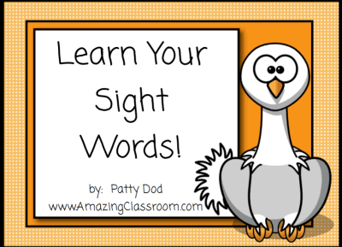 | Sight Words Lesson Thirteen  I Can Statements  I can read common high-frequency words. RF.K.3  I can tell about different sounds in a word. RF.1.2  I can read one-syllable words. RF.1.3  I can read two-syllable words. RF.1.3  I can read first grade words. RF.1.3  I can read second-grade words. RF.2.3  Resources  Extended learning click here for your for your Sight word cards
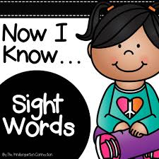 | Sight Words Lesson Fourteen  I Can Statements  I can read common high-frequency words. RF.K.3  I can tell about different sounds in a word. RF.1.2  I can read one-syllable words. RF.1.3  I can read two-syllable words. RF.1.3  I can read first grade words. RF.1.3  I can read second-grade words. RF.2.3  Resources  Extended learning click here for your for your Sight word cards
Additional Resources | - How To Teach Reading

