CTE (Career & Technical Education)

Today’s Career Tech Education (CTE) is a program of study integrating core academic knowledge with technical and occupational knowledge. Upon completion of a CTE pathway, students have the knowledge base required to sit for and pass the exam leading to industry certification, giving them the opportunity to apply for a career-ready job. While CTE is career-focused education preparing students for the world of work, completion of a pathway prepares students for college as well and is a valuable addition to one’s application, giving students a boost when applying to a particular program of study.
Watch this CTE presentation video to learn more about CTE and how it could benefit your student.
Please share this family-friendly resource with students who are interested in CTE.
If your student is taking a CTE course through an online vendor or a local program, please make sure to fill out the Course Adoption Survey. Since CTE courses need to be reported in a very specific way, please help the High School team keep track of student enrollments by filling out the survey.

CTE is a program of study integrating core academic knowledge with technical and occupational knowledge. There are CTE Pathways available in the Industry Sectors listed below. To find out about the possible careers and CTE pathways click on the industry sector below.

Industry Sectors:
  Agriculture & Natural Resources |   Arts, Media, & Entertainment |   Building & Construction Trades |   Business & Finance |   Education, Child Development, & Family Services
  Energy, Environment, & Utilities |   Engineering & Architecture |   Fashion & Interior Design |   Health Science & Medical Technology |   Hospitality, Tourism, & Recreation
  Information & Communication Technologies |   Manufacturing & Product Development |   Marketing, Sales, & Services |   Public Services |   Transportation Sector

There are three ways to complete a CTE Pathway:
- Option 1 – Students may use an online curriculum through eDynamic and/or Edmentum.
- Option 2 – Students may take courses through local ROC, ROP, CEC, or CTC programs.
  - Regional Occupational Center (ROC)
  - Regional Occupational Program (ROP)
  - Career Education Center (CEC)
  - Career Tech Center (CTC)
- Option 3 – Students may take courses offered by community college programs.

Option 1 - Online Options
 | 
Students choose one vendor’s pathway option below to complete their introductory, concentrator, and capstone courses. Please fill out the Course Adoption Survey to notify the High School team that your student is enrolling in a CTE course.
If you would like to see all of the online CTE curriculum options and find out which School Pathways course to add to your student's schedule, please use this Online Curriculum CTE Options spreadsheet.
- Edmentum EdOptions
- eDynamic Learning
  - Sequenced eDynamic CTE Pathways - This resource gives an overview of all eDynamic CTE courses and pathways available.
Capstone experiences will vary depending on the pathway and curriculum.
- Some capstone experiences with eDynamic Learning require the completion of a project that has been embedded into the final online capstone course. Other eDynamic Learning capstone courses require the student to have an internship or current work experience while completing the online course component
- The capstone experience with Edmentum EdOptions will require the choice of an end research paper, project, work experience or internship and weekly check-in with the CTE instructor who acts as a mentor through the course.
- Students who are enrolled in an eDynamic Learning pathway that requires an internship who do not have an internship ready, may instead enroll in the Edmentum capstone course and complete the research paper or project with Edmentum EdOptions.

Option 2 - Local Programs
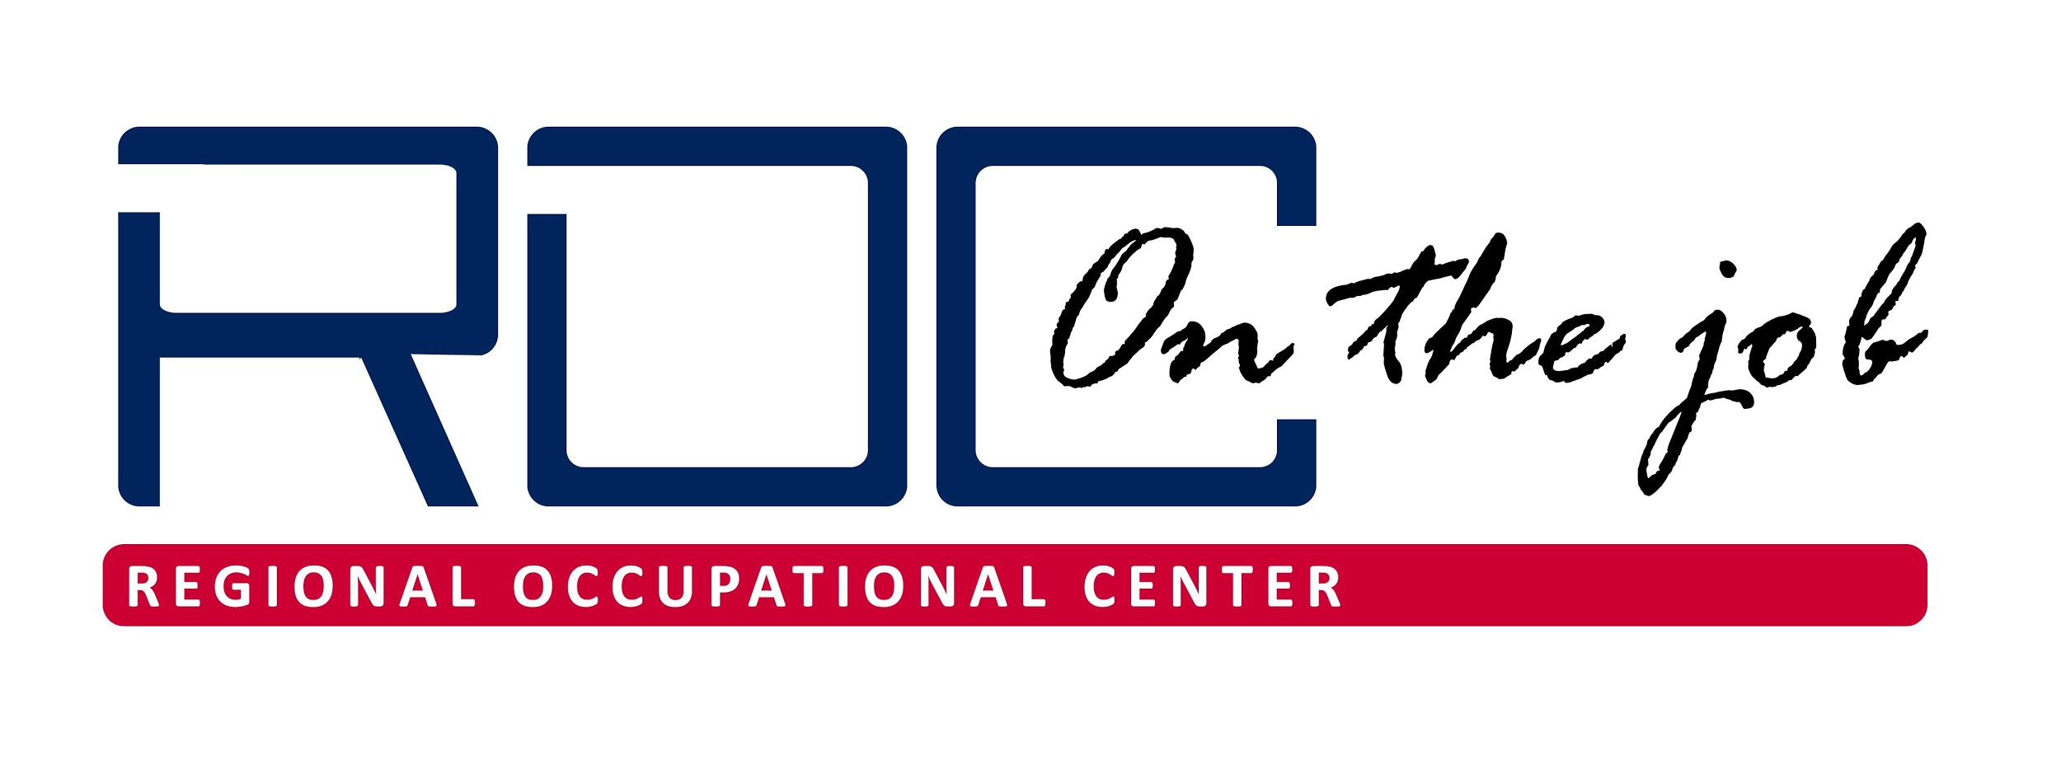 | 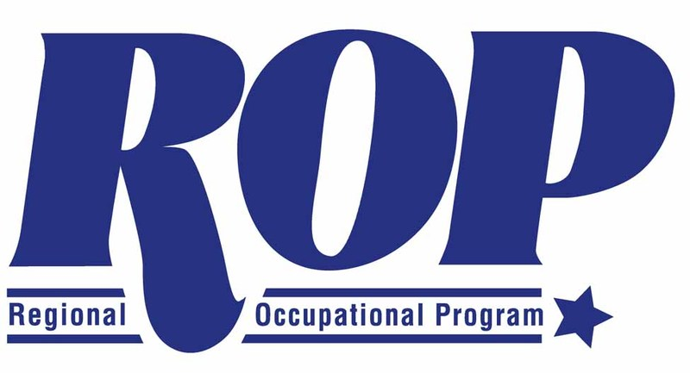 | 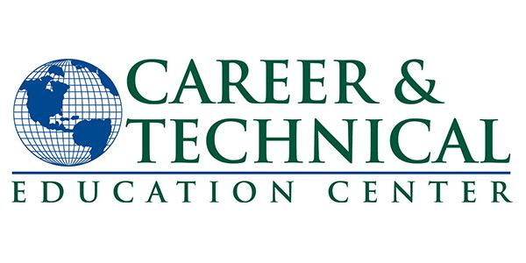
Please fill out the Course Adoption Survey and wait for a response from the high school team. Please be prepared to share the following information:
- Program name
- Website (if available)
- Program contact (if known)
- CTE pathway
Depending on the program, the course may or may not need to be added to the Master Agreement. Please await a response from the high school team before taking any further action.

Option 3 - Community College
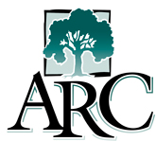 |  |  | 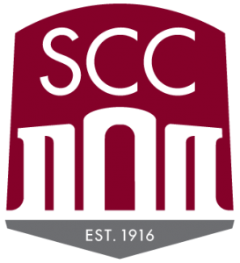 | 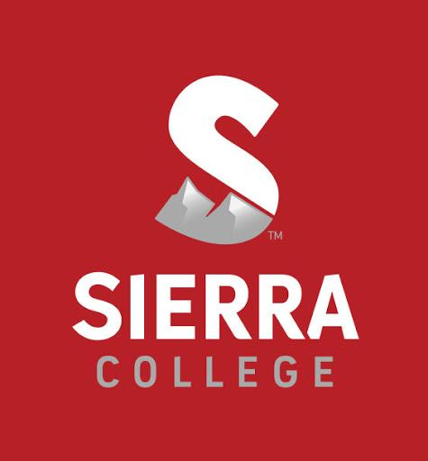 | 
Please follow the Concurrent Enrollment Policy for all college CTE courses. If you are looking for a specific program, use this Community College CTE Options spreadsheet to find out which CTE programs are offered at each college.

