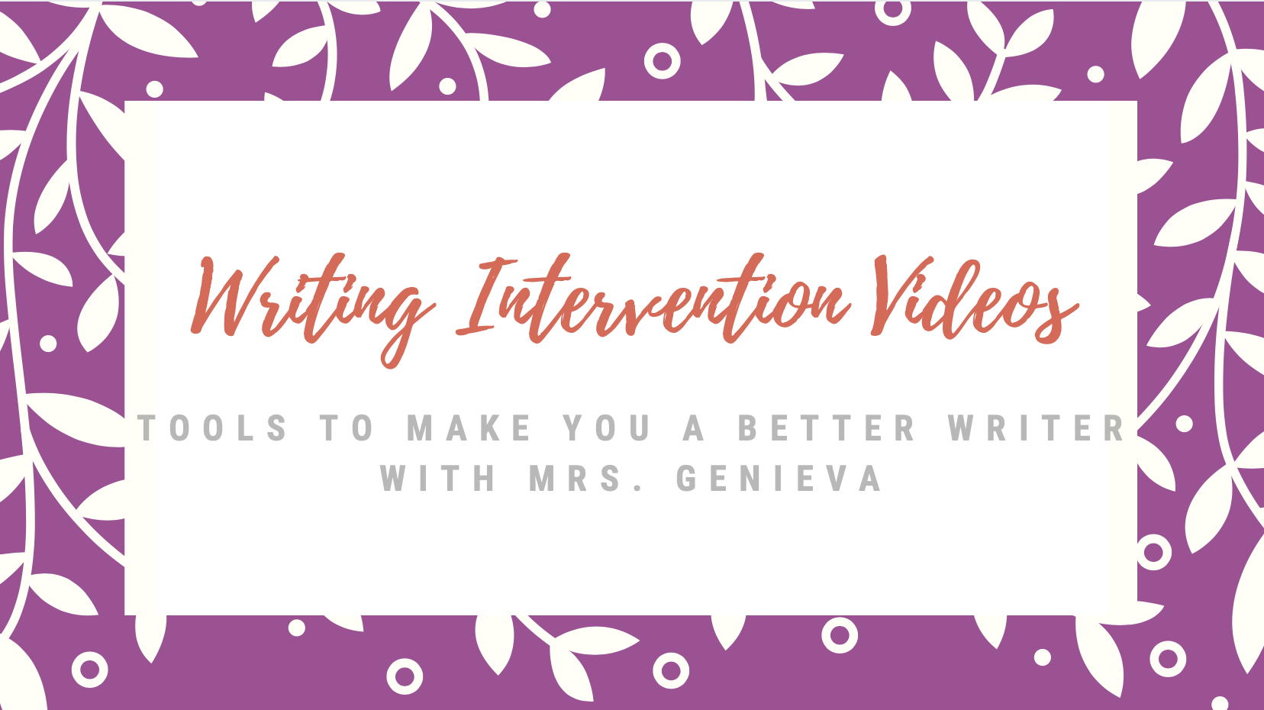

Email for Writing help or for feedback: WritersWorkshop@Inspireschools.org
Lesson Title | Objective | Video Lesson
Lesson #1: What are simple ways to improve my writing? | We will learn 6 simple ways we can improve our writing.  Your Turn: Students will leave challenged to try one on their own! | 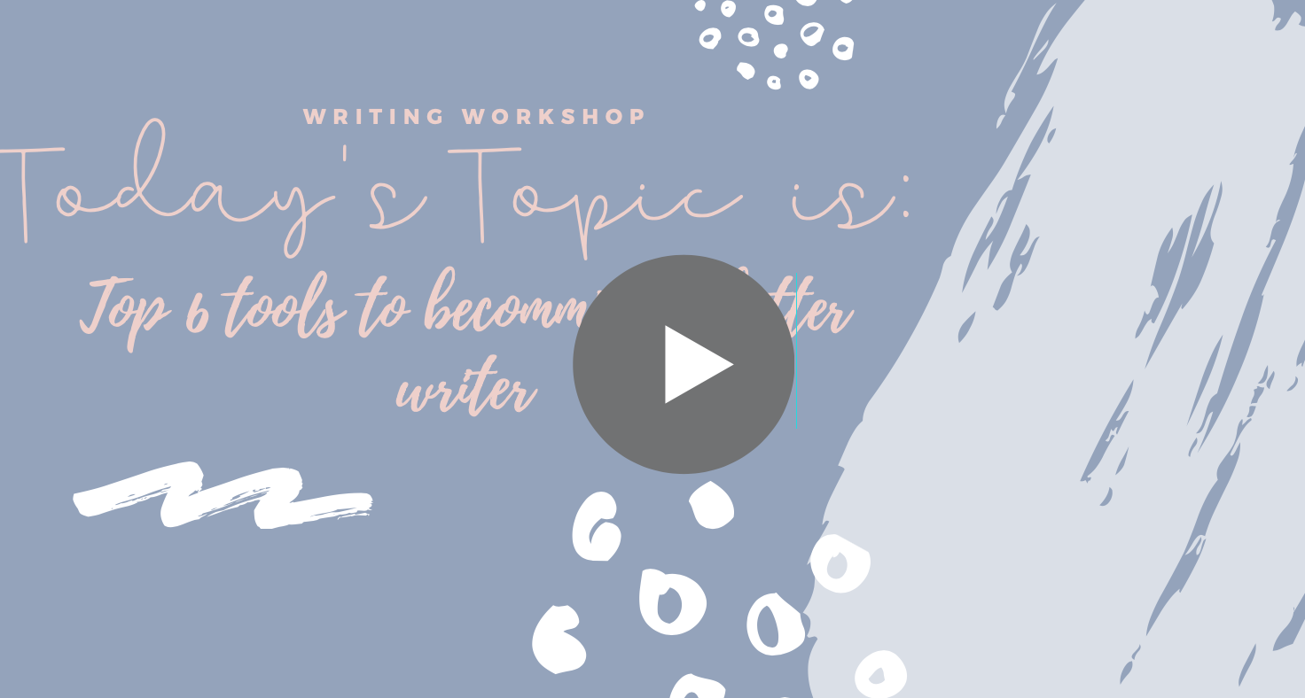  Links Mentioned in Video:  Writing Website  Prompts for Fluency Journal  Reading Response Journal Questions
Lesson #2: What are the three types of writing? | We will learn more about the three types of writing.  Your Turn: Students will be challenged to teach someone what the three types of writing are using the P.I.N. acronym they learn! | 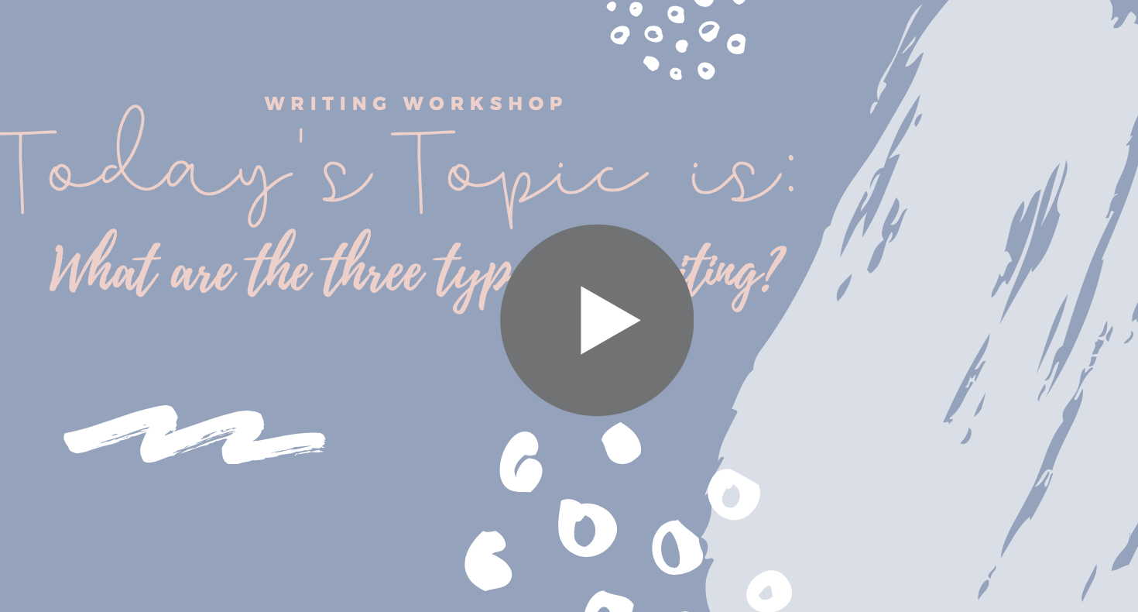  Links Mentioned in Video:  Writing Website
Lesson #3: Why is a graphic organizer useful to me and how do I use it? | We will learn how to use a graphic organizer and why it is helpful.  Your Turn: Download a graphic organizer for any type of writing and choose a writing prompt. Complete your graphic organizer and review with your Parent/Guardian. | 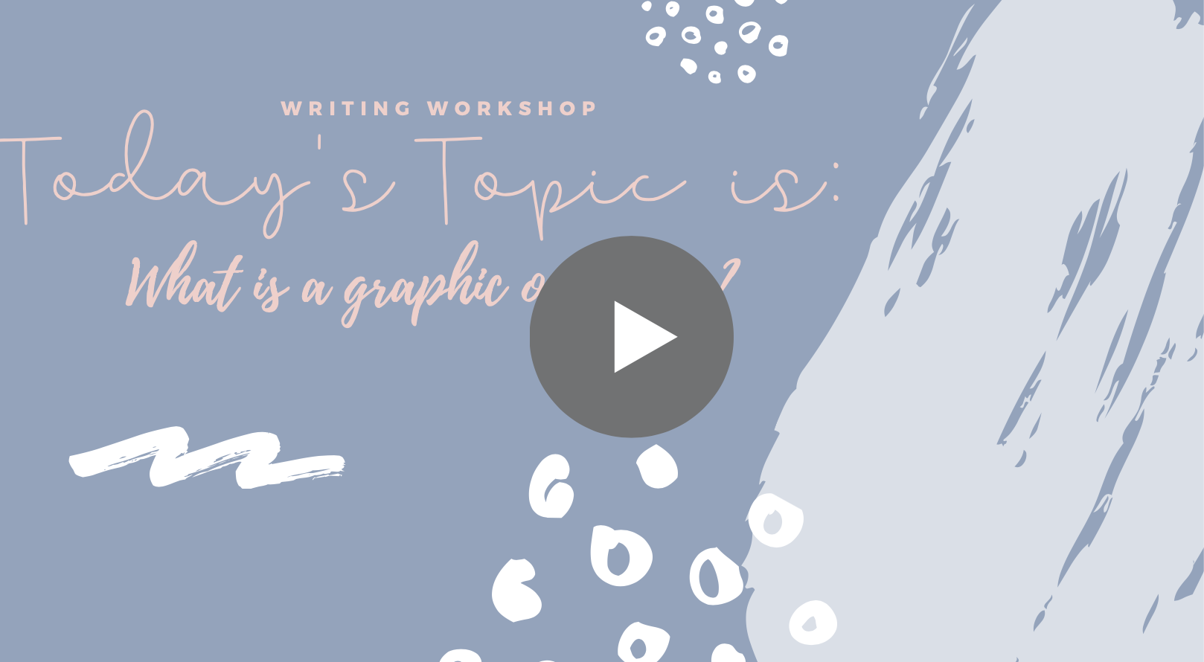  Links Mentioned in Video:  Graphic Organizers by Grade and Type
Lesson #4: What if I do not like handwriting my graphic organizer? | We will learn about tools we can use if we do not like to hand write our graphic organizers  Your Turn: Go to Sketchpad.io and try building a graphic organizer. Use the practice prompt , “The best holiday is…” You do not need to write this writing, we are just practicing using this digital tool! | 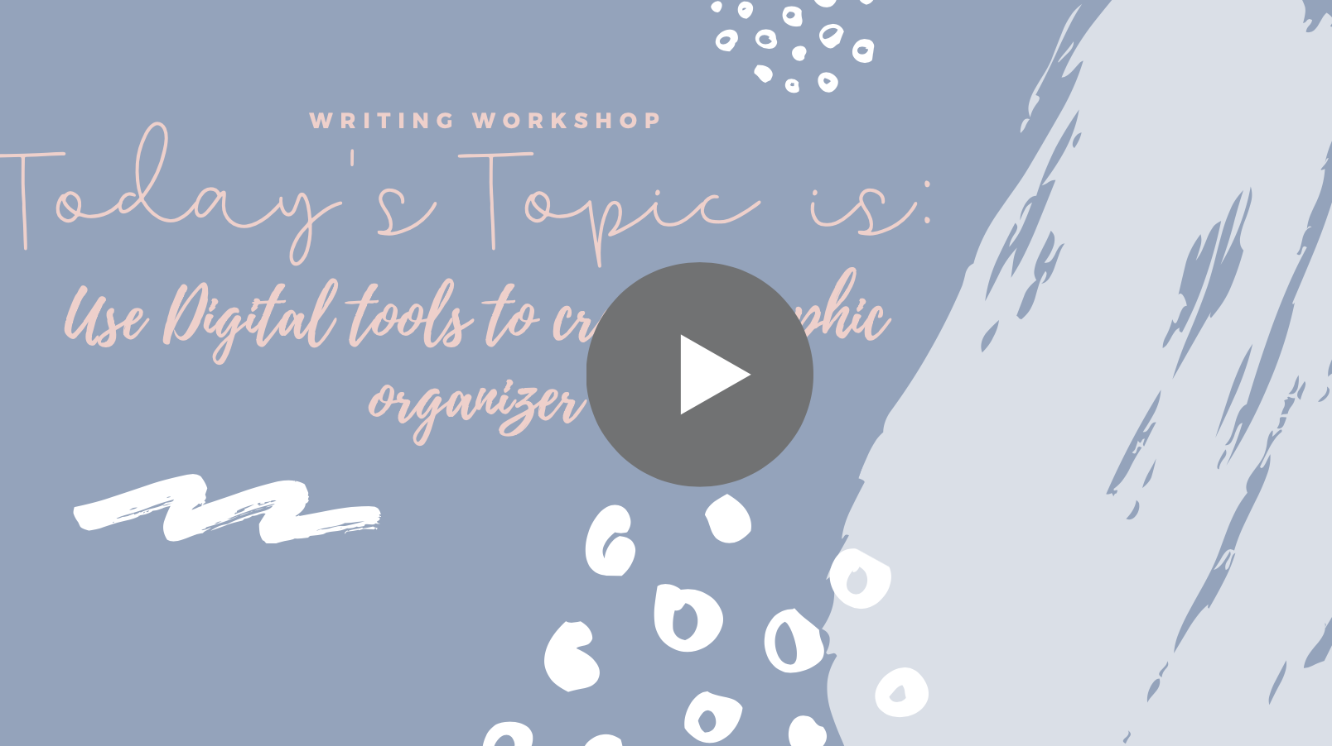  Links Mentioned in Video:  Sketchpad.io
Lesson #5: What if I do not like handwriting my writing? | We will learn about tools we can use instead of handwriting our writing.  Your Turn: Go into Google Docs and start your own document.  To Practice: Name the document, change the font and font size, indent, start a new paragraph. | 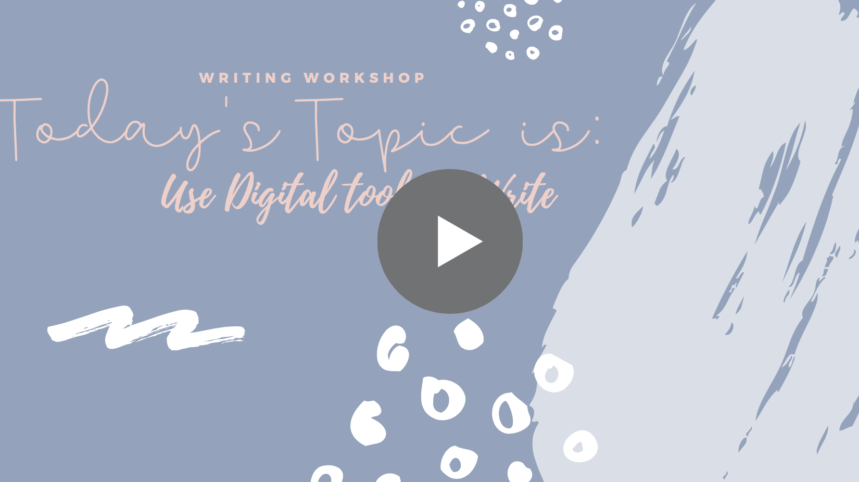  Links Mentioned in Video:  Google Docs
Lesson #6: What is a prompt? | We will learn what a prompt is.  Your Turn: Practice answering prompts. Go to the list of practice prompts and choose some to answer by talking with your Parent/Guardian. No writing needed! | 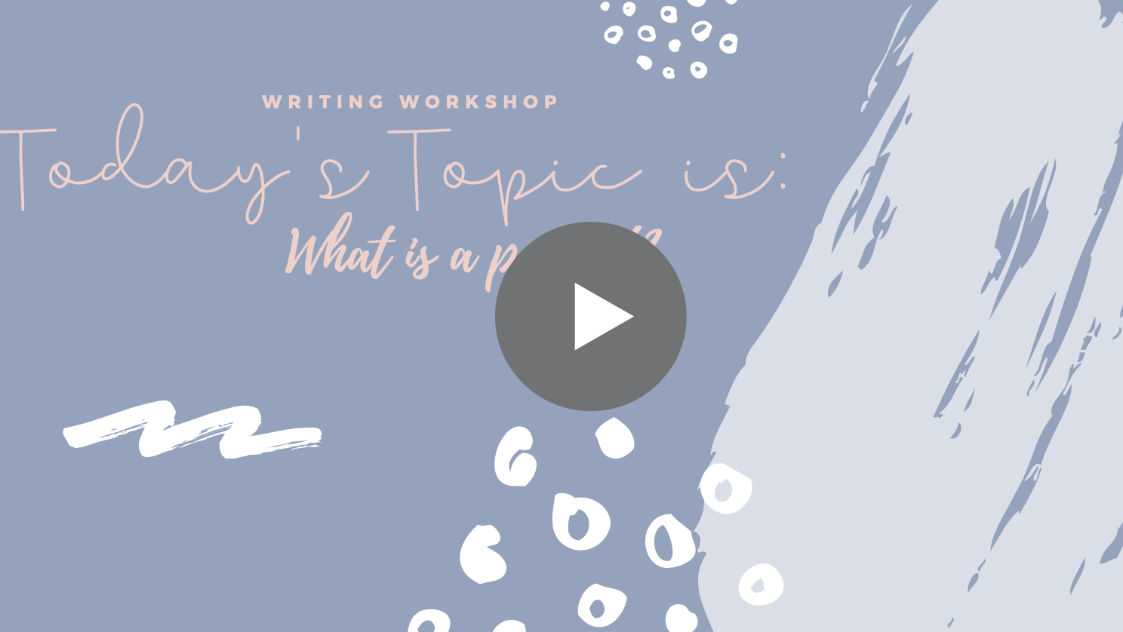  Links Mentioned in Video:  Persuasion Practice Prompts  Informational Practice Prompts  Narrative Practice Prompts
Lesson #7: What is persuasive writing? | We will learn what persuasive writing is and how to find what is expected of me to be successful at each grade level.  Your Turn: Go to the writing tools link. Find your grade level and the persuasive writing section. Pull up the graphic organizer and the rubric. Explain what you need to do to be successful to your Parent/Guardian. | 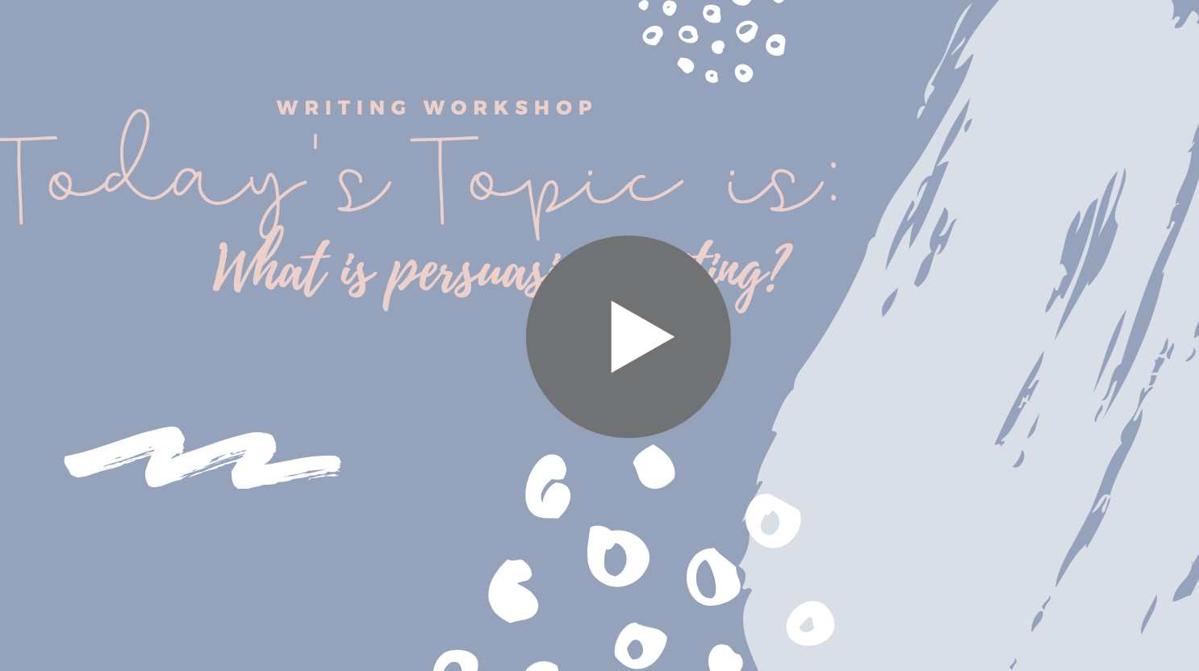  Links Mentioned in Video:  Writing Website
Lesson #8: How do I write a persuasive writing introduction? | We will learn how to write a persuasive introduction paragraph.  Your Turn: Prompt: Is cake or ice cream a better birthday dessert? Practice writing an introduction paragraph with a hook and a thesis that has your three reasons for this prompt. You can say this out loud to your Parent/Guardian or use the graphic organizer. | 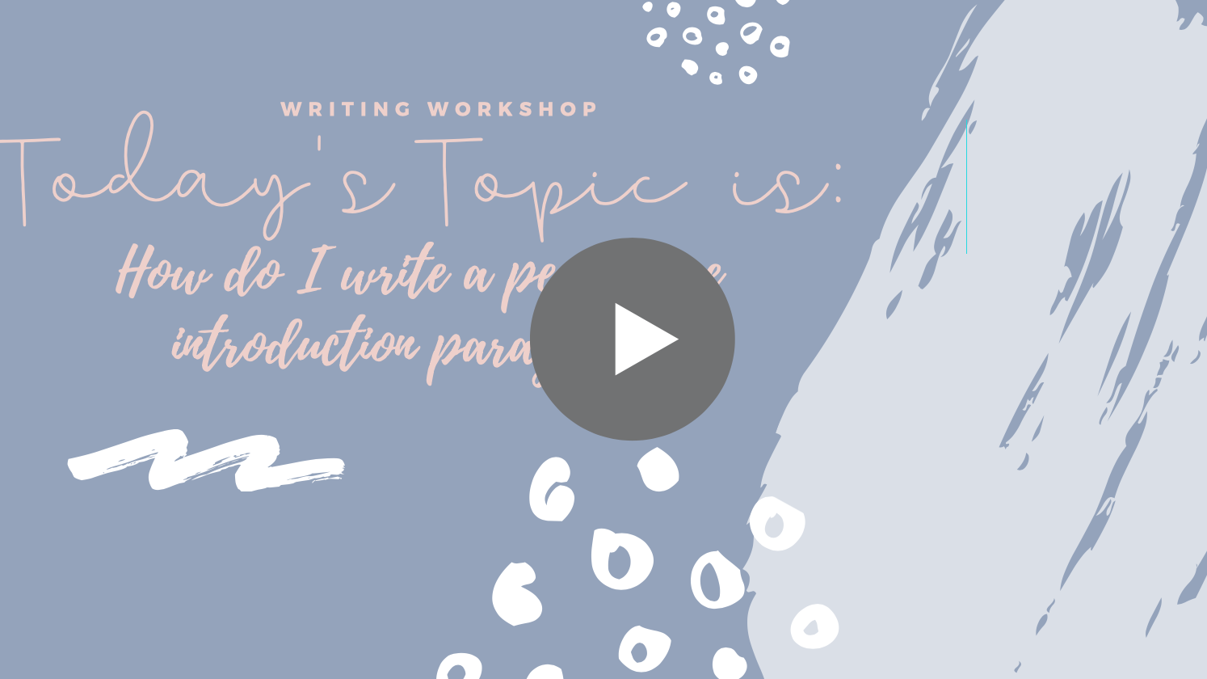  Links Mentioned in Video:  Graphic Organizers by Grade and Type
Lesson #9: In persuasive writing, how do I write a topic sentence, a concrete detail, and how do I cite my evidence? | We are going to learn how to write a topic sentence, a concrete detail that proves your reason, and how to properly cite your evidence.  Your Turn: Continue writing about the ice cream vs cake as the better birthday dessert. Write out your topic sentences then find a concrete detail for each to prove this. Don’t forget to cite your source. | 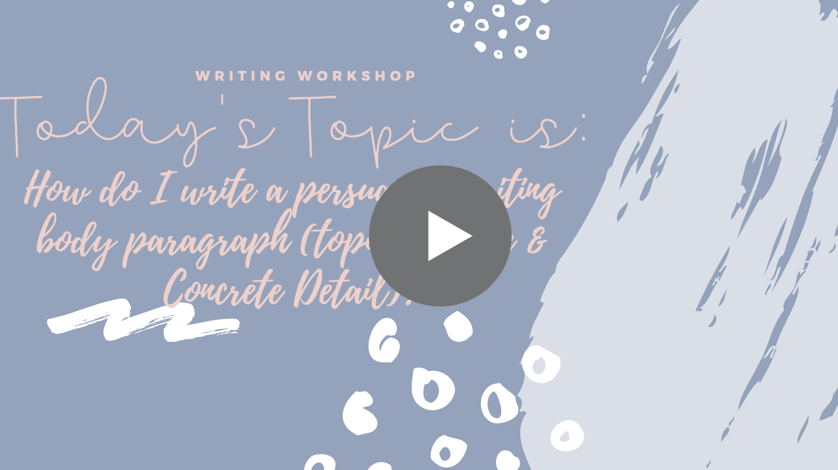  Links Mentioned in Video:  Graphic Organizers by Grade and Type
Lesson #10: How do I write commentary for persuasive writing? | We will be learning how to write commentary for our persuasive writing.  Your Turn: Add on your commentary to your three paragraphs. When you are finished have your Parent/Guardian review it to see if you explained your brain well. Feel free to send this to writing intervention for feedback. | 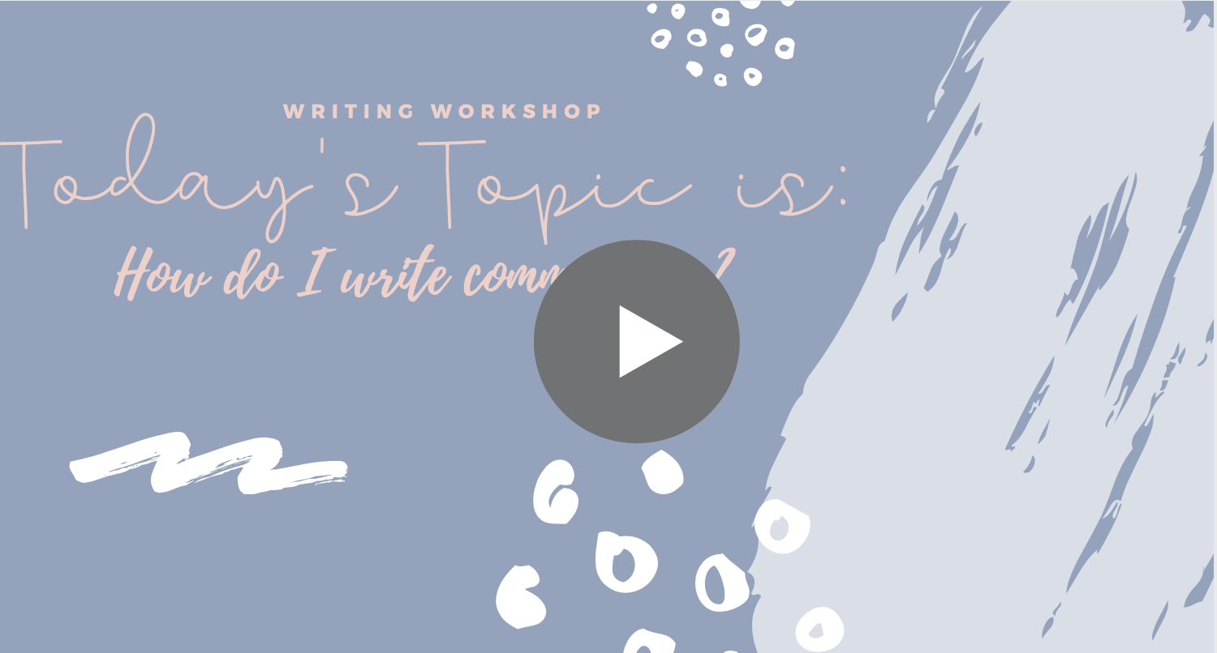  Links Mentioned in Video:  Graphic Organizers by Grade and Type
Lesson #11: How do I write a concluding sentence for persuasive writing? | We are learning about writing concluding sentences for our persuasive body paragraphs.  Your Turn: Write your concluding sentences for all of your body paragraphs. Share with your Parent/Guardian and/or writing intervention for feedback! | 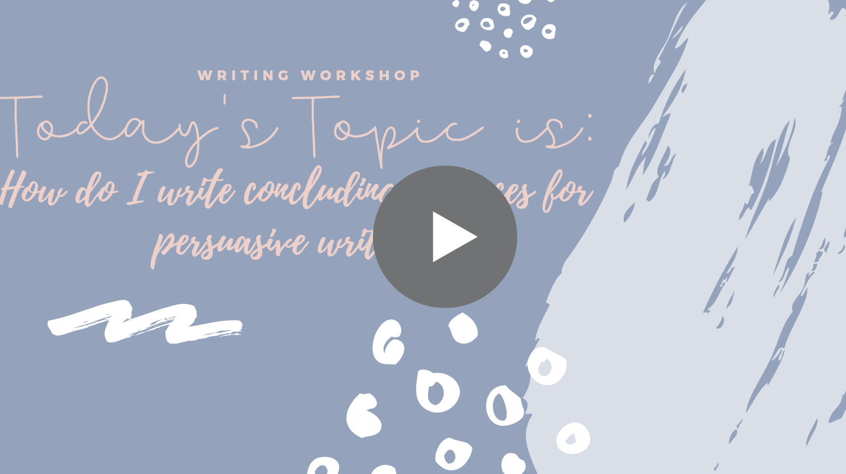  Links Mentioned in Video:  Graphic Organizers by Grade and Type
Lesson #12: How do I write a conclusion paragraph for a persuasive essay? | We will be learning how to write our conclusion paragraph to end our persuasive essay.  Your Turn: Wrap up your dessert essay! | 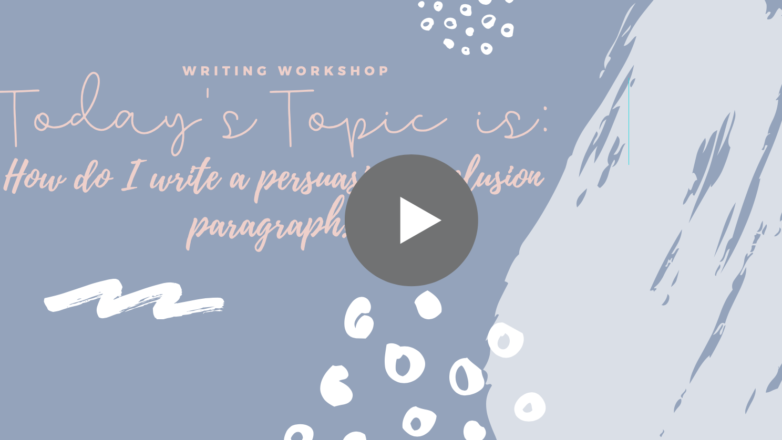  Links Mentioned in Video:  Graphic Organizers by Grade and Type
Lesson #13: What do I do with the graphic organizer for persuasive writing, after I fill this out? | We will be learning how to take our graphic organizer and turn it into what looks like an actual essay.  Your Turn: Take your graphic organizer and write it as actual writing on a piece of lined paper or typed in a document. When you are done, share it with your Parent/Guardian or to the writing intervention coordinator for feedback! | 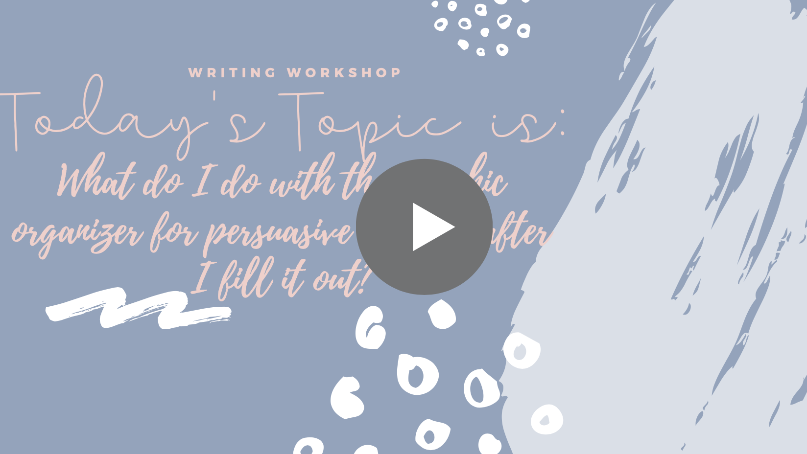  Links Mentioned in Video:  Graphic Organizers by Grade and Type
Lesson #14: What is informational writing? | We will learn what informational writing is and how to find what is expected of me to be successful at each grade level.  Your Turn: Go to the writing tools link. Find your grade level and the informational writing section. Pull up the graphic organizer and the rubric. Explain what you need to do to be successful to your Parent/Guardian. | 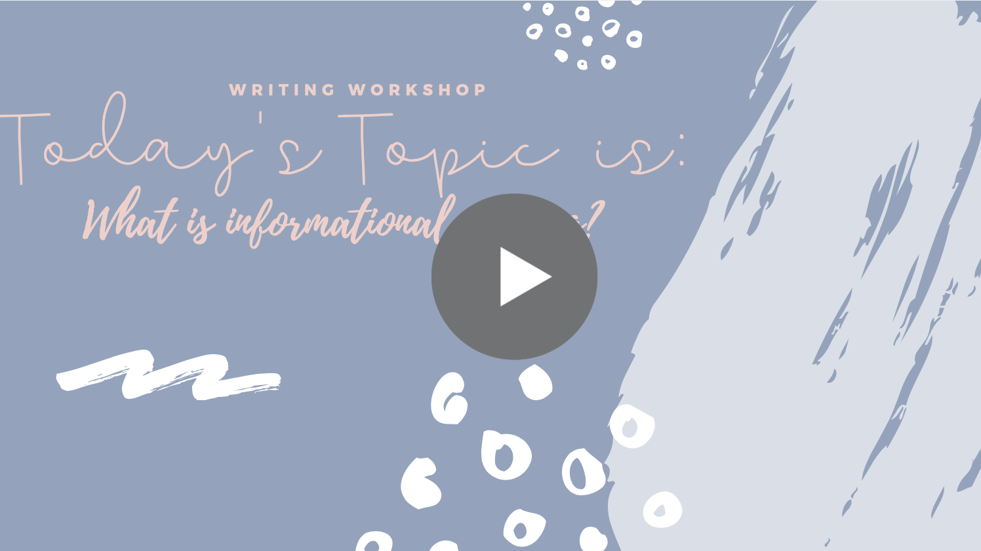  Links Mentioned in Video:  Rubrics, Graphic Organizers, and Sample Pieces By Grade
Lesson #15: How do I do research for informational writing? | We will learn three different ways we can do research, how to know if we are finding good research, and good tools for organizing and keeping track of our research.  Your turn: Choose a topic that you would like to teach to your reader. Use your graphic organizer and select 3 categories that you would like to research about your topic. Begin practicing your new research techniques that you have learned! |   Links Mentioned in Video:  Graphic Organizers By Grade  Google.com
Lesson #16: How do I write an introduction paragraph for informational writing? | We will be learning what the pieces of an informational introduction paragraph are.  Your Turn: Use your graphic organizer and complete your introduction paragraph for your topic. | 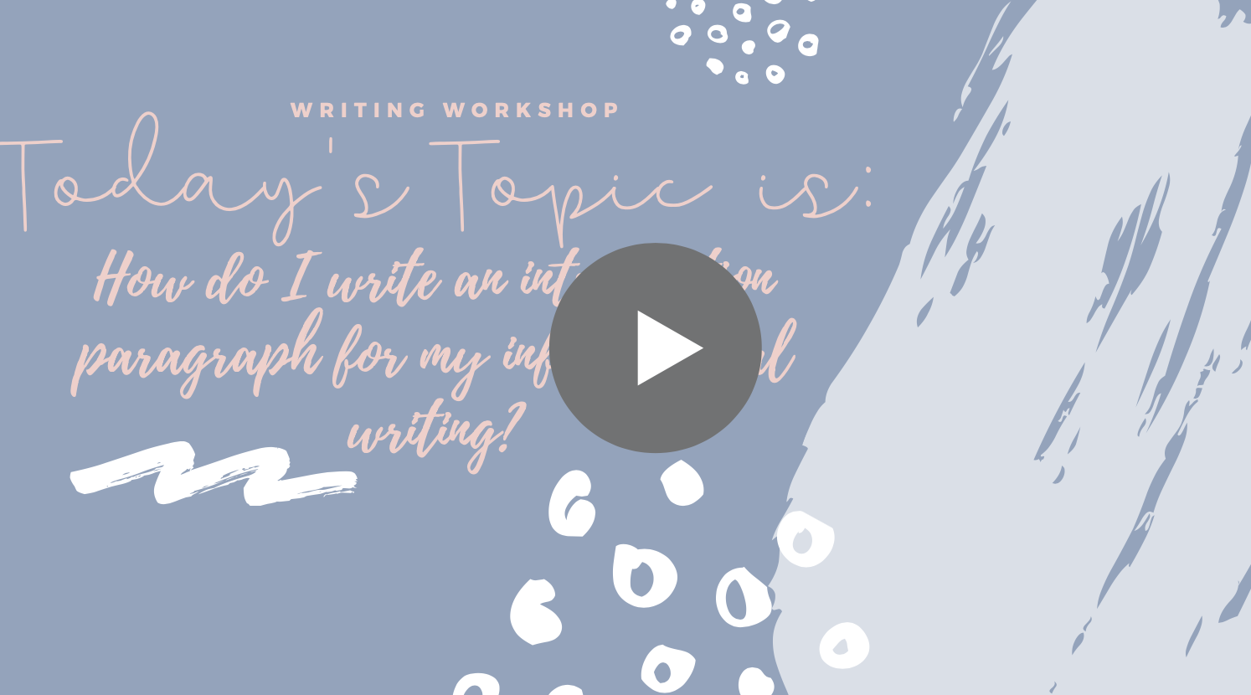  Links Mentioned in Video:  Graphic Organizers By Grade
Lesson #17: How do I organize informational writing into subheadings and paragraphs? | We will be learning about how to organize our writing into sections and how to advance into longer writing pieces that move into chapters and sections.  Your Turn: Use your graphic organizer and continue to outline your writing. Work through all of the body paragraphs that teach us about your three sub topics you chose for your piece. | 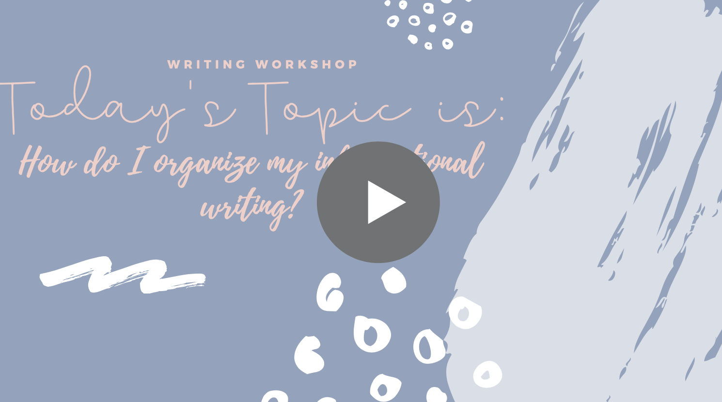  Links Mentioned in Video:  Graphic Organizers By Grade
Lesson #18: How do I write a conclusion paragraph for informational writing? | We will be learning how to write the conclusion paragraph for informational writing.  Your Turn: Take your graphic organizer and complete the conclusion paragraph for your informational piece you have been working on. When you are finished, go ahead and write out your writing on lined paper like we learned before with our persuasive writing. | 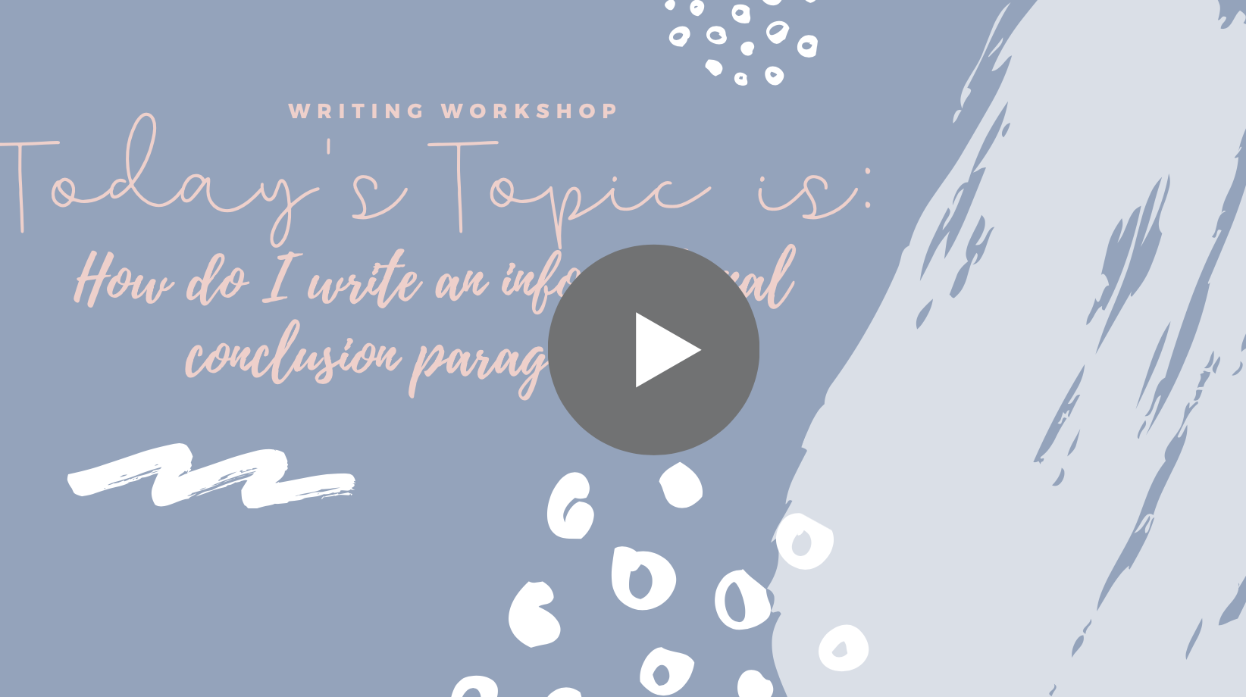  Links Mentioned in Video:  Graphic Organizers By Grade  Video 13 What to do with a graphic organizer
Lesson #19: How do I create a bibliography for my informational writing? | We will be learning how to create a bibliography and what MLA and APA formats are.  Your Turn: Take your sources that you have used and practice turning this into a bibliography. The websites that help you with this are listed to the right. | 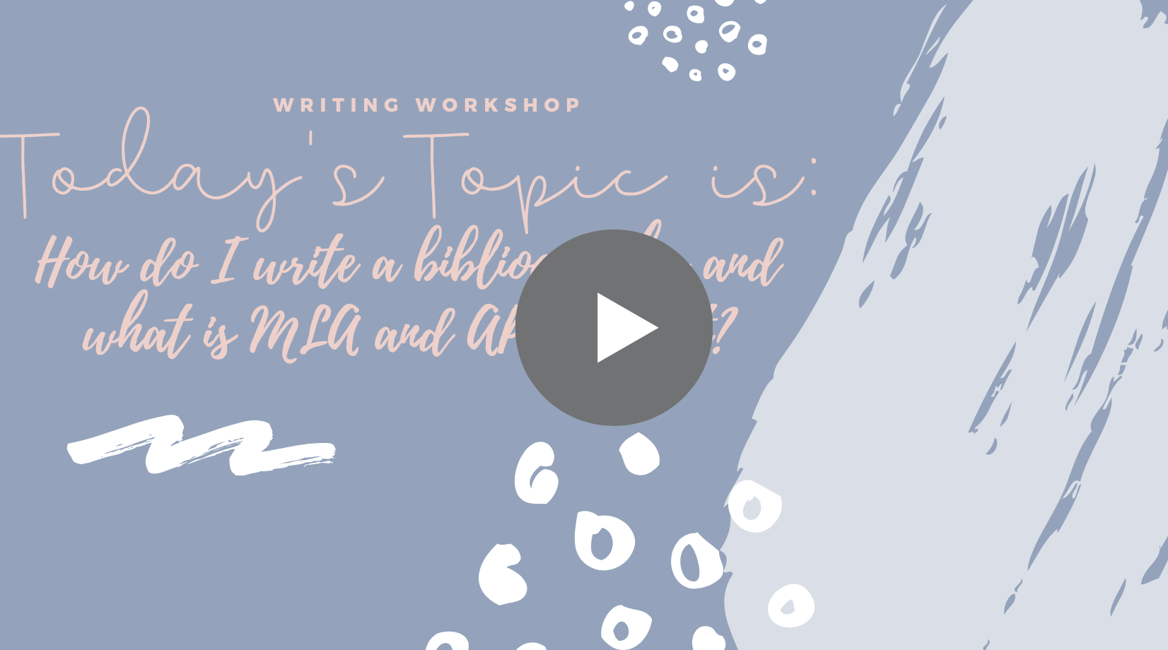  Links Mentioned in Video:  Owl Purdue Citation Assistant
Lesson #20: What is narrative writing and how do I write it? | We will be learning what narrative writing is, what is expected of us, and how to use the narrative graphic organizers.  Your Turn: Take your graphic organizer, sample piece, and the rubric and check out what you need to do. Then, come up with a story and practice filling in your graphic organizer. When completed, turn your writing into a real writing piece, just like we did with our information and persuasive writing graphic organizers. | 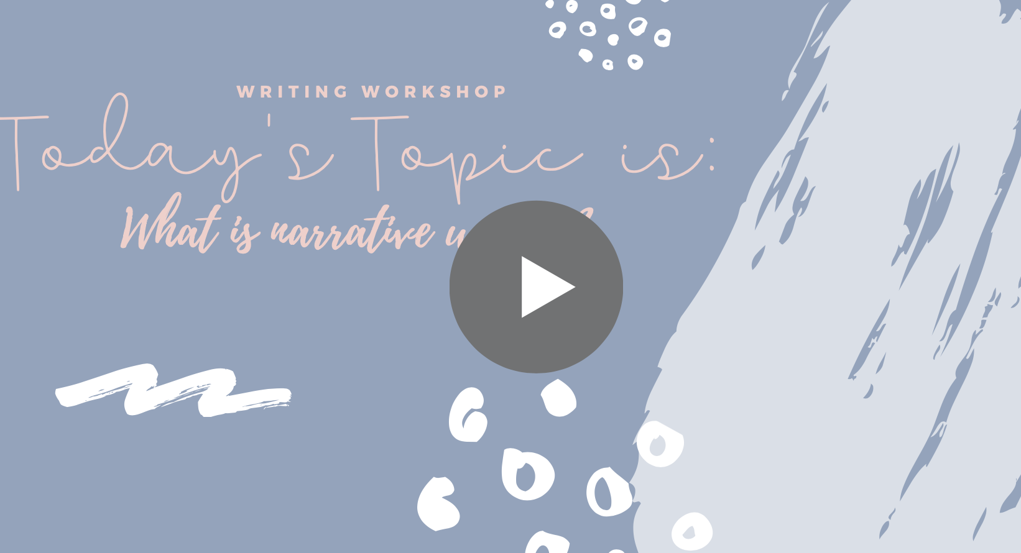  Links Mentioned in Video:  Graphic Organizers By Grade
Lesson #21: How do I edit my writing? | We will be learning how to edit our writing using a rubric as well as an editing bookmark.  Your Turn: Take your writing and the rubric for your grade level. Practice grading yourself in a different color than your Parent/Guardian. Make any changes you find that you need to make after you evaluate yourself. Then give your writing to your Parent/Guardian and have them use the same rubric to evaluate you! If you like the editing bookmark, feel free to try! | 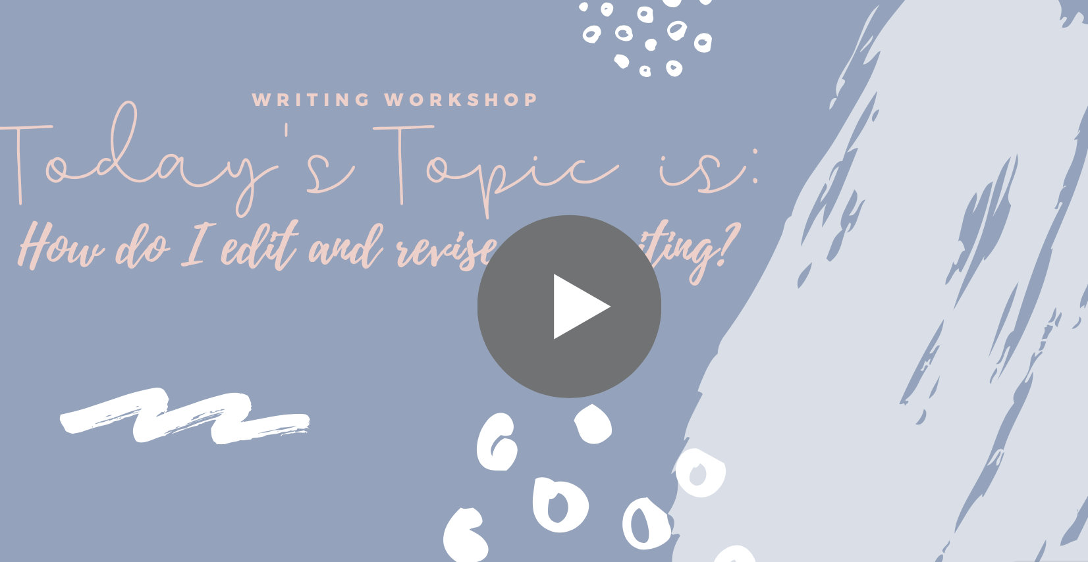  Links Mentioned in Video:  Rubrics  Editing Bookmark
Lesson #22: How do I write well on the CAASPP English Language Arts test?  Testing Age: 3rd-8th, 11th, 12th | We will be learning what kind of writing we may find on the English Language Arts state testing exams and how to work the interface.  Your Turn: Use the practice link listed to the right. Practice working through the testing interface so you are familiar. Read through the questions to understand what you may be asked. If you would like extra practice, try a practice book that you can purchase and/or the sample released practice questions (listed at right). | 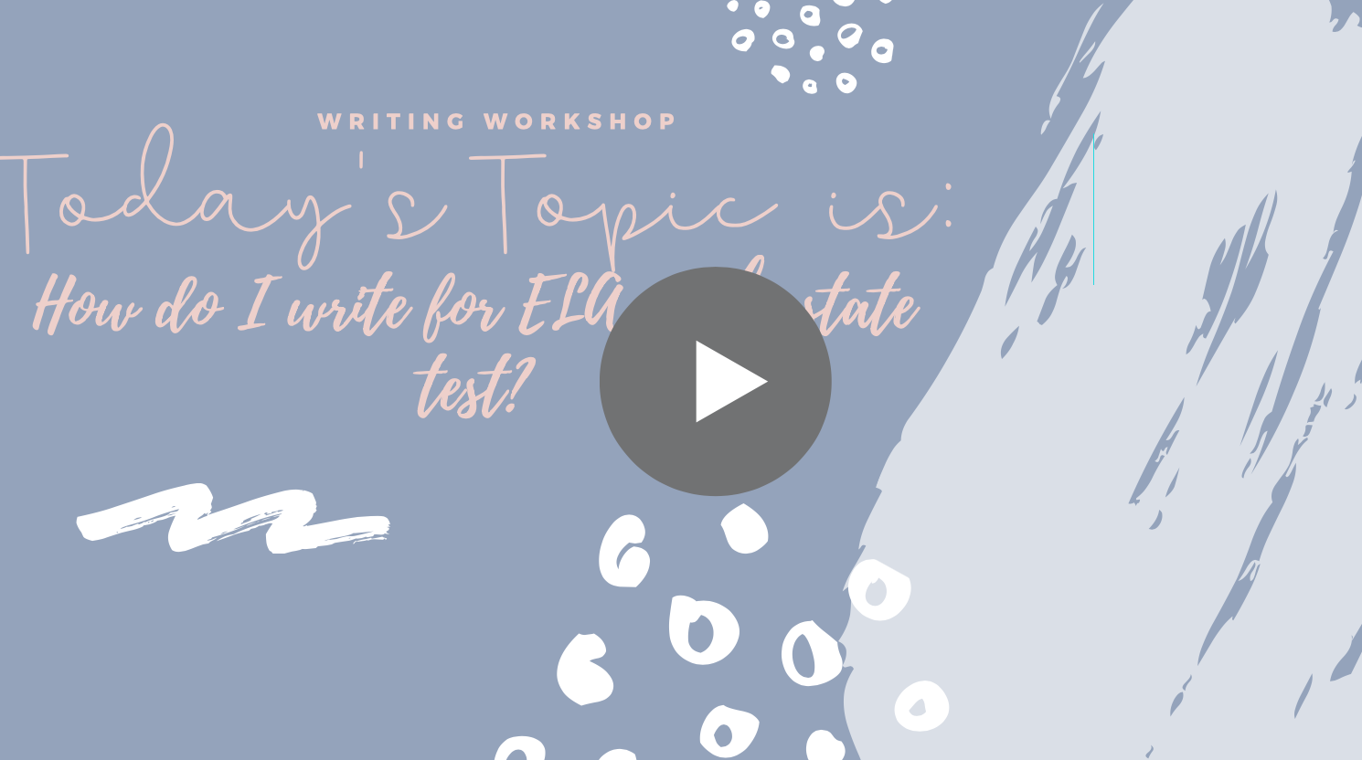  Links Mentioned in Video:  Online Practice Tests  Sample Test Questions  Sample writing prompts to cut and practice  Free Typing Program Recommendation #1  Free Typing Program Recommendation #2
Lesson #23: How do I write well on the CAASPP Mathematics test?  Testing Age: 3rd-8th, 11th, 12th | We will be learning what kind of writing we may find on the math state testing exams and how to work the interface.  Your Turn: Use the practice link listed to the right. Practice working through the testing interface so you are familiar. Read through the questions to understand what you may be asked. If you would like extra practice, try a practice book that you can purchase and/or the sample released practice questions (listed at right). | 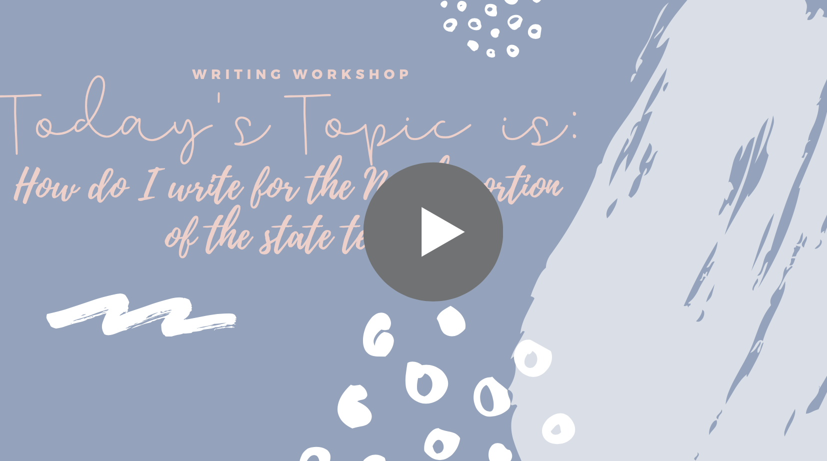  Links Mentioned in Video:  Online Practice Tests  Sample Test Questions  Free Typing Program Recommendation #1  Free Typing Program Recommendation #2
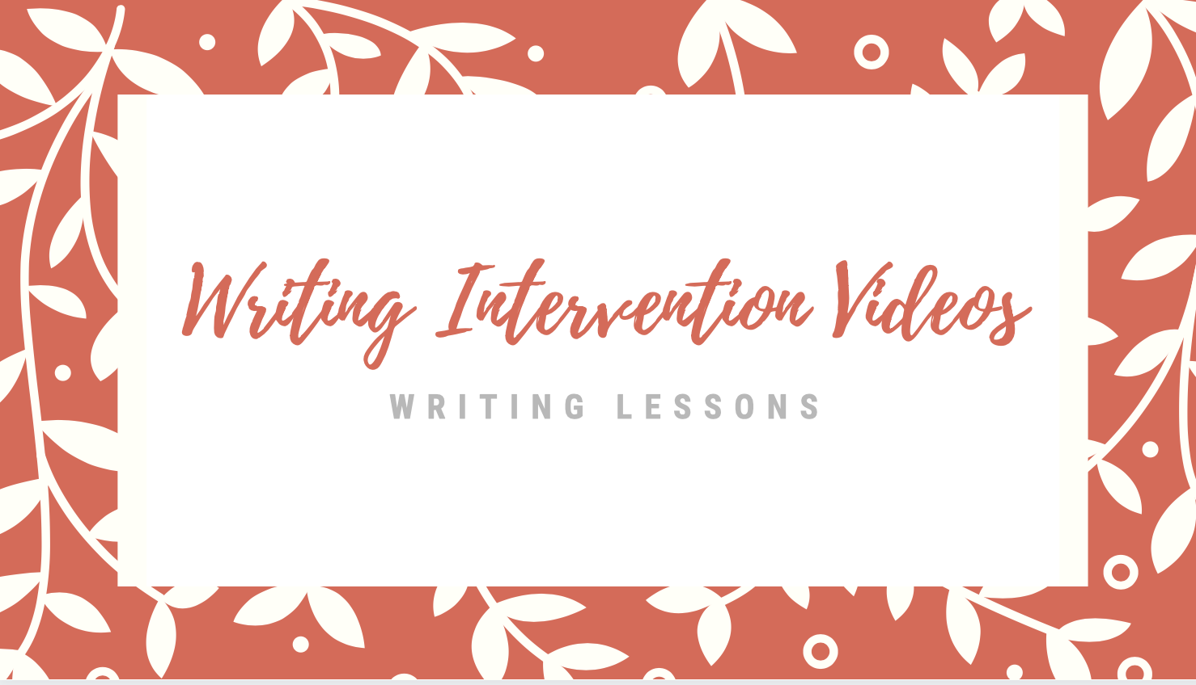
Lesson Title | Objective | Video Lesson
 | Narrative Writing
Narrative Writing Lesson #1: What can I do in narrative writing already? (Pre-Assessment) | We will be showing off what we can already do in narrative writing.  Your Turn: Get a writer’s notebook to use for this unit. Write the best moment of something that happened in your life that you can write? Make this be the best story of one time in your life. You might just focus on a scene or two. You’ll have 45 minutes to write this story, so you will need to plan, draft, revise and edit in that one block of time. Write in a way that shows off all you know!  Be sure to:  - Write a beginning for your story  - Elaborate to help readers picture your story  - Write an ending for your story.  When done, look at the rubric and your writing with a Parent to come up with goals! Print the rubric to use for this unit. | 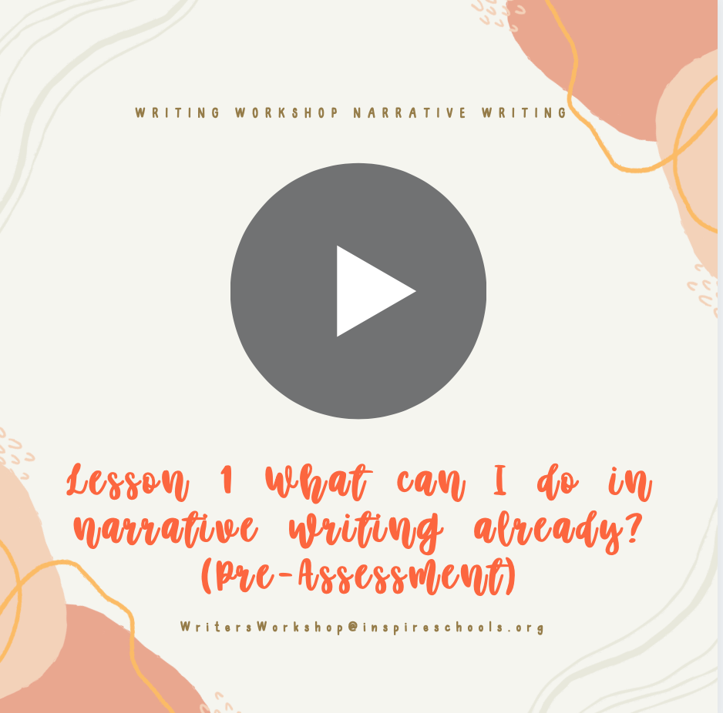  Links mentioned in this video:  Rubrics  Topic for Pre Assessment
Narrative Writing Lesson #2: Imagining Stories from Ordinary Moments | We will learn how fiction writers get ideas for their stories from small moments in their lives. We will practice doing this together as well.  Your Turn: Take the moment you thought of what happened to you and begin writing about the story in your writer’s notebook. As you write, think of any story ideas. Once you think of a few, draw a line under your writing and list them. Once you choose an idea you like, then begin writing your “planning” writing. Remember this writing shouldn’t be a perfect story but more of your thinking on paper. When you finish your writing idea, show your Parent and then look at your grade level rubric. | 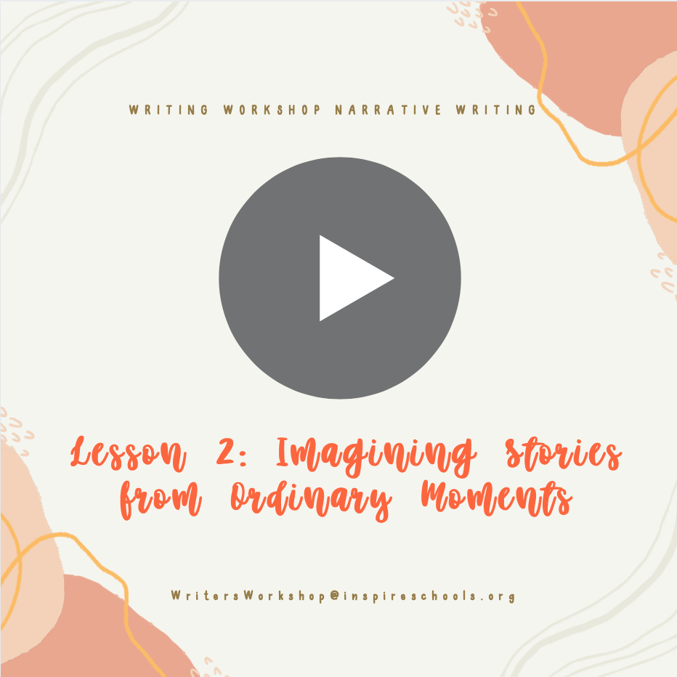  Links mentioned in this video:  Notes on How to Write a Fictional Story  Rubrics  Student Sample Story Idea #1  Student Sample Story Idea #2
Narrative Writing Lesson #3: Imagining Stories we Wish Existed in the World | We will learn that writers get ideas for stories by imagining books that they wish existed and by thinking about issues in their own lives.  Your Turn: Use your writer’s notebook and think through what books do you wish existed in the world that connects to you or has something that is important to you. If you can’t think of something, continue developing the idea of the student who wanted a book about someone who isn’t good at sports. Practice writing with the planning voice what this story would be like. When finished share with me or your Parent/Guardian:. If you would like, keep trying this with more story ideas. It becomes like a scavenger hunt trying to find stories in your world! | 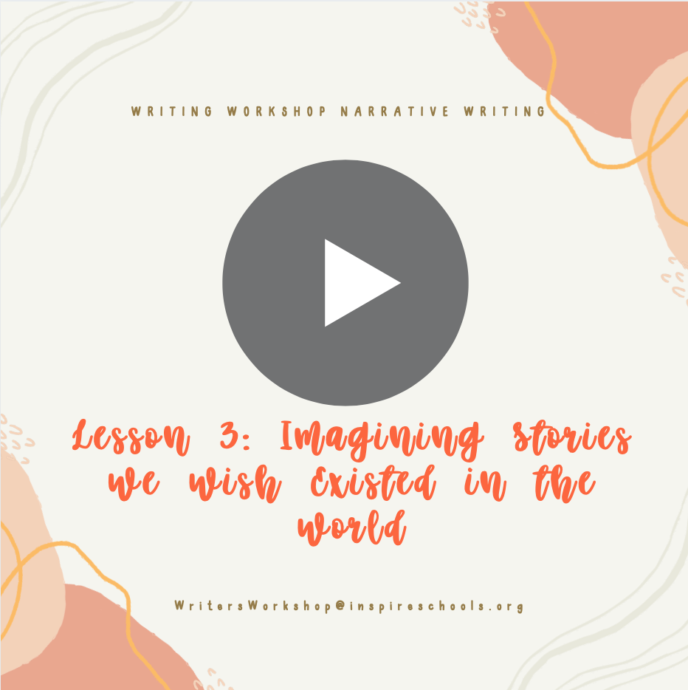  Links Mentioned in this Video  How to FInd Ideas for Stories Notes
Narrative Writing Lesson #4:  Developing Believable Characters | We will learn that all fiction writers choose one story idea and then begin to develop characters by creating internal and external traits.  Your Turn: Think through your 1 seed idea you chose. If you never chose one, you do need to end today choosing an idea.  Once you have your idea, get to know your character and create the Character Inside and Outside Chart like we made together. (In the links section, I have examples of the chart.) After you complete this for your main character, remember there will be secondary characters too. Choose 1-2 secondary characters and create a chart for them.  Parents: Look out for character lists that need elaborating. Did they say they are nice? Have the students expand. What does nice mean? If the student is stuck, talk about a character in a book they are reading. | 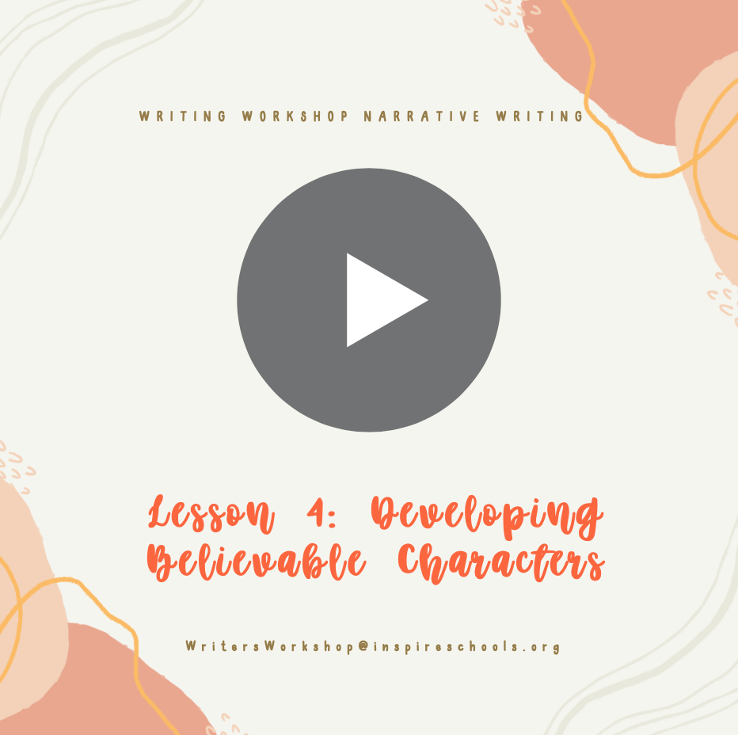  Links mentioned in this video:  Notes on How to Write a Fictional Story  Notes on How to Develop Characters  Sample Student Character Lists and Development Process
Narrative Writing Lesson #5:  Giving Characters Struggle and Motivation | We will learn that writers can develop characters by telling about the characters’ motivations and struggles. Writers then create scenes that show these things.  Your Turn: Go ahead and begin creating scenes that show your character and what they want as well as what keeps them from it.  Parents: Help guide them into creating scenes that show what the character’s desires are and what keeps them from it. If they have done well, congratulate them and point out what specifically they did well. For example, “I love when you had Timmy turn on the night light to show he is afraid of the dark. Then when his friends were over, he hid the nightlight because he really wanted to be liked. This is so good at showing his wants and struggles.” | 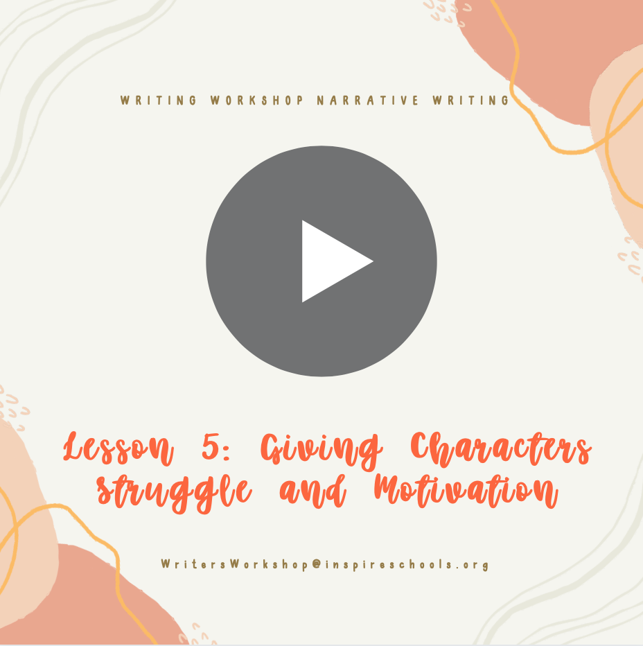  Links mentioned in this video:  Notes on How to Develop Characters  Notes on Developing Characters Ideas  Sample Student #1 Scene Draft  Sample Student #1 Second Scene Draft  Sample Student #2 Scene Draft
Narrative Writing Lesson #6:  Plotting Story Arc | We will learn that writers sketch out possible plotlines for stories.  Your Turn: You know your character and story idea. Now try making an arc. Remember to try at least 2-3 arcs until you think you have the right one. When you are finished, read through your story arc and ask yourself “Which one is the strongest?” Will this make the best story? If you are struggling, ask me or your Parent/Guardian:.  Parents: If your student is stuck, try looking at a book that they like and try plotting what the story arc is together to help them practice what this looks like. | 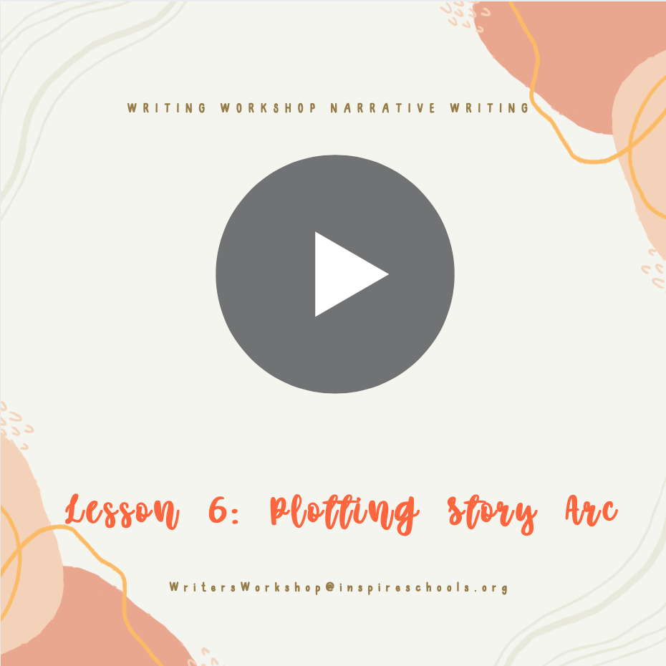  Links mentioned in this video:  Notes on How to Write a Fictional Story  Student #1 Sample Story Arc  Student #2 Sample Story Arc
Narrative Writing Lesson #7:  Show Don’t Tell | We will learn that writing scenes is where you put the character into action or have them say something, then you unfold the moment step by step.  Your turn: Take your story arc and put each part at the start of a new page so you know which scenes you need to write. Choose a lead to start with and begin writing today. Include characters talking, sounds, images, maybe even smells to paint the picture. I should be able to visualize it like a movie on a screen. Connect your scenes to each other. When done, try acting out your scene to your parents to find any gaps in the picture you painted.  Parents: Be sure that you are checking in. If you see them just summarizing, practice talking it out loud and ask them what is around me in this scene? What does it smell like? Help them to see what they need to paint the full picture. If you get stuck, grab a favorite book and check out how the author “painted” the scenes. | 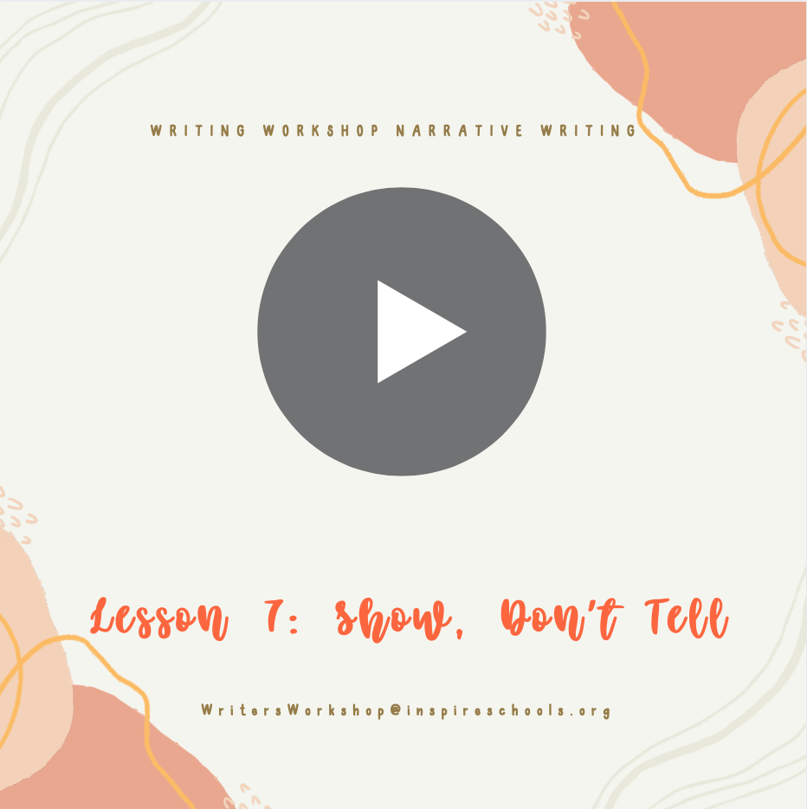  Links mentioned in this video:  Notes on How to Write a Fictional Story  Student #1 Draft of Scene  Student #1 Draft 2 of Scene with Details
Narrative Writing Lesson #8:  Heart of Story | We will learn that fiction writers create their best drafts when they experience the world through their character’s eyes, letting a story unfold like it is their own.  Your Turn: Go ahead and read what you have created so far from our last time. Step into your characters shows and get flowing! When you are finished writing, Have someone read your work, like we practiced doing before. Use the rubric to evaluate what you have done so far. We are just grading to see what we may need to work towards and what we have done successfully. | 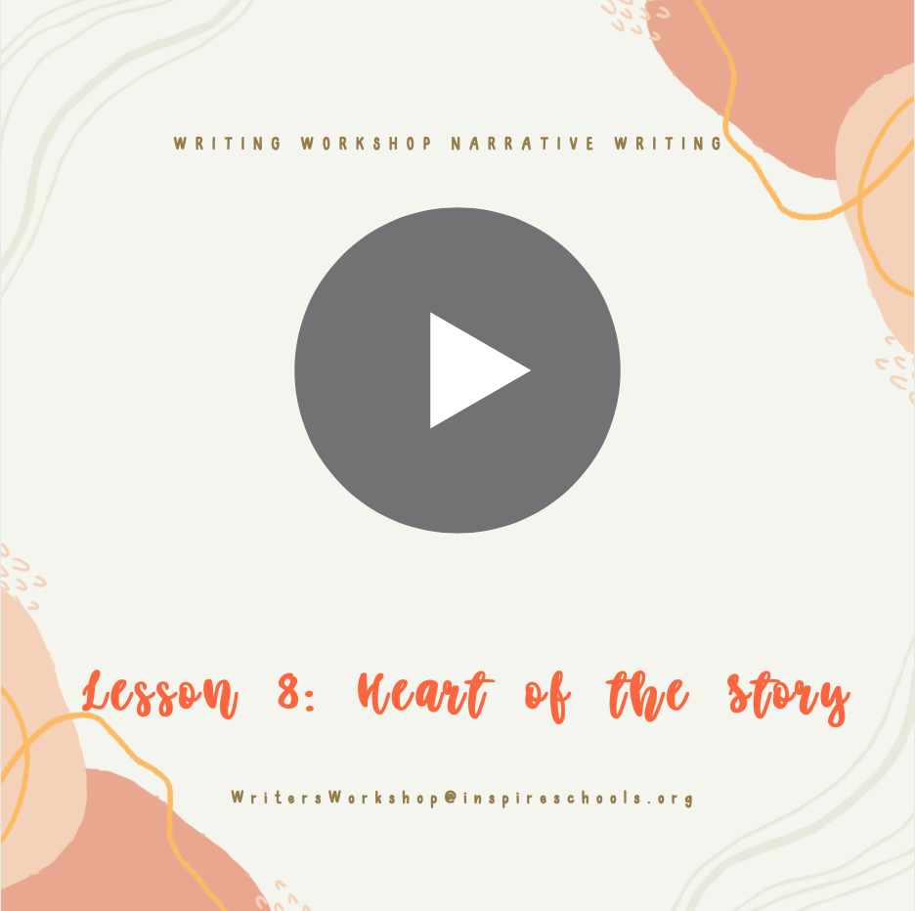  Links mentioned in this video:  Rubrics
Narrative Writing Lesson #9:  Let’s Study a Mentor Text | We will learn that there are many strategies for writing. We will look at published work to learn these techniques.  Your Turn: Decide what you need to do next. Look at some texts that you really like and find techniques that you think you can add to the lead of your writing! You may think you need to add changes that are similar to the ones I added where I established my setting. You may find a new strategy from one of your favorite authors. Have fun today exploring and learning from some of the best! We are not writing any new scenes, we are working on perfecting our lead!  Parents: Be sure that you have some books on hand you could help your student look at to find good skills. These can be picture books or chapter books. If they are stuck with writing, have them talk out making these strategy changes to their writing. | 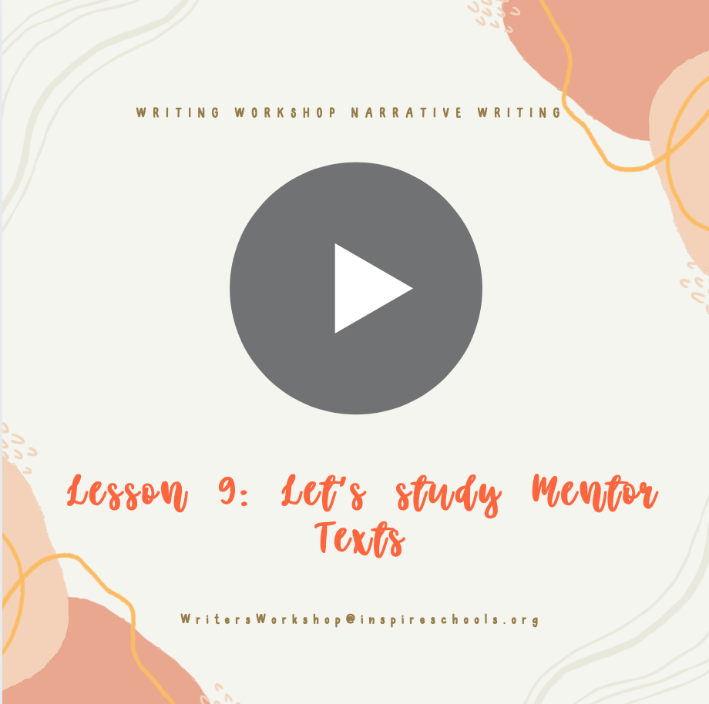  Links mentioned in this video:  Notes on How to Write a Fictional Story  Student # 1 Sample of Leads  Student # 2 Sample of Leads
Narrative Writing Lesson #10:  Orienting our Readers to our Setting | We will learn that writers “stay in the scene” making sure that the action and dialogue make sense in that scene.  Your turn: Look at your story and see where there are places that they are “in the dark”. Make sure the characters feel real. Find the places the reader is in the dark and help add more. Remember this may add new parts of your story and this is exciting. When you are done, read it out loud to someone and have them visualize the movie of your story.  Parents: Your student may struggle with finding these places. Read with them and ask questions about the character to help guide them into what they could add! If they are stuck finding a setting, try turning on a television show and have them write down what they notice about the scenery. | 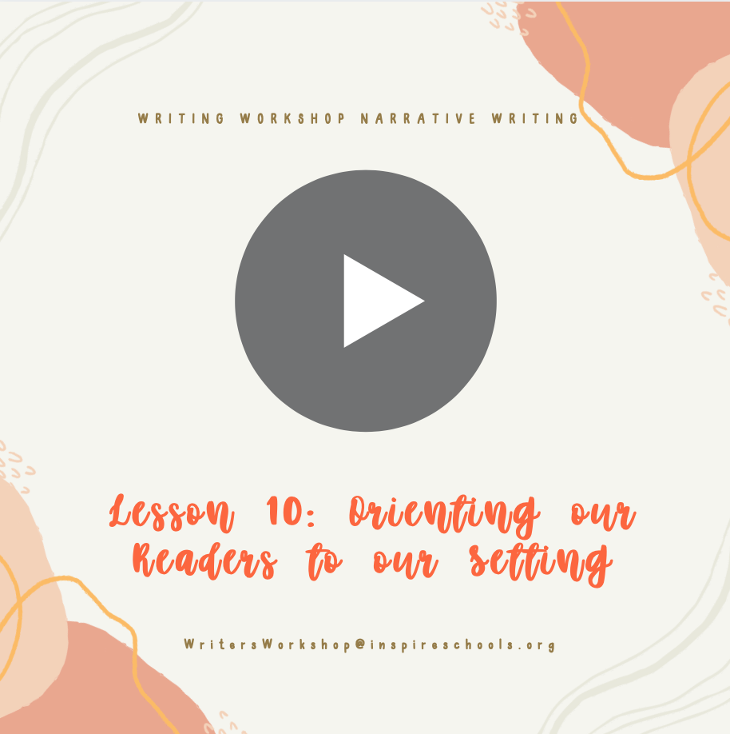  Links mentioned in this video:  Student #1 Tries to Show Not Tell Sample
Narrative Writing Lesson #11:  Powerful Endings | We will learn that fiction writers do their best to write an ending that serves the purpose of their story.  Your turn: Write 2-3 endings today at least and decide which you like the best! Remember to share your ending ideas with someone so that you can get feedback. You can also look at the sample writing pieces in our writing tools sight to see how a student at your grade level ended their piece. | Coming Soon!  Links mentioned in this video:  What to Consider When Making an Ending Notes
Narrative Writing Lesson #12:  Revisions | We will learn that when writers revise they don’t just reread. They reread with a lense that can be a rubric or a certain audience.  Your Turn: Reread using different lenses. You might put on the lens of “did I show what lesson this story is about?” “Can I make my character seem more real?” Try any other lens you would like. The goal is the lenses lead you to making changes to make your writing better. I suggest when you are doing this, read out loud. You may find some things that sound funny! | Coming Soon!  Links mentioned in this video:  Rubrics and Sample Pieces
Narrative Writing Lesson #13:  Making a Space for Writing | We will learn that writers create a unique workspace in their writer’s notebook and in their homes.  Your Turn: Go ahead and find a writer space, things or quotes that inspire you, photos, a special pen, a decorated notebook, whatever it takes to put you in the writing zone and feeling inspired. Feel free to have your Parent/Guardian share photos of your inspiring place! | Coming Soon!  Links mentioned in this video:  Rubrics and Sample Pieces
Narrative Writing Lesson #14:  Use Mentor Texts to Improve our Characters | We will learn that writers study mentor authors to notice what good writers do like using actions and revelaning details to show more about characters instead of telling.  Your Turn: Find an author you love reading any book and see what parts jump out at you, then ask yourself, why do I like those sections? Then find ways you can give it a try to add that into yours! When you finish, I think about some books titles and why the author named it that. From there come up with an idea for your story as well that can be the title! | Coming Soon!  Links mentioned in this video:  How to use Mentor Text Notes
Narrative Writing Lesson #15:  Editing with Various Lenses | We will learn that fictional writers edit by rereading and by editing as they go.  Your Turn:  - Grab the editing bookmark. Work your way through, reading out loud each time. By the end, you should feel as though your writing is the very best it can be! If you are feeling stuck, grab a writing sample and practice using the bookmark on that sample first. Then give it a try on your own! Be sure to use a different writing color or tool then what you used to write with.  - After you have finished, have someone else edit as well. IF you do not have anyone, send it to me and I can pair you with a student or I can edit for you.  - When you know it is perfect, rewrite on a new sheet of paper or type your final draft!  - Have a parent grade you using your rubric found on our writing tools page. You are a published author after this. You will want your finished piece before the next video. | Coming Soon!  Links mentioned in this video:  Rubrics and Writing Samples  Editing Bookmark
Narrative Writing Lesson #16:  Publishing and Celebration! | We will learn that writers finish pieces, share them with others, and celebrate their hard work.  Your Turn: Find a way to celebrate and share your work today. You can set up drinks and a special place in the house, invite people over, read on facetime to grandma or grandpa, or whatever you feel would celebrate your writing! | Coming Soon!  Links mentioned in this video:  Student #1 Sample Completed Draft
Narrative Writing Lesson #17:  Your turn: Independent Fiction Project | We will learn that we can take what we know about writing and try it on our own.  Your Turn: Choose a story idea that you will want to complete more independently from your list of ideas or a new idea you thought of. Just write out a little how the story will go. The story will be about…” Don’t use the actual words. Once you have it set. Start mapping out the characters from the inside and the out and decide the setting that you think you will use.  Come to the next video when you have this. We will work on turning this into a draft next time! | Coming Soon!  Links mentioned in this video:  Notes on How to Write a Fictional Story
Narrative Writing Lesson #18:  Planning and Drafting | We will learn that writers apply their skills to multiple writing projects.  Your Turn: You are moving at your own place now and you will work independently. You may be working on characters today, looking at your past work, setting, creating drafts. You will need to manage your own time well. You and your parents will come up with a due date of when the first draft should be completed! You should at least have a story arc and start your draft today! When you are done, think of a peer that can review or send it to me. | Coming Soon!  Links mentioned in this video:  How We study our Own Best Work Notes  Student #1 Sample Story Planning  Student #1 Taking Arc and Turning into Draft Sample
Narrative Writing Lesson #19:  Connecting Reading to Writing | We will learn that writers study the work they do as readers of fiction in order to learn new skills.  Your turn: Choose your book you want to try as a mentor text. If you can’t think of one, think back to how we choose a mentor text notes. Then look through and find places as you read that make you feel, that have a great sound, look at story arc, or highlight strong parts. If you find anything great add it on to your writing. If you aren’t finding anything today, just keep writing and make sure that you read with this lens of learning as you independently read next time. Remember to be on track for whatever due date that you and your parents decided! | Coming Soon!  Links mentioned in this video:  How We Choose Mentor Texts Notes  How we Use Mentor Texts Notes  How Writers Help Each Other
Narrative Writing Lesson #20:  Focusing the Reader | We will learn that writers can learn from visual artists to help make our readers visualize our reading.  Your Turn: Start with your introduction. Maybe you want to spark emotion, try making a zoomed in lens. Maybe you want some action so you want to set a wide scene of a lot going on.  From there, feel free to try this in other places. I want you to take a look at your grade level rubric and see how you think you are doing on everything. Is there anything else to add? | Coming Soon!  Links mentioned in this video:  Example of Changing to Medium Shot  Example of Changing to a Wide Shot
Narrative Writing Lesson #21:  Choosing Punctuation with Effect | We will learn that writers use punctuation to male sentences easier to understand and to change how readers interact with our writing.  Your Turn: Look at a section of your story or the whole thing if you are done. Find if there are emotional places, places to slow down, or anywhere you think you can use punctuation in order to tell your reader what to do. “Simon Says”  By the end of this session, you should have done some more revising and you should have a completed draft of your story. If you need a few more days before your set due date, then do not move on to the next video. The next video is about evaluating and celebrating! (I want you to feel excited about that, so I would put an exclamation here!) | Coming Soon!
Narrative Writing Lesson #22: Celebration and Publish | We will learn that writers finish pieces, share, celebrate, and learn from it to help with future writing.  Your Turn: Evaluate your writing with a rubric and then have your parents or myself edit your writing. Then find a way to celebrate and share your writing with those you love. It is important to celebrate. | Coming Soon!  Links mentioned in this video:  Rubrics and Writing Samples
Narrative Writing Lesson #23: Taking What I know and Using it | We will learn how to use what we know and do it in a timed writing setting often used for state testing, SAT, ACT, high school and college level courses. | Coming Soon!  Links Mentioned in this Video:  Steps to a Timed Writing Notes
 | Persuasive Writing
Persuasive Writing Lesson #1: What can I already do in Persuasive writing? (Pre-Assessment) |  | Coming Soon!
Persuasive Writing Lesson #2: Essay Structure Boot Camp |  | Coming Soon!
Persuasive Writing Lesson #3: Collecting Ideas |  | Coming Soon!
Persuasive Writing Lesson #4: Writing to Learn |  | Coming Soon!
Persuasive Writing Lesson #5: Using Elaboration Prompts to Grow Ideas |  | Coming Soon!
Persuasive Writing Lesson #6: Mining our Writing |  | Coming Soon!
Persuasive Writing Lesson #7: Boxes and Bullets to Frame Writing |  | Coming Soon!
Persuasive Writing Lesson #8: Writing Boot Camp |  | Coming Soon!
Persuasive Writing Lesson #9: Composing and Sorting Mini Stories |  | Coming Soon!
Persuasive Writing Lesson #10: Creating Parallelism in Lists |  | Coming Soon!
Persuasive Writing Lesson #11: Organizing for Draft |  | Coming Soon!
Persuasive Writing Lesson #12: Building a Cohesive Draft |  | Coming Soon!
Persuasive Writing Lesson #13: Becoming our Own Job Captain |  | Coming Soon!
Persuasive Writing Lesson #14: Writing Introductions and Conclusions |  | Coming Soon!
Persuasive Writing Lesson #15: Revising our Work with Goals in Mind |  | Coming Soon!
Persuasive Writing Lesson #16: Run Ons and Sentence Fragments |  | Coming Soon!
Persuasive Writing Lesson #17: Moving from Personal to Persuasive |  | Coming Soon!
Persuasive Writing Lesson #18: Persuasive Into Essay |  | Coming Soon!
Persuasive Writing Lesson #19: Evidence work |  | Coming Soon!
Persuasive Writing Lesson #20: Connecting Evidence and Thesis |  | Coming Soon!
Persuasive Writing Lesson #21: Evaluation and Publishing |  | Coming Soon!
Persuasive Writing Lesson #22: Share our Pieces Celebration |  | Coming Soon!
 | Informational Writing
Informational Writing Lesson #1: What can I do in informational writing? (Pre- Assessment) |  | Coming Soon!
Informational Writing Lesson #2: Getting a Sense of Informational Writing |  | Coming Soon!
Informational Writing Lesson #3: Planning and Writing with Independence |  | Coming Soon!
Informational Writing Lesson #4: Teaching to Rehearse your Writing |  | Coming Soon!
Informational Writing Lesson #5: Elaboration |  | Coming Soon!
Informational Writing Lesson #6: Bringing Information Alive |  | Coming Soon!
Informational Writing Lesson #7: Looking at Mentor Texts |  | Coming Soon!
Informational Writing Lesson #8: Set Goals |  | Coming Soon!
Informational Writing Lesson #9: Writers Plan for Research |  | Coming Soon!
Informational Writing Lesson #10: |  | Coming Soon!
Informational Writing Lesson #11: |  | Coming Soon!
Informational Writing Lesson #12: |  | Coming Soon!
Informational Writing Lesson #13: |  | Coming Soon!
Informational Writing Lesson #14: |  | Coming Soon!
Informational Writing Lesson #15: |  | Coming Soon!
Informational Writing Lesson #16: |  | Coming Soon!
Informational Writing Lesson #17: |  | Coming Soon!
Informational Writing Lesson #18: |  | Coming Soon!
Informational Writing Lesson #19: |  | Coming Soon!
Informational Writing Lesson #20: |  | Coming Soon!
Informational Writing Lesson #21: |  | Coming Soon!
 | Persuasive Writing in Response to Literature
Persuasion with Literature Writing Lesson #1: |  | Coming Soon!
Persuasion with Literature Writing Lesson #2: |  | Coming Soon!
Persuasion with Literature Writing Lesson #3: |  | Coming Soon!
Persuasion with Literature Writing Lesson #4: |  | Coming Soon!
Persuasion with Literature Writing Lesson #5: |  | Coming Soon!
Persuasion with Literature Writing Lesson #6: |  | Coming Soon!
Persuasion with Literature Writing Lesson #7: |  | Coming Soon!
Persuasion with Literature Writing Lesson #8: |  | Coming Soon!
Persuasion with Literature Writing Lesson #9: |  | Coming Soon!
Persuasion with Literature Writing Lesson #10: |  | Coming Soon!
Persuasion with Literature Writing Lesson #11: |  | Coming Soon!
Persuasion with Literature Writing Lesson #12: |  | Coming Soon!
Persuasion with Literature Writing Lesson #13: |  | Coming Soon!
Persuasion with Literature Writing Lesson #14: |  | Coming Soon!
Persuasion with Literature Writing Lesson #15: |  | Coming Soon!
Persuasion with Literature Writing Lesson #16: |  | Coming Soon!
Persuasion with Literature Writing Lesson #17: |  | Coming Soon!
Persuasion with Literature Writing Lesson #18: |  | Coming Soon!
Persuasion with Literature Writing Lesson #19: |  | Coming Soon!
Persuasion with Literature Writing Lesson #20: |  | Coming Soon!
Persuasion with Literature Writing Lesson #21: |  | Coming Soon!

