HS Directory

High School Directory
Please click here to see the appropriate point of contact for high school questions.
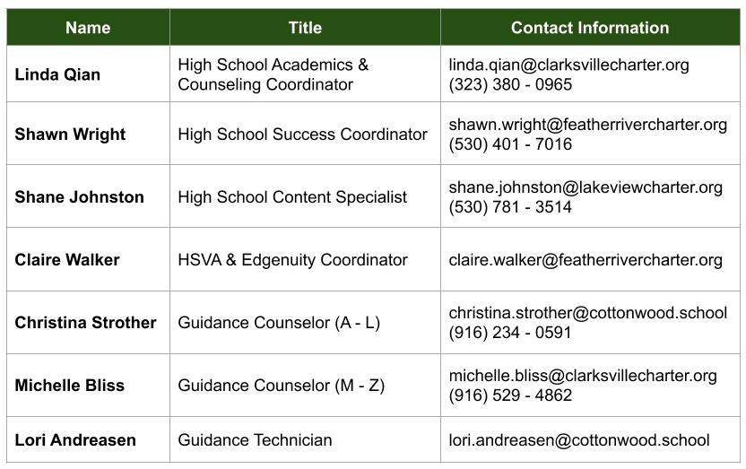
For a directory of High School Virtual Academy and Edgenuity HQTs, please click here.

