Foster & Homeless Youth

Basic Information:
- Education Code 51225.1 allows foster youth, homeless/transitional, probation students, and migratory students to be exempt from Inspire graduation requirements that exceed state requirements if:
  - The student transfers schools after completing 2 years of high school
  - The student is not reasonably able to complete Inspire graduation requirements within 4 years of high school
  - The educational rights holder or student (if over 18 years old) must determine whether it is in the youth’s best interest to graduate under AB 167/216
- The student must meet California graduation requirements.
- The Guidance Counselor will evaluate the student’s records and determine whether the student is reasonably able to complete high school graduation requirements.

Graduation Requirement Comparison:

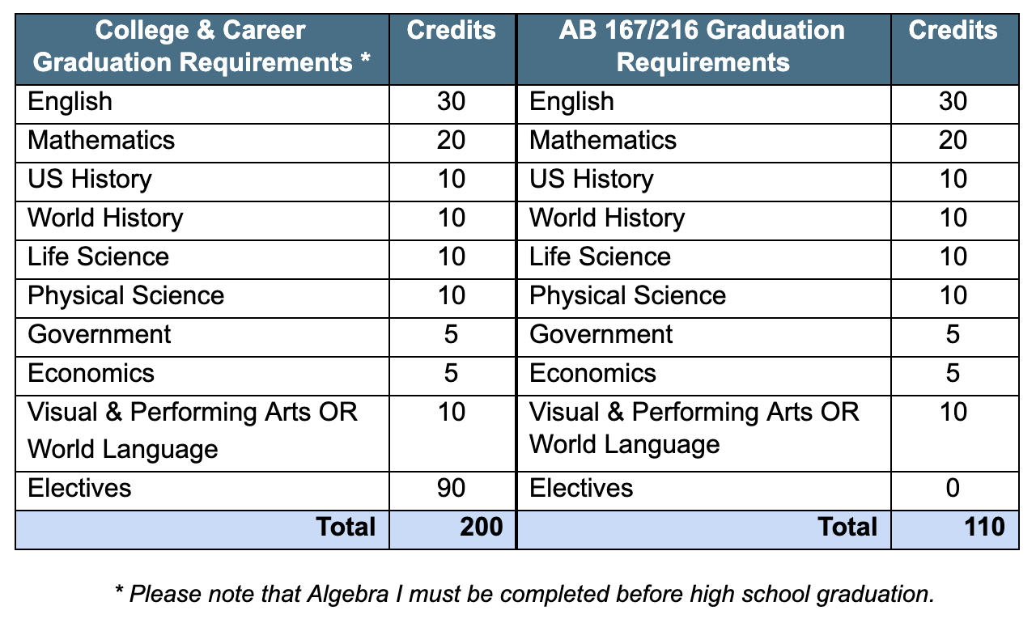

HST Role:
- If your student is eligible for the AB 167/216 graduation path, then the student will be enrolled in the appropriate graduation path in School Pathways.
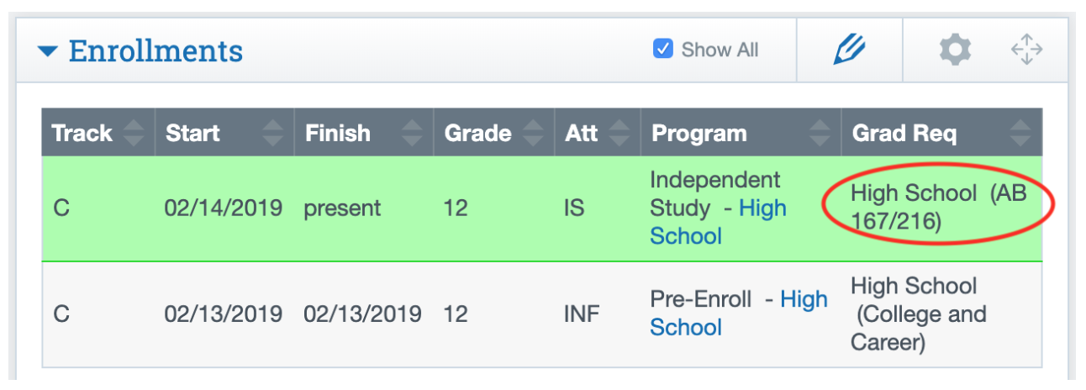
- If your student is eligible for the AB 167/216 graduation path, please make sure that they have access to curriculum, tech, and enrichment as soon as possible. It is vital that students start working towards graduation goals immediately.
- Documentation of the student’s eligibility will be uploaded to the student’s Dashboard under the Notes section in Pathways.
- If you believe your student should be enrolled in the AB 167/216 graduation path and there is no documentation in School Pathways, please reach out to your Guidance Counselor immediately.
- If your student is ineligible for the AB 167/216 graduation path, their status can be re-evaluated at any time during the school year. Please continue to monitor your student’s course progress and notify the inspire counselor immediately if you think the student may be struggling.
- Please note, students who graduate with the AB 167/216 may or may not be able to apply to a 4-year college right after high school graduation. Please consult with the Guidance Counselor to see what the student’s post-high school options are.

