Progress Indicators
Progress Indicators are for students in grades TK-8 and are done four times a year. They help the school gather valuable data on a student's progress of their grade-level standards and they are NOT shared with the parents.
PI Excel Form PI FAQ

2020-2021 Progress Indicator Windows
During each window it is the responsibility of each HST to determine progress indicators for all of their TK-8 students for all four core subjects and to upload them into Pathways.
Window 1 | Window 2 | Window 3 | Window 4
10/19/20 - 10/23/20 | 01/11/21 - 01/15/21 | 03/15/21 - 03/19/21 | 05/25/21 - 06/02/21

A Step-by-Step Guide to Completing Progress Indicators

Step 1 - Get Set Up

1. Download a copy of the Progress Indicator Excel Form. (The link is located at the top of this page.)
Make a saved copy of the form for yourself. Be sure to rename it and file it some place that you can easily find it later.
Note: If you have students in different schools, you will need separate spreadsheets for each school.

2. Name your file based on the following conventions:
If you work for 1 school:
First Initial_Last Name_ProgressIndicators_# (e.g. L_Von Drake_ProgressIndicators_1)
If you work for 2 or more schools:
First Initial_Last Name_progressindicators_#_school (e.g. L_Von Drake_ProgressIndicators_1_LakeView)

3. Input your TK-8 roster information.
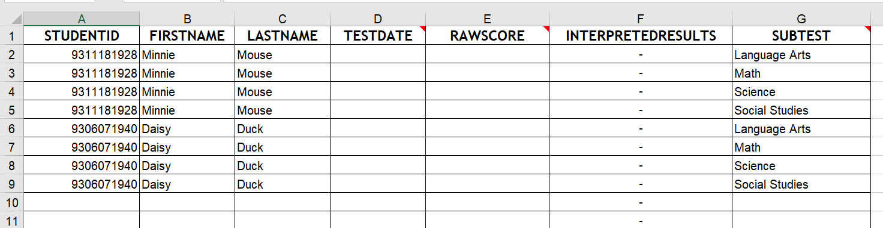
Fill in your roster information for each student starting on line 2.
Note: You will need 4 entries for each student, one for each core subject.
- You can copy the information from your roster tracker or directly from your roster in Pathways.
- Make sure that your place the correct information in each column and that their are no spaces in front of the text when you input it.

Step 2 - Input Your Data
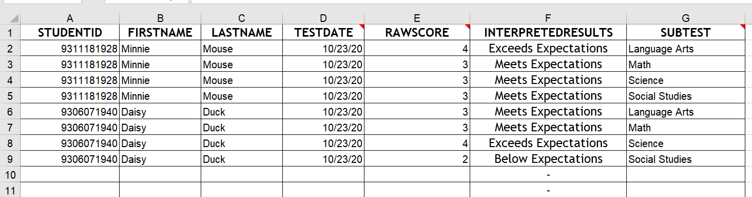
- Input your test date.
  - This can be any date with in the reporting window.
- Input your Raw Score. Use I Can Statements, test scores, work samples, and your experiences and observations with the student to determine their score.
  - Note: when you into your score into column E the form will automatically complete Column F for you.
  - If you need help with determining Raw Scores, checkout the PI FAQ (link at the top of the page.)

Step 3 - Clean up Your Spreadsheet
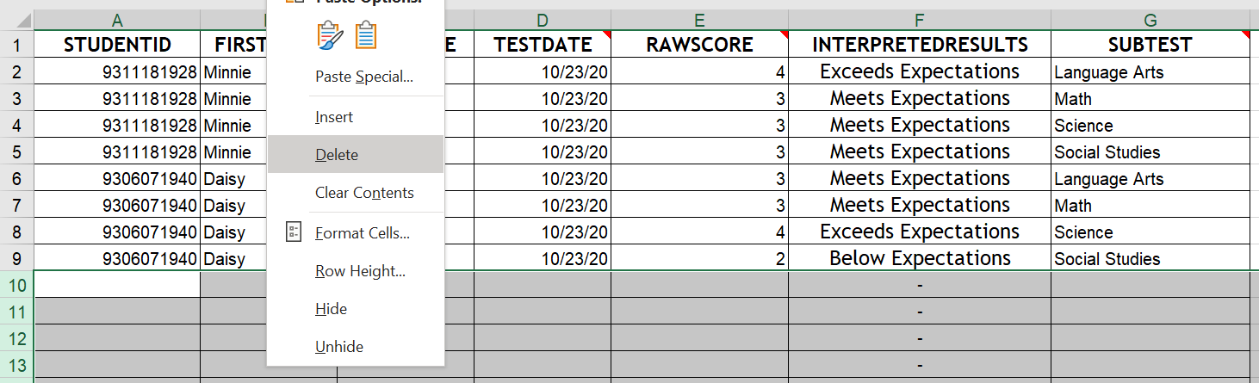
- Once you are done filling out the form you need to delete all of the blank rows that have a '-' in column F. To do this select the rows, right click, and then select 'Delete'.
Tip:If you have a large number of rows to delete you can select the first blank row and then hold down 'ctrl' and 'shift' and press the down arrow key. This will select all the rows below the row that you initially selected. Then right click and select "Delete".
Note: if you skip this step your data will not upload to Pathways correctly.

Step 4 - Export to CSV
Before your Progress Indicators can be uploaded into Pathways you must export the data as a CSV file (Comma Seperate-Values file).
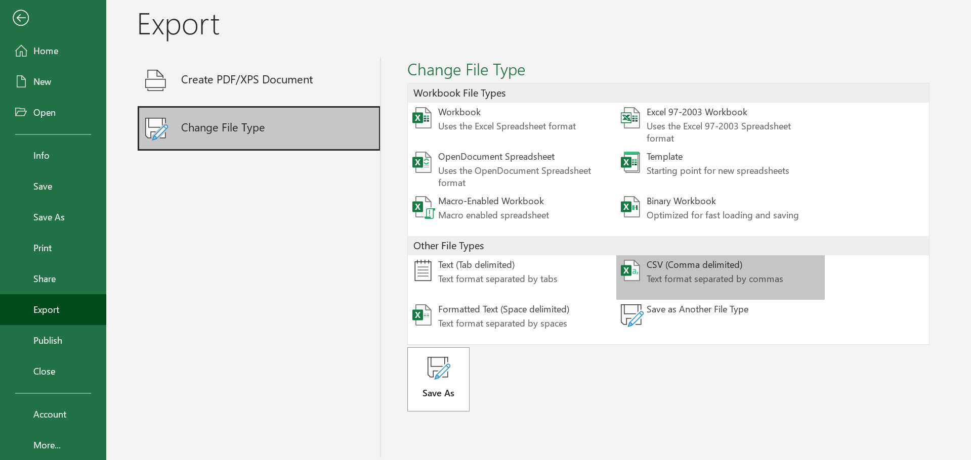
- Select 'File' from the menu. Then 'Export', then 'Change File Type', then 'CSV (Comma delimited)', and then click 'Save As'.
  - Remember to save the file using the naming conventions mentioned above and save it in a location where you can easily find it.

Step 5 - Upload to Pathways

1. Log into your school's Pathways system and Open Scorefile Import.
After logging in navigate to: Admin > Test Module > Scorefile Import

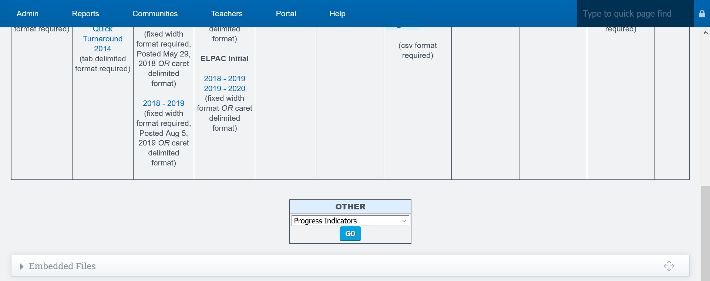
Select 'Progress Indicators' from the the Other Menu and click 'Go'.

2. Upload your PI CSV file.
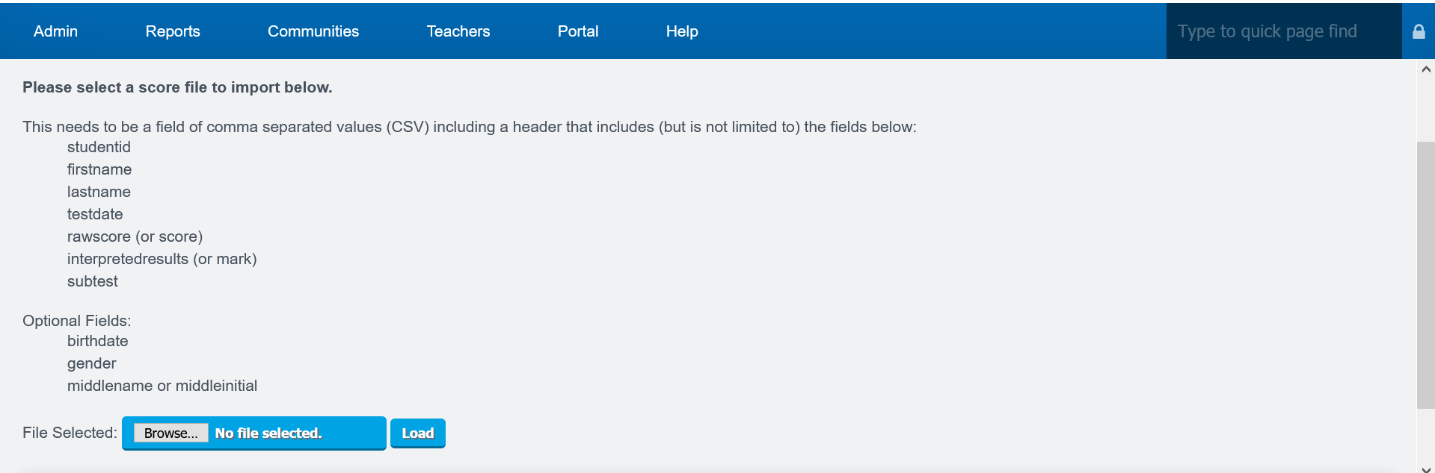
Click 'Browse' and the locate your saved CSV file. Click 'Load' to have Pathways match your data with the system's data.

3. Verify that everything was recognized by the system.
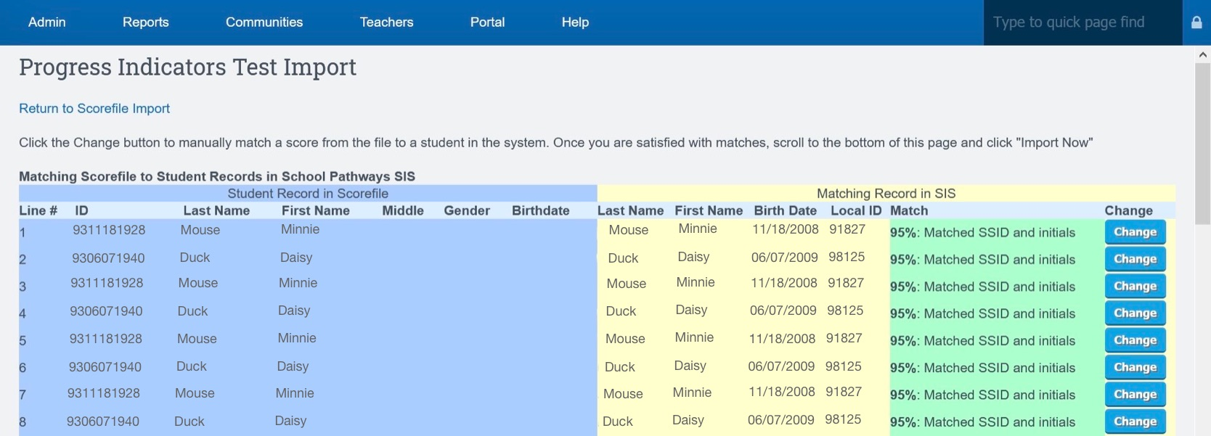
If everything can be read by Pathways and matches what is in the system your screen will look like the one above.

If something cannot be read by Pathways or if the information in the files doesn't match what is in the system then your screen will look like the one below.
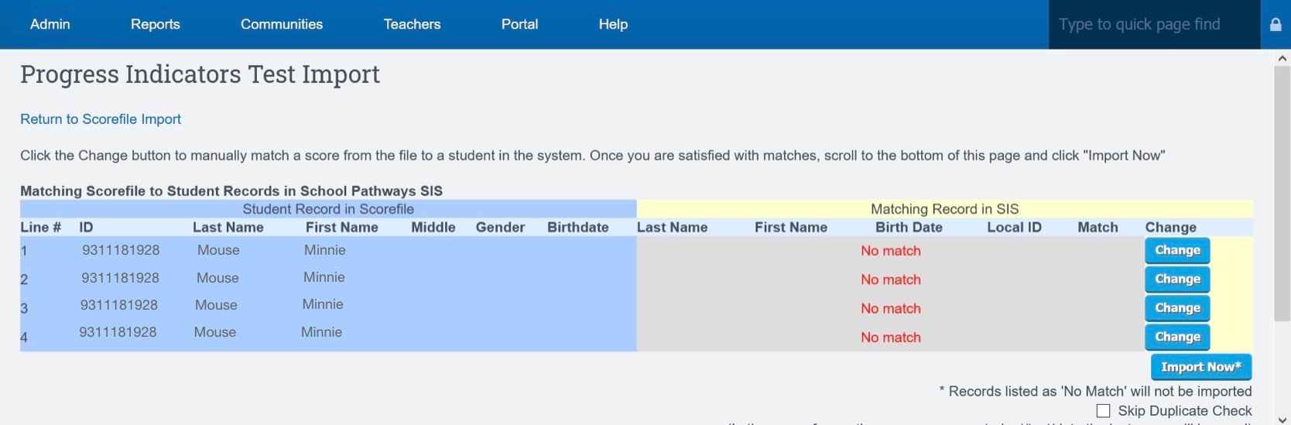
- If you get a 'No match' response on all of the lines check that you chose the correct file for upload. If you picked the wrong file, return to the previous screen and select the correct file.
- If you chose the correct file the first time, or if only some of the lines say 'No match' your issue may be caused by a formatting issue or the presence of a space in front of some of the cell entries in your file. (An errant space in front of the student ID number is often responsible for a 'No match'. Correct the file and try the upload again.
- If you need further help, check the PI FAQ (link at the top of this page) or reach out to your RC Team for help.

4. Import Your Scores
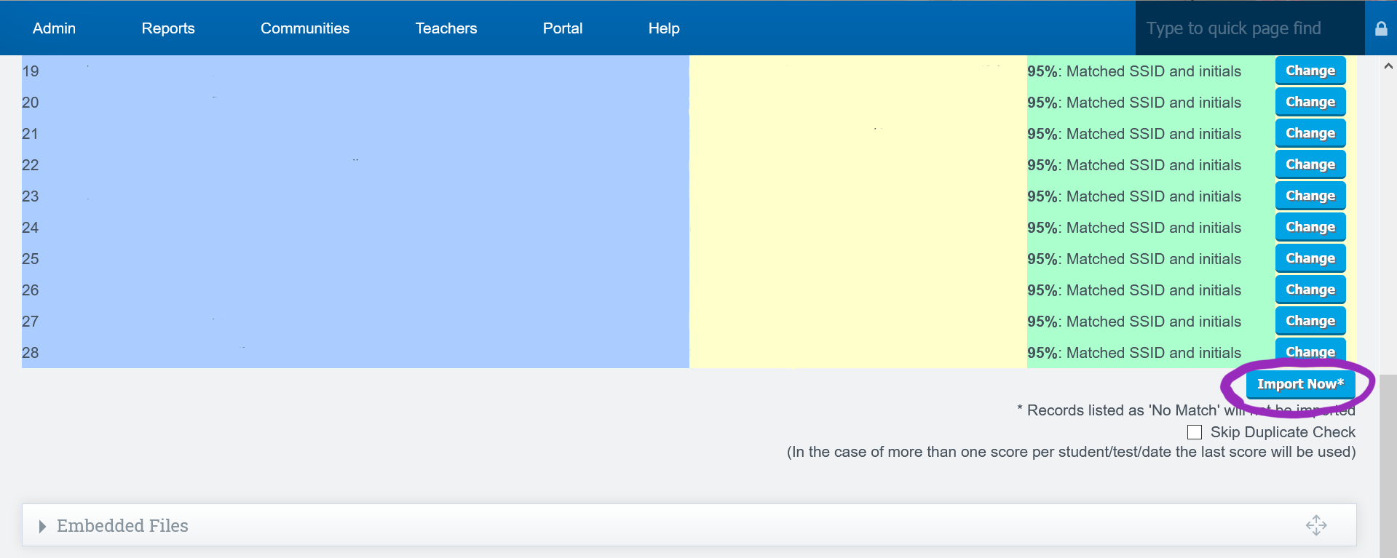
- Once everything reads correctly in Pathways and you do not have any 'No match' lines you can complete the upload.
- To do this click 'Import Now' at the bottom of the report to start the upload process.
- On the next screen you will be given confirmation that the files were upload. Click 'Continue' to finalize the upload.

Tip: If you want to see the information you just uploaded you can find it on each student's dashboard under the 'Tests' tab.

