How to Place a Staff Order

Step 1 - Go to Inspiration Station and Login
Go To Inspiration Station

Step 2 - Make Sure you are on your Staff Dashboard
It should look similar to this:
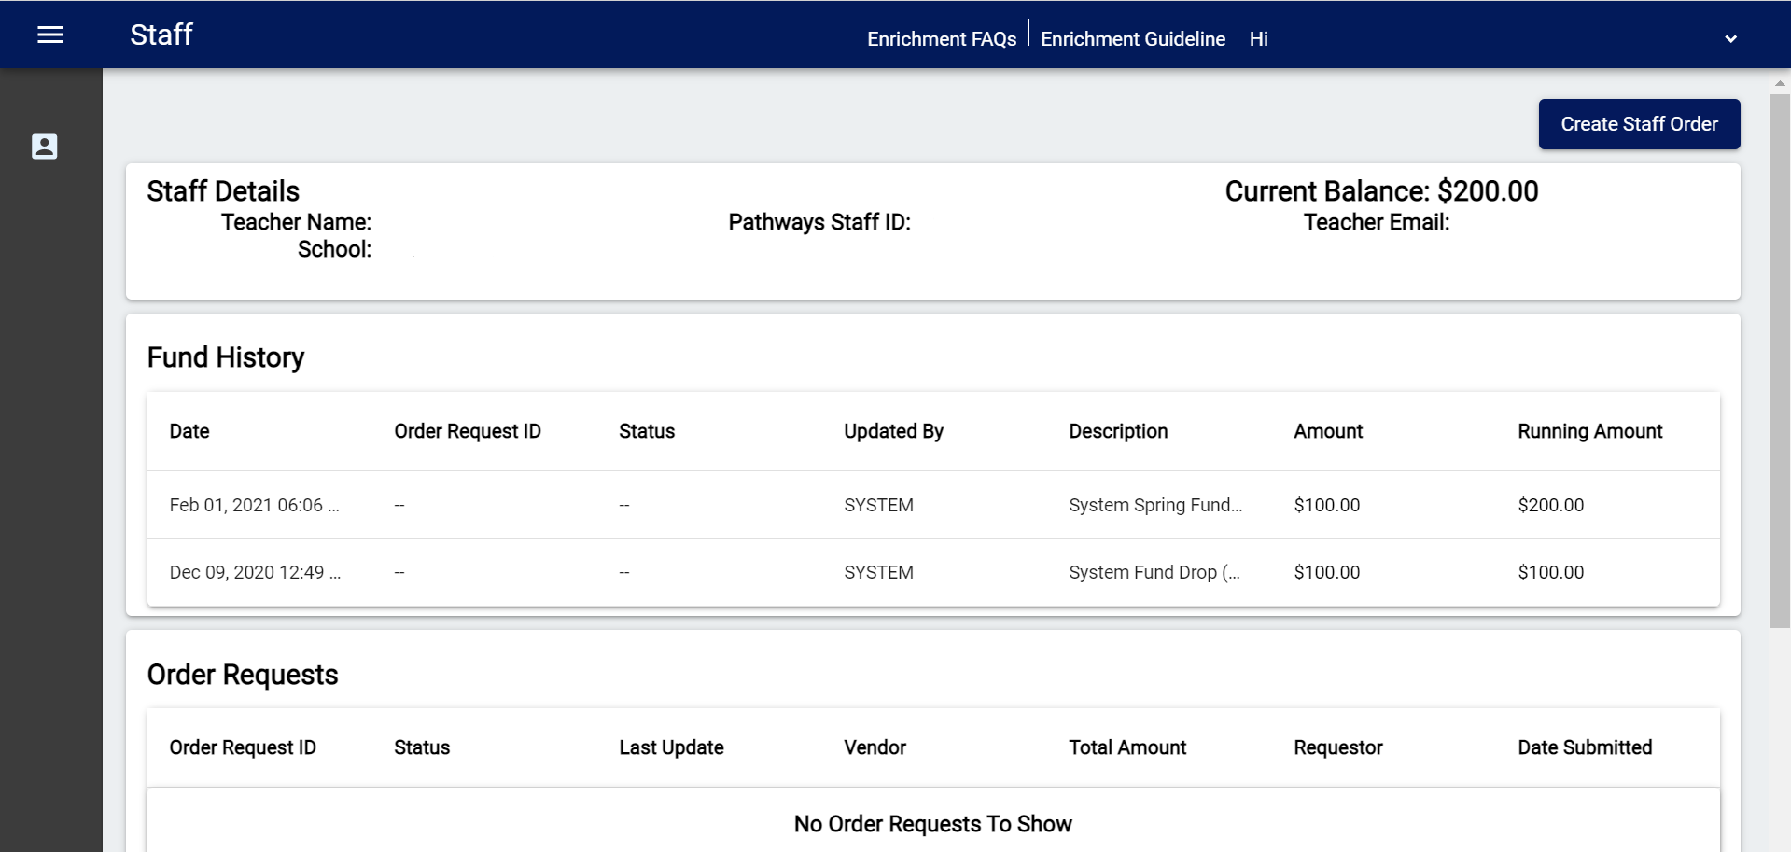
Note: If you are not on your staff dashboard you can get there by click on this icon found on in the menu on the left.


Step 3 - Create a New Order
Click on the "Create Staff Order" to start a new order.
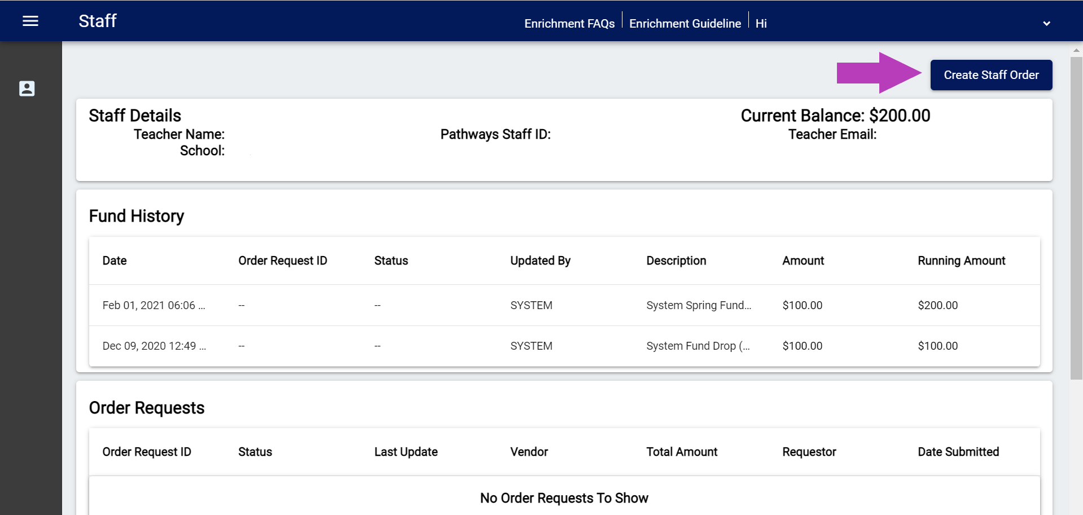

Step 4 - Select Your Vendor
For staff orders you can only place product orders and you can only order from authorized vendors. Currently, our vendors are: Amazon, Office Depot, and Staples.
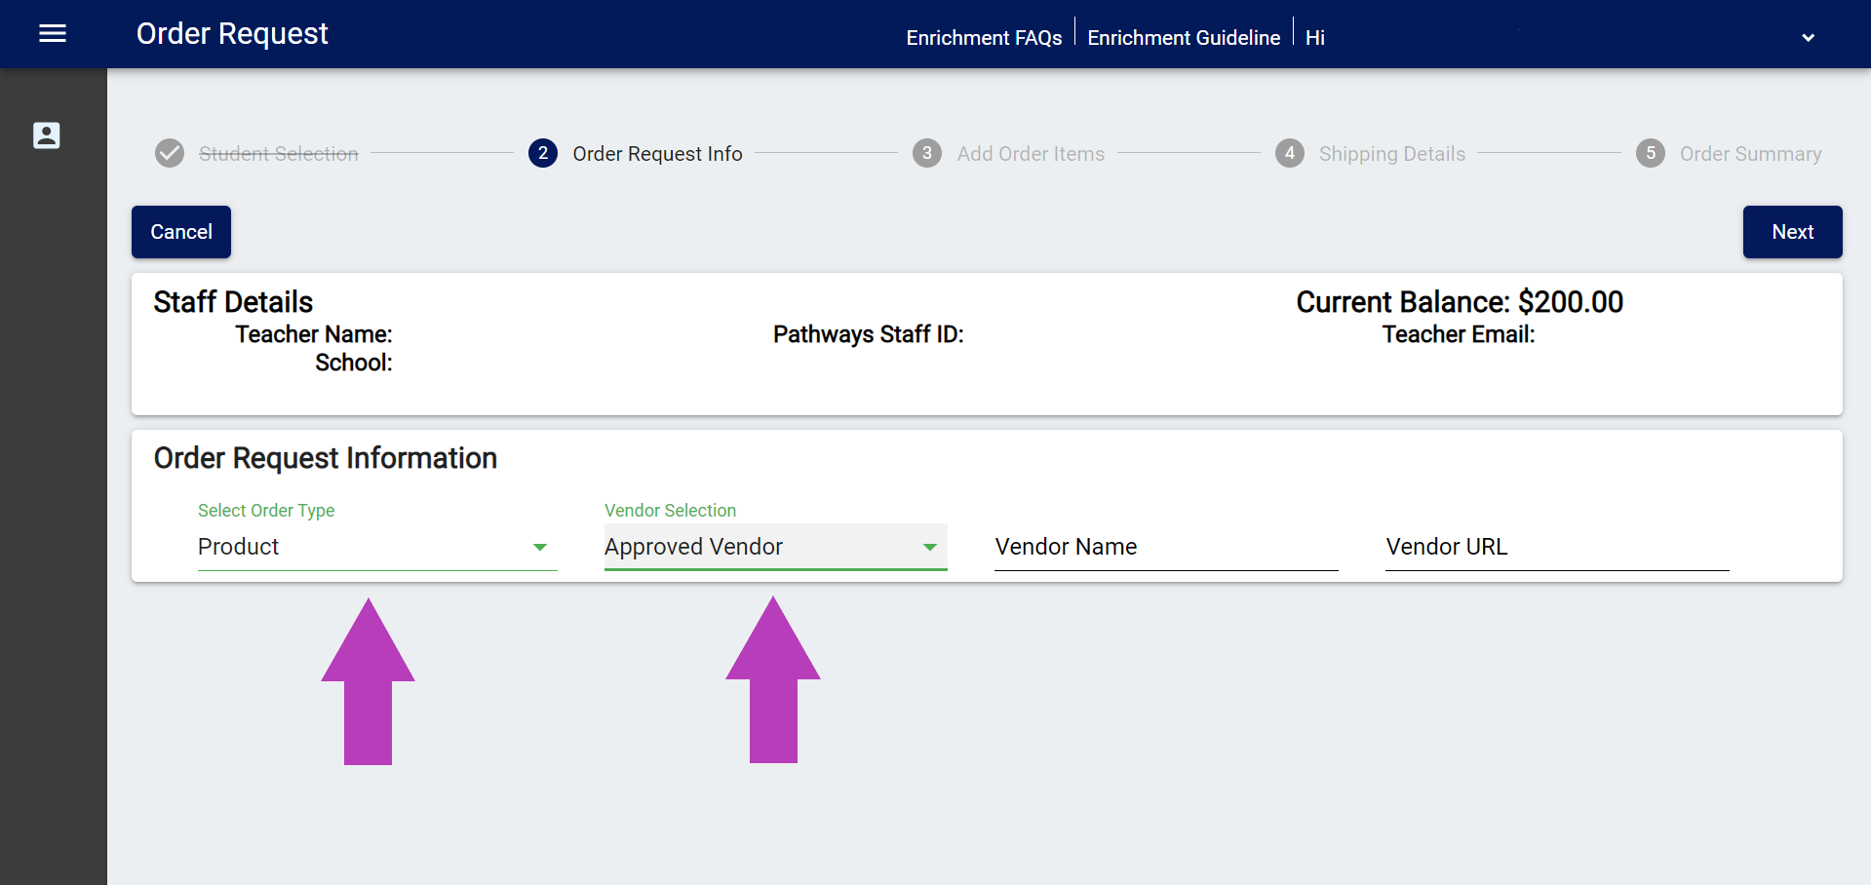
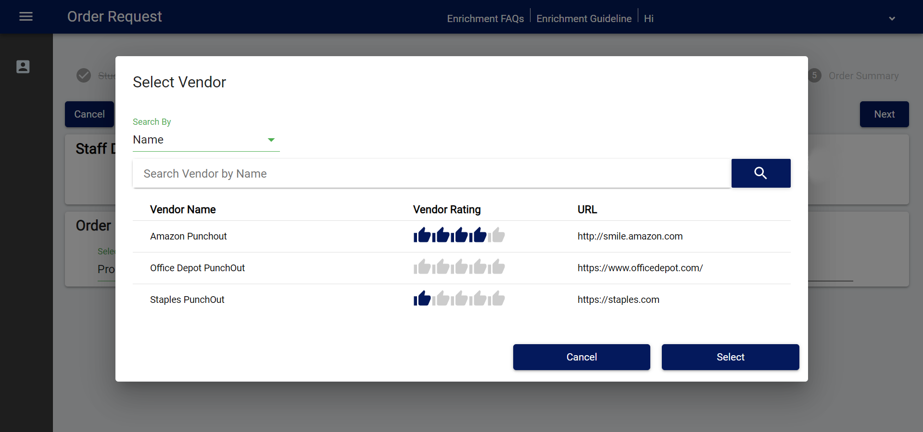

Step 5 - Enter/Verify Your Shipping Information
Note: If your information is not already in the system you will need to enter it under Shipping Details. Use your name for the Address Name and fill in all of the fields. You will not be able to continue without doing so.
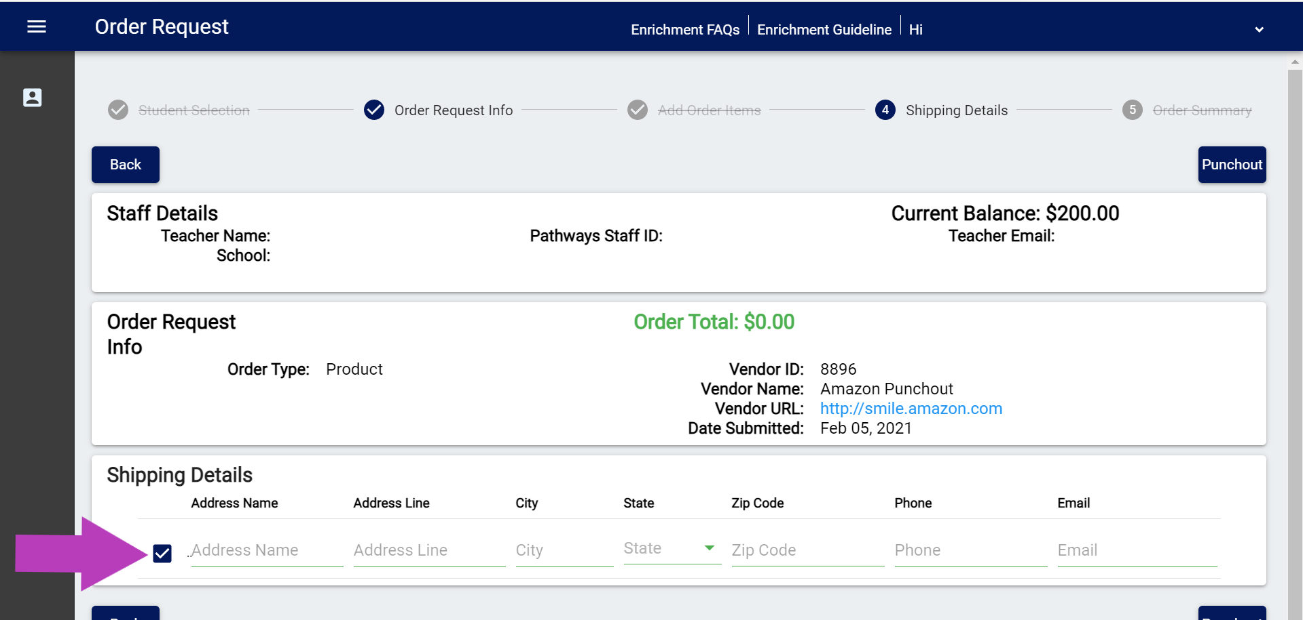
When you are done, click on "Punchout" to proceed.

Step 6 - Punchout
After clicking on Punchout you will need to select "OK" to be redirected to the ordering site for that vendor.
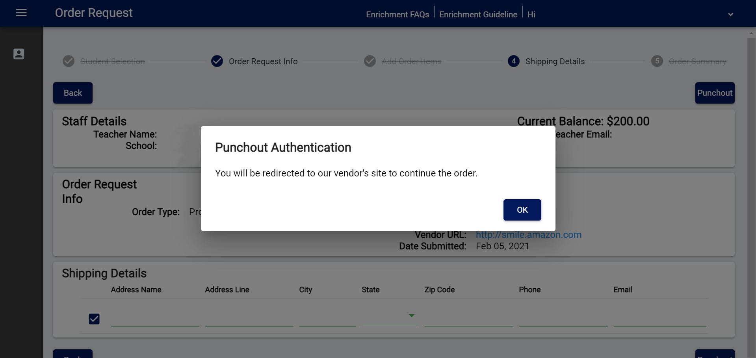

Step 7 - Place Your Order
Shop the site and place items in your shopping cart like you normally would. Once you are done view your cart to verify everything is correct and then click "submit order". This will send the order information back to the EOS system where it will wait for approval and processing.
The pending order should now show on your dashboard. (Note: you may need to refresh the page before it will display.)

