How to Assign High School Courses
How to Assign High School Courses (PDF)

- Login to Pathways and jump to the student’s scope.
- Click on Teachers then PLS/Student Roster
- Update the roster options as follows then click update:
School Year: current school year
Date Range: Entire School Year
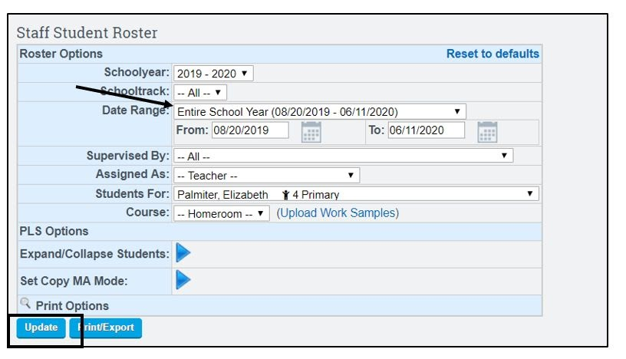
- Click the blue arrow next to the student you want to assign classes to:
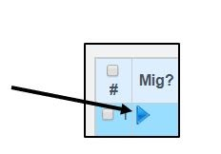
- Make sure the correct semester is selected, then click Add Class:
Please note that we create year long Master Agreements in the fall, so courses will be added to both semester 1 and 2.
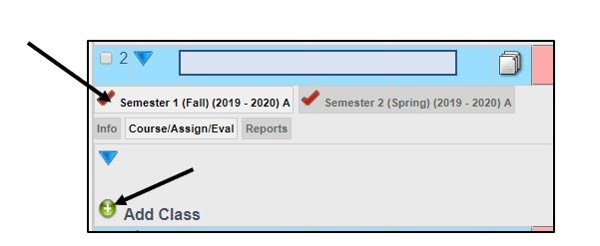
- Search for the title of the course you want to add in the search bar:
Keep your search general so that you are more likely to find the course you are looking for.
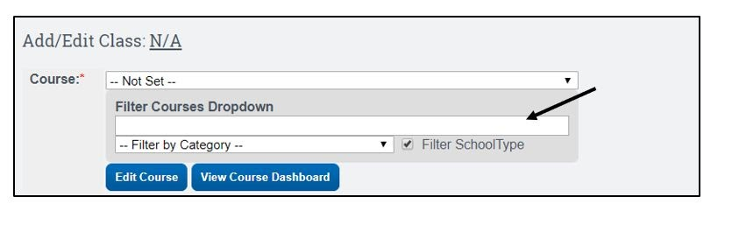
- Click on Not Set to see the courses available matching the words you searched for:
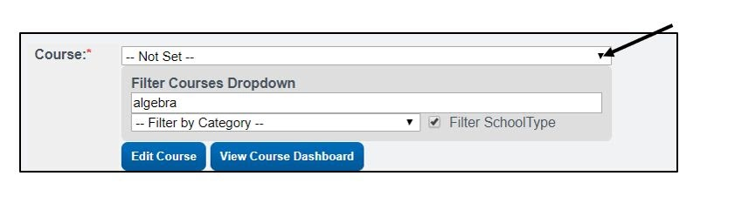
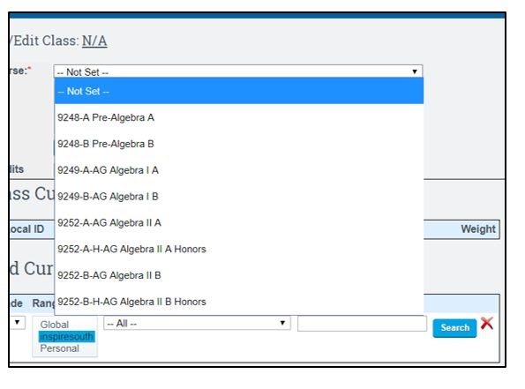
- Choose the course from the list that you want to assign:
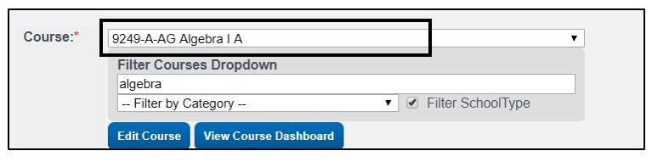
- Most of the course settings will automatically update for you, including Credits, Class Name, and Transcript Category. Do not change these settings without discussing with your HSSC.
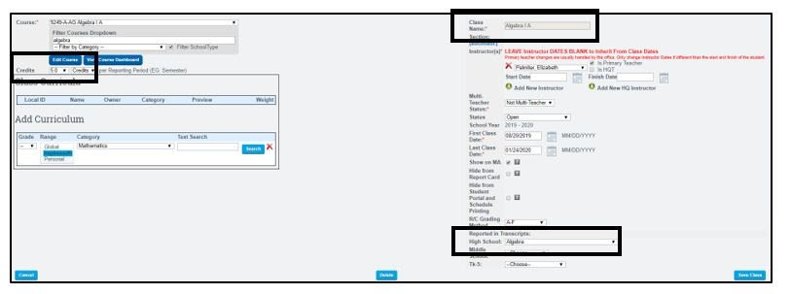
- Double check that everything looks correct (teacher name is your name, semester dates, show on MA is checked, etc.), then click save class:
**New for 2019-2020: you do not need to add curriculum, and you do not need to add an HQT. The curriculum team will add the HQT for you.
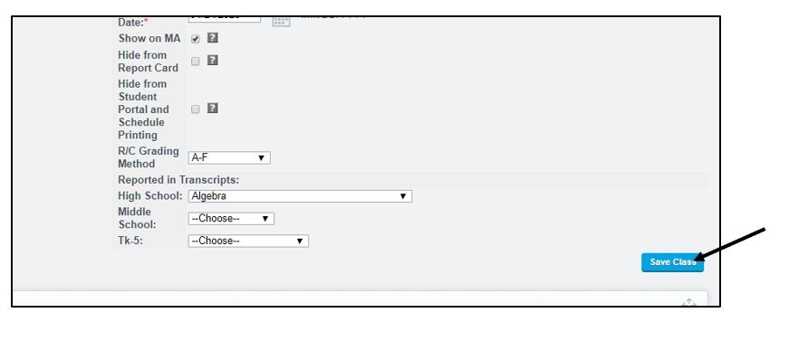
- The course will now be listed under the student on the roster page:
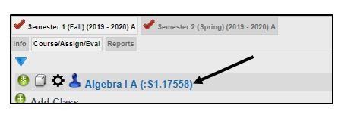
- Repeat the steps above for all courses, for both fall and spring semester. Undecided electives may be left off the student’s schedule, and an addendum will be completed in the spring.
- Once all courses are added, the directions for sending a Master Agreement will be followed, using the same process as TK-8 students.

