How to Add High School Curriculum
How To Add High School Curriculum
High School Curriculum needs to be added by the HST before assignments can be made.
Step 1: Go to your PLS/Student Roster and make sure dates are set correctly
Step 2: Click on the Blue Arrow for the student who needs curriculum added.
Step 3: Make sure to click on Semester 2 (Semester 1 classes can be left as is)
Step 4: Click on the green circle (Edit Class) button on the far left.
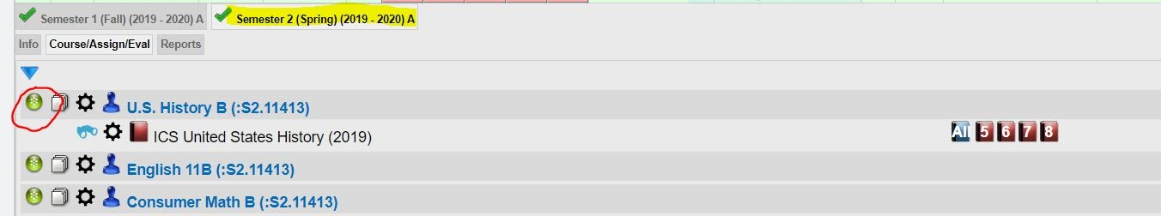
The page opens where curriculum can be assigned. From here the HST has several options of what curriculum to add.
Step 5: For ICS Course Outlines:
Choose the name of the school under Range and search “ICS” in the Text Search to bring up the list of ICS course outlines.
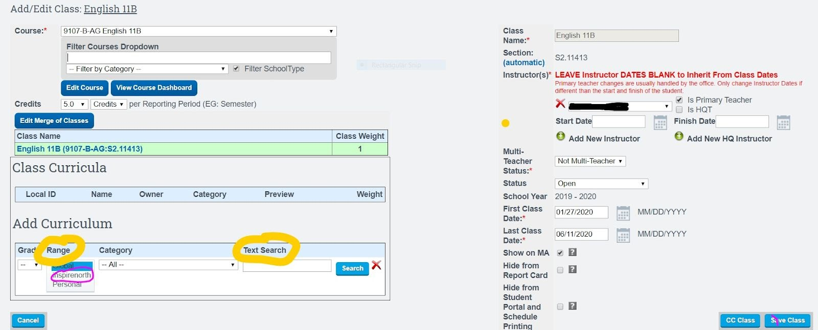
Review the list of classes and choose the desired class.
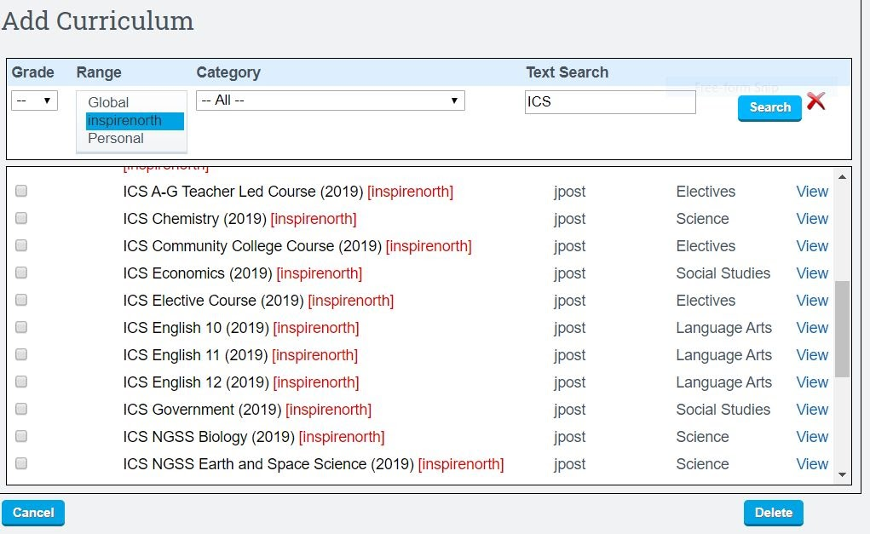
If you have other students taking the same course and needing the same curriculum, you can CC Class to the other students and it will load on their list automatically.
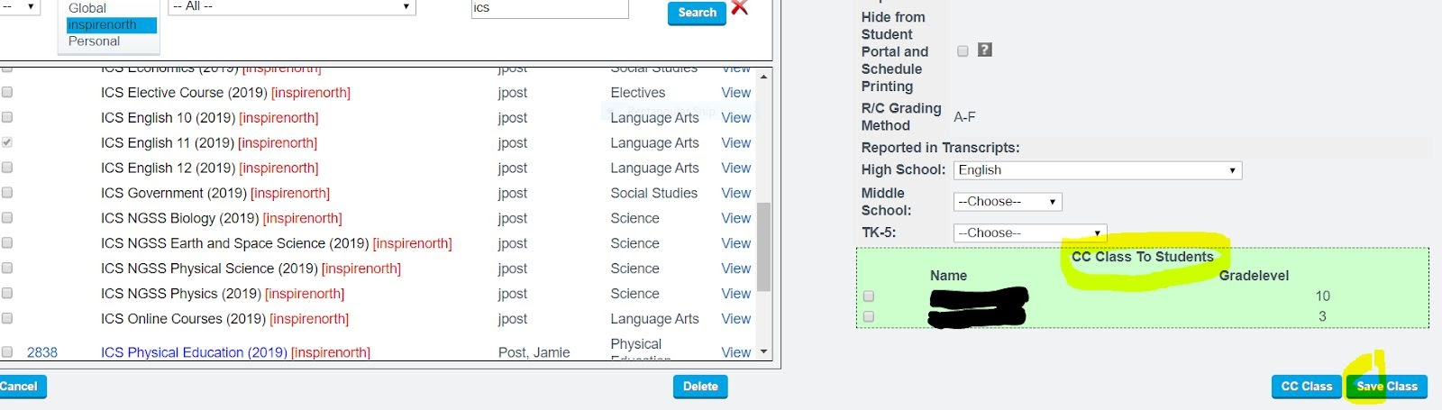
Click “Save Class”
For students enrolled in online courses such as “Edgenuity”: HST has 2 options. HST can search the name in the Text Search and choose the appropriate class. Make sure to choose school name in the Range
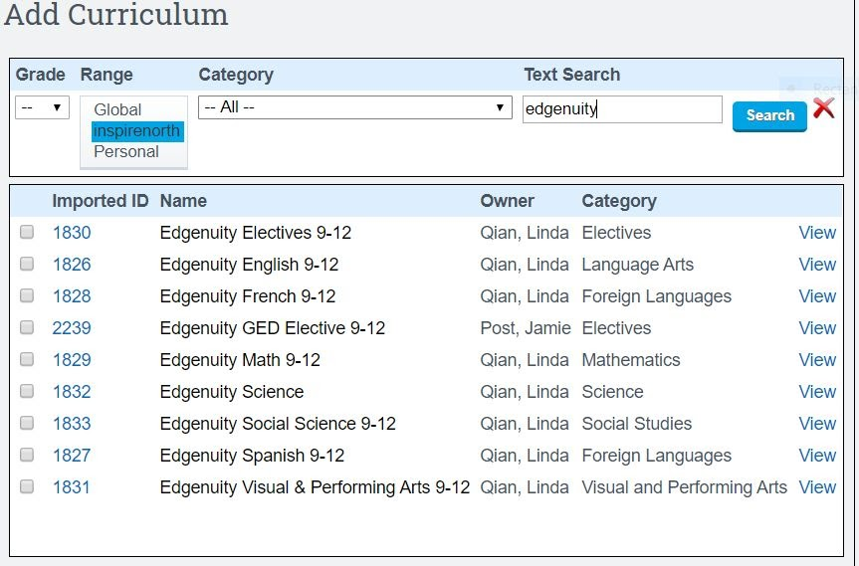
Pathways also has loaded our 5 Generic ICS Course outlines with broad assignments that can be used for online courses led by HQT’s. To find these, make sure to choose the school name in Range, not Global.
The 5 Generic ICS Courses are listed at the end of this document.
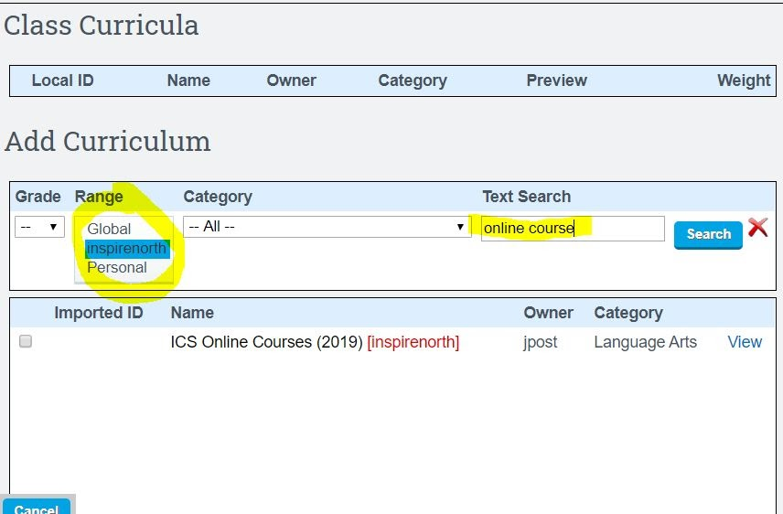
HST can also use the “Global” option to search thousands of other curricula already loaded into the Pathways system if desired. This is just an option.
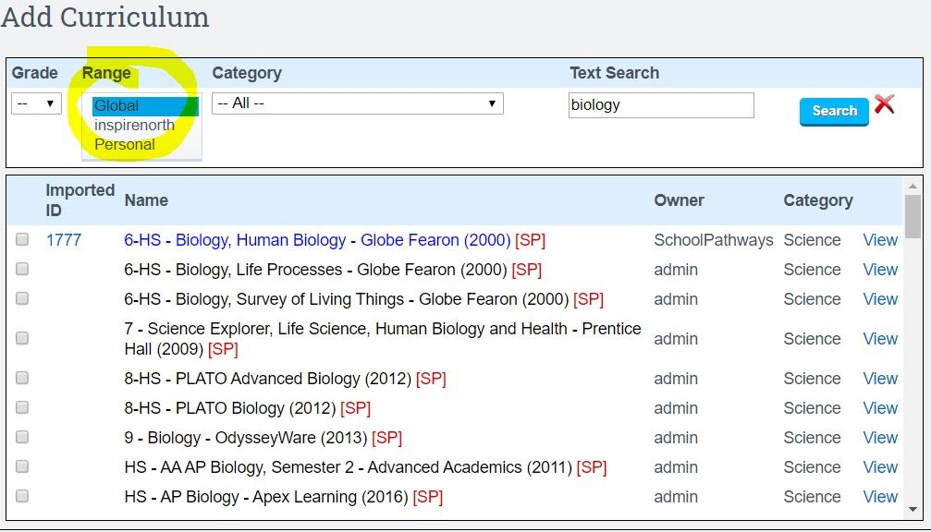
Continue this process for each of the High School courses the student is taking.
You can now start assigning work. The steps are the same as the step by step for TK-8.

Five Generic ICS High School Courses
Each course has multiple modules. Below illustrates how Module 1 appears for each course.
Module 1: Online course
Objectives:
1. Students will follow the online instructions and complete online tasks as assigned in online program.
Assignments:
Complete online tasks.
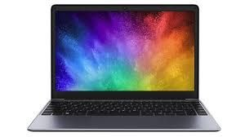

Module 1: Teacher Led Course
Objectives:
1. Students will follow the instructions and complete tasks given in teacher led course.
Assignments:
Complete tasks outlined in teacher led course.


Module 1: Physical Education
Objectives:
1. Students will follow instructions and complete activities as assigned in physical education program.
Assignments:
Complete physical education activities.


Module 1: Community College Course
Objectives:
1. Students will follow the instructions and complete tasks as assigned in the community college course.
Assignments:
Complete community college tasks.
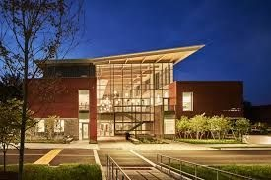

Module 1: Elective Course
Objectives:
1. Students will follow the instructions and complete tasks as assigned in elective course.
Assignments:
Complete tasks outlined in course description.


