Global Notes
Using the Global Notes feature at the bottom of a student's dashboard in School Pathways allows you to leave notes pertaining to the student's enrollment status, grade level, transfer status, and many other topics. They are especially useful for making other departments aware of unique aspects or issues pertaining to the student.
Global Notes 2020 2021 (Power Point)
Global Student Notes (PDF)

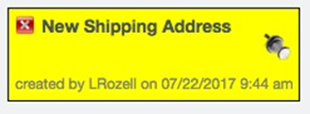

At the bottom of every student dashboard page is the ability to add a Global Note
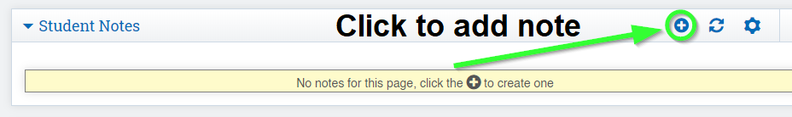

You may choose to add the note to a list on the page as you see here:
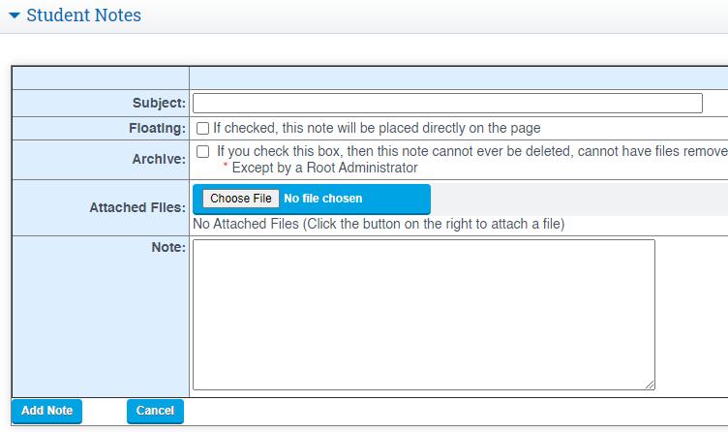

Or the note may be placed directly on the page for maximum visibility! To do this, mark the Floating checkbox. This will create a floating textbox with the Global Note in it that can be moved around the dashboard.
