Contact Manager
- ACCESS TO CONTACT MANAGER
- CREATE CONTACTS FOR SELECTED STUDENTS
- ADMINISTRATIVE CONTACT REPORT
- HOW DO I SEND CONTACT MANAGER NOTIFICATIONS?
- ADMINISTRATION: SET-UP NOTIFICATION FLAGS
- ADMINISTRATION: SET-UP VENDORS
- ADMINSTRATION: CONTACT MANAGER SCHOOL POLICIES
Contact Manager (PDF)
Contact Manager is a tool all staff can use to track comments/contacts with students and their families. Contact lists are automatically created for teachers that have an association with the students through homeroom or as independent study supervising teachers. Quickly allows staff to note time, focus, and outcomes of any meeting with any student. In addition, there is an option to send notifications to specific individuals, regarding the specific contacts.
The Student Engagement feature integrated into Contact Manager allows a school to track any instructional sessions for any student across time. Any staff member who deals with any student can leave brief information regarding:
- Time spent with the student (minutes, hours). This can be documented in the past or automatically in the present.
- Any type of educational activity can be tracked: phone, in-person, class time, small group instruction, tutoring, email, etc.
- Time and subject matter information can be left for every student in a class or for an individual student.
Depending on permissions set, some users will be able to view all contact lists while others will be able to only view the homeroom teacher's/independent study teacher's contacts if they too teach the student.

ACCESS TO CONTACT MANAGER
Contact Manager can be accessed from four vantage points:
- Administration > Student Info > Contact Manager
If you enter Contact Manager via this route, you have the ability to select and view contacts for any Staff if Security privileges allow
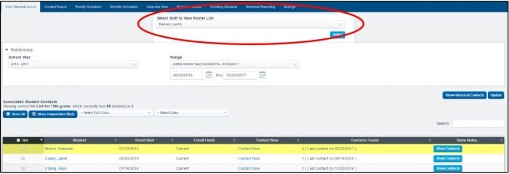
- Teacher Pages > Contact Manager
If you enter Contact Manager via this route, you only have the ability to select and view contacts for your rosters (Homeroom, PLS Classes, LC Classes, HQT Classes, SPED, etc.)
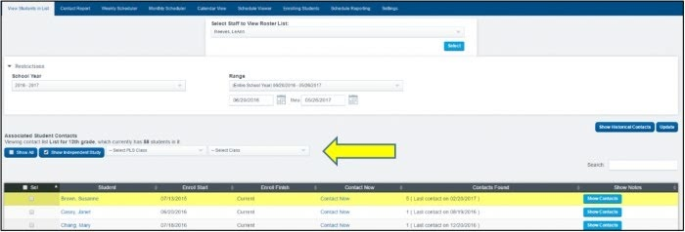
- Each Student Dashboard via the icon:
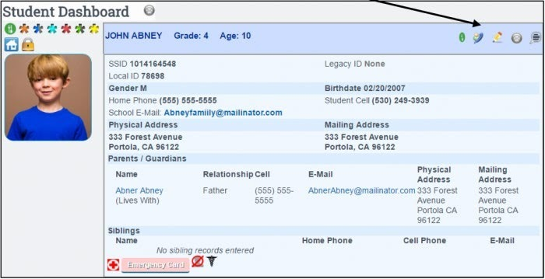
- Each Staff Dashboard via the icon:
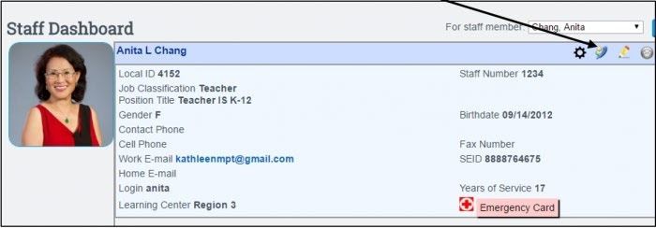

CREATE CONTACTS FOR SELECTED STUDENTS
Click “Contact Now” to create contact for individual student. Or select a group students and click the “Create Contacts for Selected Students” button.
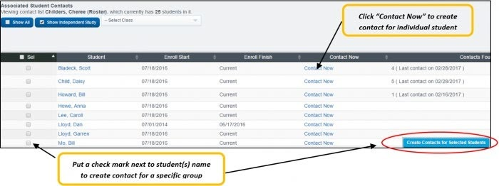
Enter all relevant information to the contact and “SAVE CONTACT”
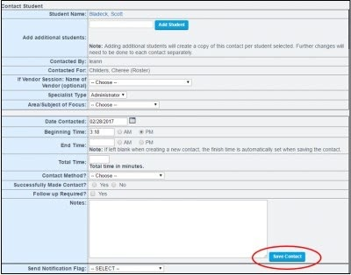
NOTE: Information relevant to the student is available by expanding the blue arrow
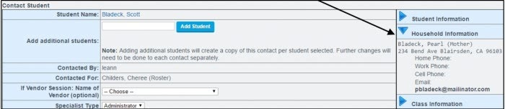
After your contact is saved, you can return to your roster to view all contacts. Click the “Show Contacts” box to expand and view/read any contacts made for any student. Contacts may be printed for individual student or a group of selected students.
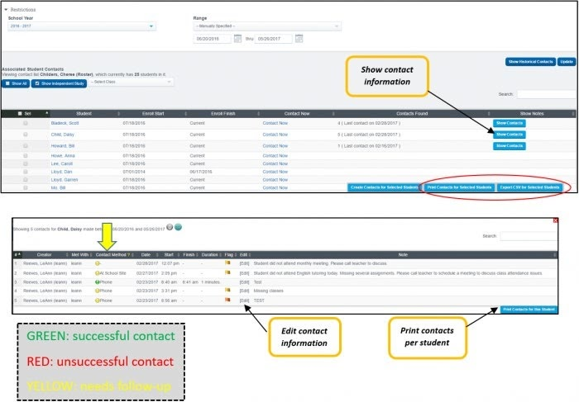

ADMINISTRATIVE CONTACT REPORT
- This report is used to view contacts for a specific date range, Teacher, Student, and Vendor Staff, and more. Various filters are available to pull a report of contacts that have been logged within Contact Manager.
- To access, click the gray Contact Report tab > Select dates & filters > Show Report
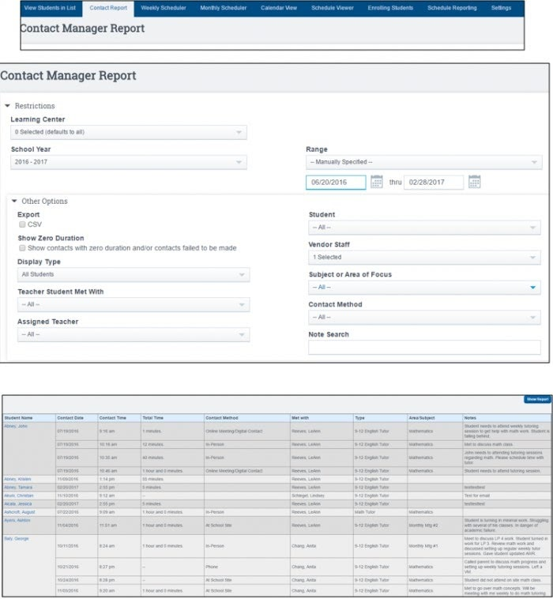

HOW DO I SEND CONTACT MANAGER NOTIFICATIONS?
- When creating a contact in Contact Manager, you may send a notification to selected staff members and/or parents of the student, regarding the nature of the contact that is being created.
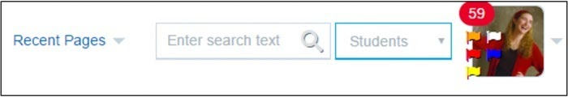
- Staff members will have notification flags appear next to the profile picture at the top of right of the SIS
  - Color of the flag indicates level of importance or priority of notification (Emergency, Attention Needed, Academic Failure, General Information)
- Sending a notification
  - Create contact as described in steps above and enter all relevant information
  - Prior to saving contact, select type of “Notification Flag” from the drop-down box. Once the flag is selected the color of flag will be displayed (Example: “Attention Needed ASAP” is highlighted red)
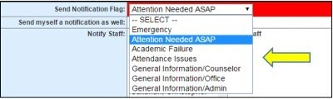
  - Select staff members to notify. Multiple staff may be selected by holding CTRL + Click to select multiple Staff and/or chose to send Parents an Email notification.
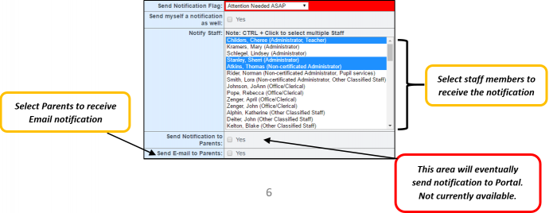
  - SAVE Contact
  - Once the contact is saved and you “Show Contacts” for a specific student “Notification Flag Information” the flag notification sent will be noted. You can also clicking on “Edit” of contact saved
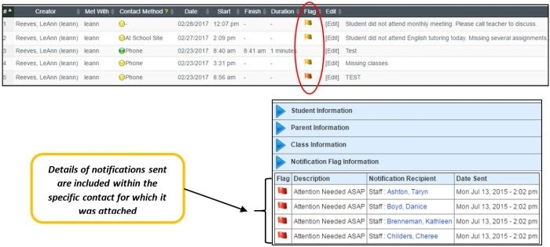
- Where will staff see the notifications they have received?
  - Staff members will have flags next to the notifications envelope count in the blue header of the SIS to show nature of notification
  - Color of the flag will indicate level of the importance or priority of notification
  - Hover over the flag for a brief description
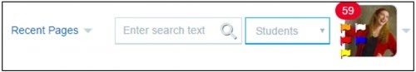
  - Click directly on the flag to read notification
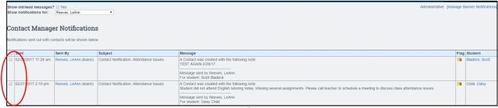
  - To mark the notification as Read, click the box to the left of the notification, typing CONFIRM, and clicking “Mark All Checked Contact Notifications as Read”. The Date and time read will be noted.
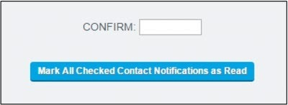

ADMINISTRATION: SET-UP NOTIFICATION FLAGS
- To set-up notification flags go to Administration > Settings > Trigger Emails
- Click on the “Notification Flags” tab
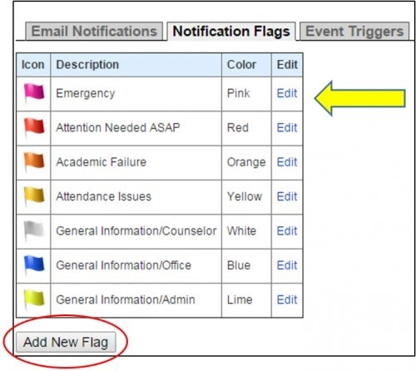
- You may “Edit” the default flags that are available or…..
- Click “New Flag”, enter flag description, select color, and “Save Flag Settings”
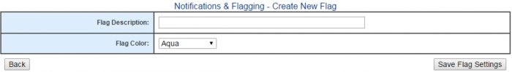

ADMINISTRATION: SET-UP VENDORS
- Go to Administration > Portal Management > Vendors
- You can set-up vendors that will be providing services to students, so that staff that have access to Contact Manager for student can enter information related to the Vendor Session with the student(s). Once vendor names are entered, they will be available for selection from a drop down box when entering contact information.
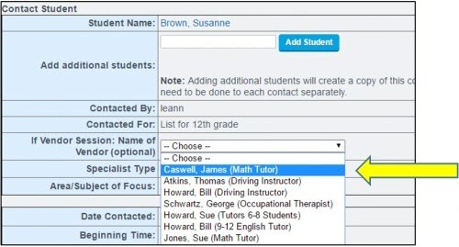
- Click “Add New Vendor” and enter all necessary information and click “SAVE”
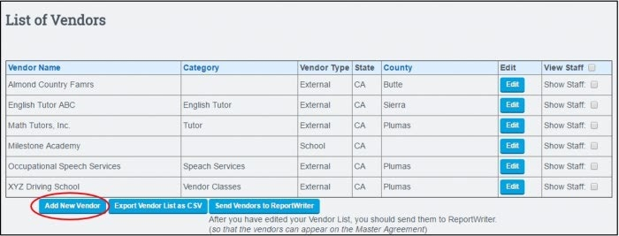
- Click to “Show Staff” and then click “Add New Staff” to add name of staff providing the vendor services
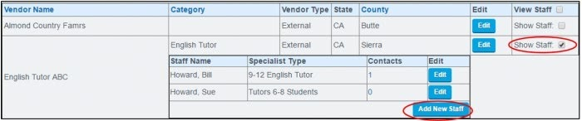

ADMINSTRATION: CONTACT MANAGER SCHOOL POLICIES
- Schools have the ability to customize the options in the drop downs for “Area/Subject of Focus” and “Contact Method”
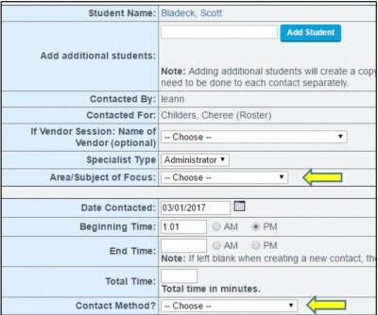
- Access School Policies via Admin > Settings > Policies > Contact Manager – click to show policies
- See policies #8 and #9. Enter custom list with no commas or spaces. Then “Set Preferences”
