Attendance

Key Things to Remember:
- Families LOG Attendance - HSTs CLAIM
- The school year is broken up into 8 Learning Periods (LPs).
- Attendance is due on the last day of each LP.
- Families LOG attendance through their Parent Portal.
- HSTs CLAIM attendance in Pathways for each school/scope they are assigned.

DIRECTIONS
- LOGGING Attendance (Families)
- CLAIMING Attendance (HSTs)
- How to Send an Attendance Log (Only use if needed)
- How to Check for Attendance Completion
- Blank Paper Attendance Logs 20-21
- Attendance FAQ 20-21

Attendance Due Dates
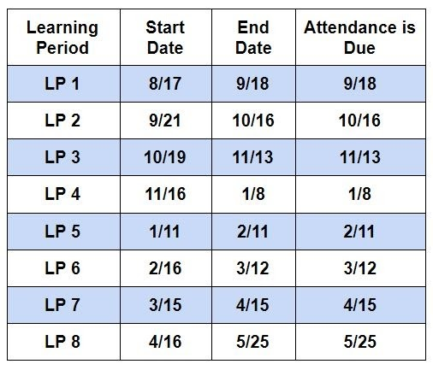
TIP: Send your families an email each time attendance is due. Encourage them to form a habit of logging attendance right away. Carefully review each attendance log submitted to verify that it is signed and dated by the guardian. The date signed must be on or after the last day of the LP. If there are any errors, reach out to the parent to make the required corrections. Make sure to note any days not logged by the parent and mark those days as absences when claiming attendance. If a parent has not submitted a completed attendance log within a few days of the LP end date, please follow up with friendly reminders. Families have one week to complete this task.

BEST PRACTICE:
Get into the habit of claiming your attendance on the last day of each Learning Period as well! It is not necessary for you to wait for your families to finish first. At the end of the attendance period, make sure to carefully review all attendance logs submitted. If there are any discrepancies between the days logged and the days claimed, reach out to your SAA (Student Accountability Assistant) for a code in order to modify the attendance claim.

IMPORTANT:
Our funding is directly tied to student attendance. It is important that parents participate in educating their children every day and that they log attendance when required.

NON-COMPLIANCE:
Not submitting attendance can trigger our Non-Compliance process. Please review our policy HERE and work with your RC to determine what steps need to be taken.

Official Attendance Policy
Parents are responsible for ensuring that their child is actively engaged in learning each school day. Monthly Student Learning Logs (Attendance Log) must be signed and submitted to your HST at the end of each learning period. The following are acceptable reasons for not logging attendance: prolonged illness, hospitalization, bereavement, family emergency, natural disaster. In such cases the absences would be considered excused. Some instances may require verification, such as a doctor’s note, to be provided to your teacher. HST's will be knowledgeable of student progress, learning, and engagement in school. This can occur at regularly scheduled meetings, calls, emails, and or other methods. If the HST is unable to obtain knowledge of the progress, learning, and engagement in school, attempts to contact will be documented and a non-compliance letter may be sent. After multiple failed attempts to contact a family, the school may deem that enrollment in Inspire is not in the best interest of the student and he/she may be subject to withdrawal.

How to Check for Attendance Completion

Perform a GridLogCheck
- Once in your scope, select: Teachers > Compliance > Archived Compliance
- Under Other Options find "Report Title" and select the report "GridLogCheck."
- Select which date range you want.
- Include students with or without archived reports.
- Select yourself as staff and click generate report.
- View each attendance log to verify days logged, parent signature, and date.

How to Send an Attendance Log
- If your family has a difficult time completing attendance through their parent portal, you may wish to send them a completed attendance log to sign. Be sure to check with the family first to confirm which attendance days should be logged.
- From your roster, click on a student's name to go to their dashboard.
- Once on a student's dashboard, click on the Learning Log icon.
- Select the LP you wish to send an attendance log for.
- Make sure the parent signature box is selected.
- Click "Review Log."
- Check the days the student was in attendance. If the student attended all days, click the "check all" box beneath the calendar. Click "Save Changes."
- Click "Sign and Archive."
- Add the parent's email address and click "Send."
- Similar to a Master Agreement, when the parent signs the document, you will be notified via email. Click on the link in your email to finalize the document.

