Accessing Pathways

1. Start in Oversight.
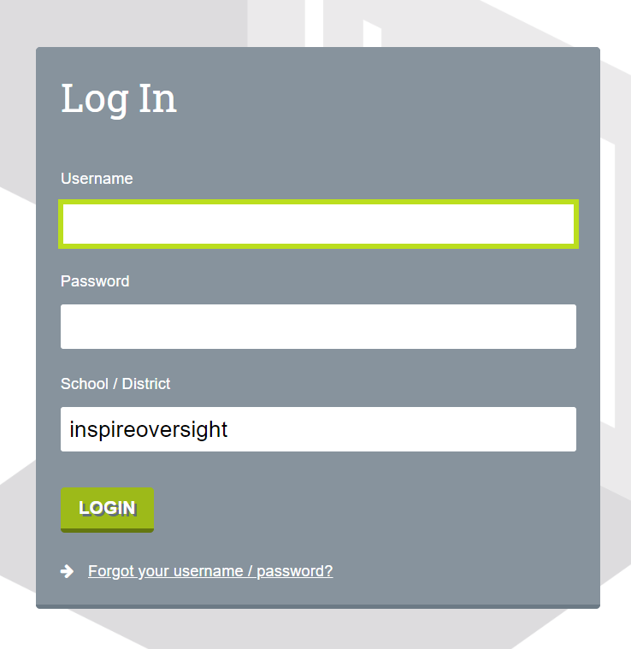
In your web browser, navigate to https://inspireoversight.plsis.com/
To login to Pathways for the first time use these login credentials:
Username: 1st initial.last name (ex: h.potter)
Password: Inspire1!
Once you are logged in, you will need to update your password. Change your password before jumping into any scope/school. If you change your password in Oversight it will apply the change to any school system to have access to.

A Word of Caution: Avoid changing your password within any of the school systems, this can lead to you have multiple passwords and can lead to problems later with accessing other programs that connect with Pathways.

1.5 Change your password, if you have not already done so.
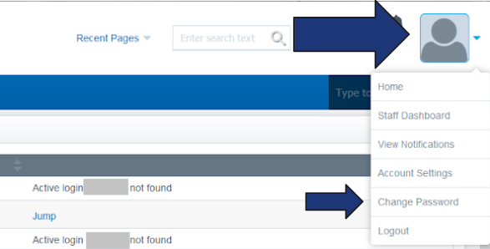
- Click on the person in the upper right hand corner and select "Change Password". Enter your new password following these rules:
  - It cannot match your previous password.
  - It must be at least 8 characters long.
  - It must have at least 1 lower case letter.
  - It must have at least 1 upper case letter.
  - It must have at least 1 number.
  - It must have at least 1 special symbol. (! @ $ # % ^ & * ( ) _ { } [ ] < >)
Once you are done, click save and then log in again.

2. Jump into the school system that you want to use.
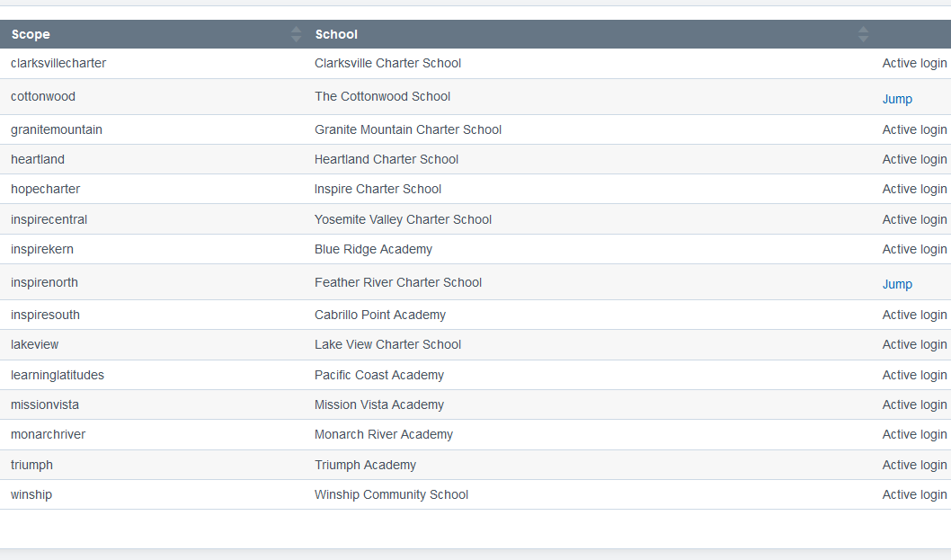
You can only access schools that have a blue "Jump" link next to them. Click on the link to open the system to the school you want to access.

