
Overview

Caring for Students, Appreciating Parents, Respecting Each Other

Our schools are committed to empowering each student to reach their full potential. Our students are engaged learners capable of deep understanding, creative thinking, and innovative approaches to problem solving. Using the I Can Statements (State Standards), the student interests, talents and learning styles profile as their guide, as well as hands-on experiential learning, field trips, park days, and activities in the local community, credentialed teachers partner with parents to develop unique Personalized Learning Plans for each student.

The Assignment & Work Record is a parallel to the I Can Standards and could be referred to as a digital checklist. Think of it like the lesson plans that you keep as a teacher-- your goals for student learning. The AWR fulfills the “assignment” piece of Independent Study law, and makes these assignments evident to auditors.

The goal is to make the rollout of the AWR process as easy as possible for teachers and not to disrupt the relationship teachers have with families. It is essential to the health and longevity of our school that we utilize the AWR’s as evidence of teacher assignments and student progress in grade-level standards. AWR documentation will allow auditors to easily view the standards assigned to our students in a professional standardized format. Thank you for making this transition mid-year and helping make this a positive experience for our team and families.

This document is intended to answer questions, provide information to help implement the AWR’s and address regional policies for our North schools.

Please always feel free to reach out to your leadership team with comments, concerns or ideas!

We appreciate the hard work you do to help our homeschool families grow, learn and thrive!
We will start using this process at the start of Semester 2. There is no need to go back and make any changes to Semester 1.

If you need help, Pathways is available 8am-5pm M-F 866-200-6936
AWR Resource Guide  Start Here! | Use the AWR Resource Guide to reference support materials
Adding Curriculum | All TK-8 I Can Statements have been loaded by Pathways. You can start assigning standards.  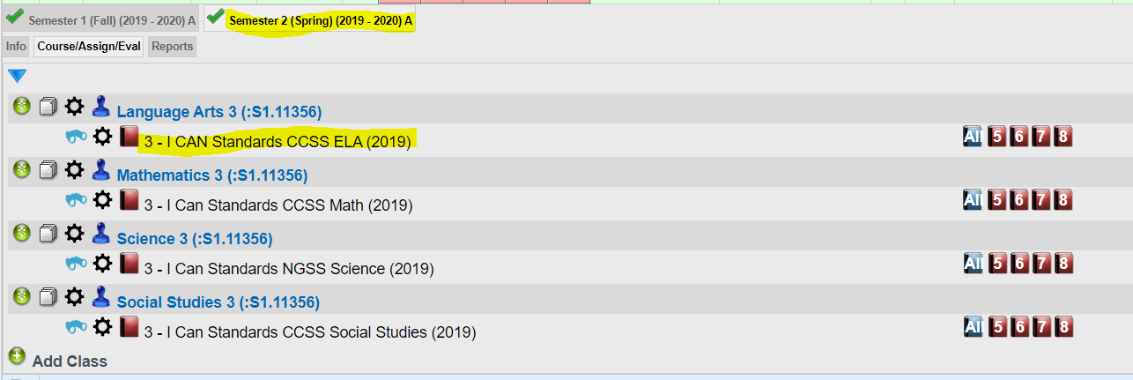  High School Curriculum needs to be added by the HST before assignments can be made.  See How To Add High School Curriculum Document for instructions.
High School Courses in Pathways | The following ICS High School Course Outlines are available in Pathways:  ICS English  ICS Math  ICS Science  ICS History  ICS World Languages  ICS Electives  There are 5 Generic Courses in Pathways that can be used for the following types of classes. Because HQT’s are not going to be adding assignments to PW, these allow the HST to enter a general statement.  Online Course (this can be used for both HQT & non-HQT online classes)  A-G Teacher Led Course  Physical Education  Community College Course  Elective Course  HST can search by name of school under Range and then Text Search “ICS” to see the list. See document linked above for more details.
How to Assign Standards | HST should use professional judgement and the personalized learning plan of the student to determine how many standards to assign each LP and how to divide the standards over the course of the year.  There are many factors to take into consideration when assigning the standards: curriculum, projects, student level and learning style.  HST can start by spreading the standards out over the course of the semester and make adjustments as necessary if needed.  Best practice is to discuss with families what they are planning to do the next LP and then assign I Can Standards that relate. Assignments can be adjusted up to the signing of the AWR at the end of the LP.  HST does not need to go back and add standards for Semester 1. Teachers should keep their personalized notes and standards assigned.
How many I Can Standards should be Assigned | The goal is for students to cover 100% of standards for their grade level, but a minimum of 80% is required.  A standard can be repeated for more than one LP if the student is working towards mastery or is doing more work related to the standard.  Pathways has thousands of curricula available for use. HST’s have the option to use these, but are not required. If you choose to use other curricula in Pathways, that is fine, but each student must also be assigned I Can Standards.
Assigning Standards out of Grade Level | Since Common Core Standards are linked across grade levels, HST should use the student’s current grade level standards. The student may just be working on that standard for a longer period of time in order to reach mastery.  If a student is working below grade level in LA or Math, assign a grade level standard in the topic and you can add a comment explaining what the student is working on more detail.  Students should only be assigned standards below grade level if that is part of the student’s IEP.  Students can be assigned standards above grade level, and this is available in Pathways.
TK-8 Science & Social Studies Options | We understand that many homeschool families work on projects together that may span several grade levels of standards. In Pathways, we have added a group of more project-based standards that can be used for grade span learning. These standards will make assigning for these subjects much easier.  ICS Grade Levels K-8th Social Studies I Can Statements  ICS TK-8 Next Generation Science Standards
Parent Role | Assigning standards in Pathways is the job of the HST. HSTs have the personal relationship with families to know how much or little to involve them in this process. All families should be provided the I Can Standards (in school planners) and work with the HST on developing a Personalized Learning Plan that takes into consideration all of the wonderful things the student is doing and how to creatively tie them to grade level standards. There are a variety of homeschooling and learning styles amongst our families so use your professional judgement on how to make this work with each one.  There’s lots of flexibility here to customize the process to the needs of each family:  HST can use the Standards Report from STAR 360. HST will have data three times a year to indicate mastery of standards.  HST can also assign standards as observed at each meeting. This can be an ongoing conversation with the family. Especially good with self-directed/unschooling/eclectic learners.  HST can add specific curriculum in addition to the standards if a family wants a print out/Portal record of assignments by LP. This is optional and only for families that would benefit.  The AWR can be printed or downloaded and emailed to parents at any time. Please note that if you print before attendance has been claimed, the attendance will say “0 days” at the top. Accurate attendance days on the AWR will be reflected after attendance has been claimed and archived.
Progress Reports & Grading | The planned Progress Indicators & Progress Reports will remain for the spring semester.  Grades will not be required to enter on the AWR.  Report Card options will remain the same for the spring semester.
SPED | All students are general education students first. Some students have special education supports and services but all students should be working on their grade level standards. Special education IEP goals are linked to grade level standards.  Special education supports and services are in addition to the general education program and they work on specific goals identified in the IEP.  All special education students are working on the same standards, as they are general education students with varying needs. AWRs will look the same for special education and general education students.
Signing the AWR Each Learning Period | Any changes made to the AWR must be made prior to claiming attendance.  AWR needs to be signed after the attendance has been claimed  AWR signing is due the same day as attendance. Claim attendance first.  AWR’s need to only be signed by the teacher with a digital signature. Attendance dates will match the number of days claimed by the HST, NOT the parent.
Work Samples & AWR | A standard that relates to the Work Samples being uploaded should be assigned in the corresponding LP. As we all know, families may change course and provide work that was not originally assigned. An HST can adjust assigned standards in an LP as long as the AWR has not yet been signed.
General Tips and Tricks | After the standard has been clicked, it will be grayed out. Clicking the standard shows that the student is working on the standard, but has not necessarily mastered it.  Assignments will be viewable by parents in Student Portal.  Remember these are assignments, not an exact record of everything accomplished, students do not have to have these mastered.  HST’s are able to add comments and provide more detail if desired. Files can also be attached to the assignments.  As much as you can, keep the curriculum that you add as standards-based as possible. This streamlines the process and make CCing easier.

